Local Anesthesia: New Techniques, The Latest Trends, and Troubleshooting
Katrina M. Sanders RDH, BSDH, M.Ed, RF

Abstract
Injection failure not only causes unnecessary patient discomfort and apprehension, it can also frustrate providers, as well. The causes are varied; patient specific considerations, varied anatomical modifications, and injection technique. As a practicing clinician for over a decade, Katrina has never delivered an Inferior Alveolar Nerve Block yet she consistently achieves successful mandibular anesthesia. Learn how you can, too!
Now for the good news. In this interactive, engaging course, Katrina Sanders, RDH, M.Ed. guides participants through the common causes of injection failure, including anatomical and physiological conditions. Explore techniques used in private practice, including appropriate doses of anesthesia, anatomical and armamentarium considerations. We’ll also discover alternative injection techniques and discuss new trends in the provision of pain management. Building on a solid basis of anatomy, attendees will learn how to deliver and troubleshoot local alternative injections— safely and effectively.

Objectives:
• Review indications, relevant anatomy and technique factors of common dental injections
• Identify the physiological and anatomical considerations that may lead to inadequate anesthesia
• Develop critical thinking skills for troubleshooting local anesthetic delivery
• Gain strategies for addressing inadequate local anesthesia during patient care
• Discover alternative delivery techniques
• Learn about new trends in the delivery and reversal of local anesthesia

Image
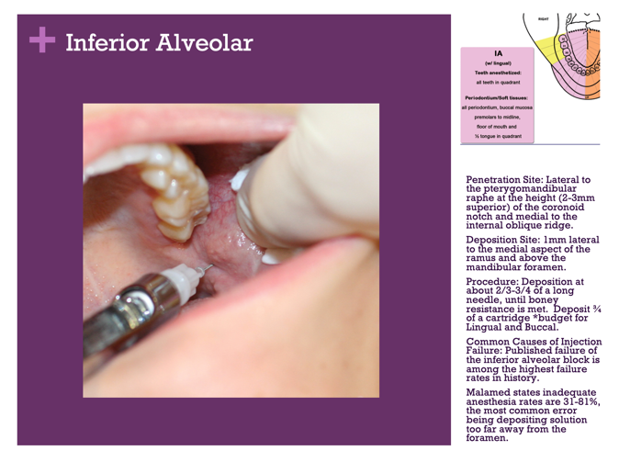
Recent Publications
- Sanders, K (2016) Introduction to the Dental Hygiene Profession. 3rd ed. Gos Publishing.
- Sanders, K (2018) Gen Y Aren’t They In Your Office?. DentalTown.
- Sanders, K (2018) Dear IA Nerve Block: It’s Not Me, It’s YOU!. Today’s RDH.
- Sanders, K (2018) The 5 Injection Techniques You Need to Master. Modern Hygienist.
- Sanders, K (2018) Are You Suffering from Burnout?. Modern Hygienist.



Biography
A graduate of the University of Minnesota’s School of Dentistry and Northern Arizona University’s Graduate program in Educational Leadership, Katrina M. Sanders RDH, BSDH, M.Ed, RF is a published author, international speaker, and key influencer. As an award-winning dental hygienist, Katrina is the recipient of the Kathleen J Newell Dental Hygiene Achievement Award and the Community Dentistry and Dental Public Health Award. Katrina educates, consults and performs clinical and surgical periodontal procedures as the Clinical Liaison, Hygiene Excellence & Innovation for AZPerio, the country’s largest periodontal practice. The proud founder of Sanders Board Preparatory, Katrina speaks as a keynote lecturer for several study clubs and dental hygiene associations. Katrina is a distinguished member of Phi Kappa Phi Honor Society and sits on the advisory board panel for several dental and dental hygiene organizations. www.katrinasanders.com
Email: katrina@katrinasanders.com

Notes/Comment

