Infection Control: When You Absolutely Don’t Want to “Go Viral”
Katrina M. Sanders RDH, BSDH, M.Ed, RF

Abstract
In more practices than we may care to admit, sterilization procedures are not always aligned with current recommendations. There have been cases throughout the United States in which inadequate infection control practices have led to the spread of hepatitis, HIV, and antibiotic-resistant bacteria, to name a few.
To ensure our patients aren’t exposed to viruses, bacteria, and protozoa, dental professionals need to understand more than what to do and what not to do; they also need to understand why. In this lively, engaging course, Katrina Sanders, RDH, M.Ed. takes participants on a historical journey of social norms which lead to infectious diseases. We’ll trace the evolution and spread of disease from patient zero outward, showing the microbiological, immunological, and human impacts of the chain of infection.
Examine the infection control process and its application in ensuring the practice is up to date with current recommendations. A review of case studies will bring to life real-world infection control breaches. Each member of the team will understand their role in keeping patients safe through compliance with standard precautions.

Objectives:
• Understand the infectious disease process as it relates to dental professionals
• Explore infectious diseases that are easily contracted
• Evaluate behaviors that promote the spread of infection
• Examine the timeline of historical events that have led to the spread of disease
• Gain a deeper understanding and appreciation for why infection control is imperative today
• Describe the role that the immune system plays in fighting the spread of infection

Image
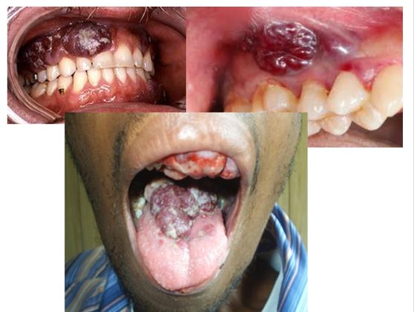

Recent Publications
- Sanders, K (2016) Introduction to the Dental Hygiene Profession. 3rd ed. Gos Publishing.
- Sanders, K (2018) Gen Y Aren’t They In Your Office?. DentalTown.
- Sanders, K (2018) Dear IA Nerve Block: It’s Not Me, It’s YOU!. Today’s RDH.
- Sanders, K (2018) The 5 Injection Techniques You Need to Master. Modern Hygienist.
- Sanders, K (2018) Are You Suffering from Burnout?. Modern Hygienist.



Biography
A graduate of the University of Minnesota’s School of Dentistry and Northern Arizona University’s Graduate program in Educational Leadership, Katrina M. Sanders RDH, BSDH, M.Ed, RF is a published author, international speaker, and key influencer. As an award-winning dental hygienist, Katrina is the recipient of the Kathleen J Newell Dental Hygiene Achievement Award and the Community Dentistry and Dental Public Health Award. Katrina educates, consults and performs clinical and surgical periodontal procedures as the Clinical Liaison, Hygiene Excellence & Innovation for AZPerio, the country’s largest periodontal practice. The proud founder of Sanders Board Preparatory, Katrina speaks as a keynote lecturer for several study clubs and dental hygiene associations. Katrina is a distinguished member of Phi Kappa Phi Honor Society and sits on the advisory board panel for several dental and dental hygiene organizations. www.katrinasanders.com
Email: katrina@katrinasanders.com

Notes/Comment

