Cracking Perio Codes with Class: Diagnostic Decisions
Katrina M. Sanders RDH, BSDH, M.Ed, RF

Abstract
Failure to diagnose periodontal disease is consistently a top complaint filed with state dental boards. The first step in treating and managing a patient’s care (with maximum insurance reimbursement) is diagnosing disease accurately, ethically, and comprehensively. As diagnostics continually evolve, dental providers are encouraged to put down the scaler and pick up the probe. Active and appropriate diagnosis leads to comprehensive and effective therapy. This course walks the dental provider through the nine classifications of health and disease as established by the American Academy of Periodontology (AAP), as well as effective clinical decision-making in the management of each diagnosis. The struggle for appropriate diagnostics to maximize insurance coverage remains a common stress in the dental office.
Katrina Sanders RDH, M.Ed authored a textbook which is used in dental hygiene schools to teach the foundational
details behind periodontal diagnostics and coding. This course walks the dental billing team through effective coding techniques to best enable insurance coverage.
We will review anatomical and clinical observations that aid in the identification of active disease as well as the system for case types and classifying diseases. Gain guidance in coding, narrative suggestions for informed refusal, and templates for appeals to support advanced coverage by third-party payers.

Objectives:
• Review clinical parameters involved in distinguishing periodontal classifications, including contrasting
terms of gingival disease and periodontitis
• Discuss the paradigm shift within the nonsurgical approach to periodontal therapy
• List, describe, and differentiate the various periodontal diseases
• Analyze effective protocols for implementing diagnostic, preventive and periodontal codes
• Explore future trends of periodontal classification as discussed by the American Academy of Periodontology

Image
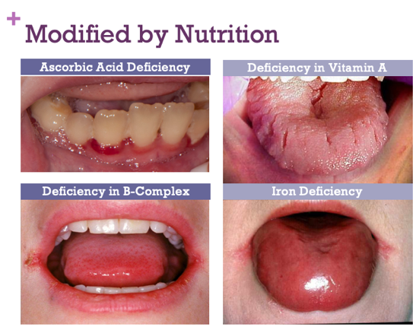
Recent Publications
- Sanders, K (2016) Introduction to the Dental Hygiene Profession. 3rd ed. Gos Publishing.
- Sanders, K (2018) Gen Y Aren’t They In Your Office?. DentalTown.
- Sanders, K (2018) Dear IA Nerve Block: It’s Not Me, It’s YOU!. Today’s RDH.
- Sanders, K (2018) The 5 Injection Techniques You Need to Master. Modern Hygienist.
- Sanders, K (2018) Are You Suffering from Burnout?. Modern Hygienist.



Biography
A graduate of the University of Minnesota’s School of Dentistry and Northern Arizona University’s Graduate program in Educational Leadership, Katrina M. Sanders RDH, BSDH, M.Ed, RF is a published author, international speaker, and key influencer. As an award-winning dental hygienist, Katrina is the recipient of the Kathleen J Newell Dental Hygiene Achievement Award and the Community Dentistry and Dental Public Health Award. Katrina educates, consults and performs clinical and surgical periodontal procedures as the Clinical Liaison, Hygiene Excellence & Innovation for AZPerio, the country’s largest periodontal practice. The proud founder of Sanders Board Preparatory, Katrina speaks as a keynote lecturer for several study clubs and dental hygiene associations. Katrina is a distinguished member of Phi Kappa Phi Honor Society and sits on the advisory board panel for several dental and dental hygiene organizations. www.katrinasanders.com
Email: katrina@katrinasanders.com

Notes/Comment

