Todd Cohen’s Keynotes and Workshop
Designed for all
Dental Professionals.

Prepared for
5th International Conference on Dental Science and Education
www.toddcohen.dental
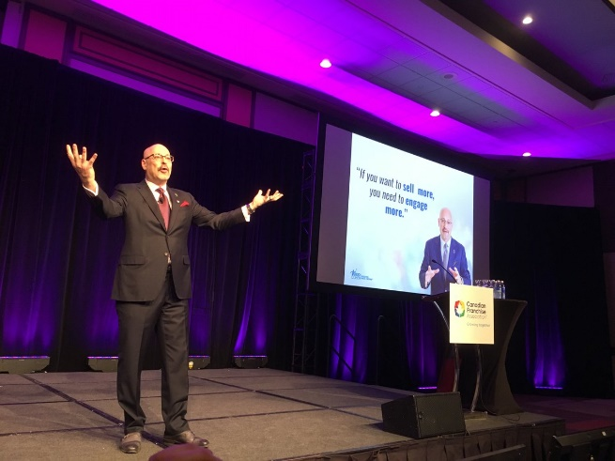

What Dental Professionals are saying about Todd Cohen!
“….Todd is a dynamic speaker who energized and inspired a hundred twenty dental professionals; sparking discussion that has continued on to this day… understanding our value proposition as a dental profession. Knowing your value proposition you can handle patient objections and concerns with grace creates an environment in which the patient feels comfortable and appreciated… resulting in more case acceptance and referrals”
-Dr. Jon Engel, DDS- California
“Todd Cohen was an instrumental addition to our Annual Symposium! His message of how we all sell ourselves every day and how to be better networkers was very inspirational, motivational and timely. Every single attendee was very pleased with having Todd as our speaker and his workshops were also highly attended and well received. Todd has an ability to connect the art of sales to the skills we all have and how we can all advance ourselves with every single connection we make. He spent the entire symposium with us and was amenable and open to every suggestion we had about utilizing his content. The return on investment was evident after our Annual Symposium and we enjoy seeing attendees continued to quote Todd in different venues. I give Todd my full and enthusiastic recommendation if you are seeking something different and absolutely enlightening.”
-Rhoda Kublickis, Immediate Past President, Florida Dental Hygiene Association
"Todd Cohen possesses a unique ability to find the inner, untapped talents of the audience that participates in his programs. His delivery of a succinct action plan is an ongoing gift that springboards success in those ready to propel their business or career to the next level. I embraced Todd's suggestions right out of the gate and the results have been outstanding!"
-Debbie Z. Sabatini, RDH, Consultant, Author and Speaker
“If you are looking for content that is new, exciting and highly relevant to our profession, please don’t look any further than Todd Cohen. Todd has been a featured speaker and workshop presenter at many conferences of dental and healthcare professionals and his message resonates deeply with the attendees. Todd delivers in an spirited and motivating way that leaves people energized and ready to do amazing things with their practices and themselves. Additionally, he has an amazing ability to tailor his message to his audience whether top level executives in business or direct care health care providers. I highly recommend Todd as your next speaker!”
-Linda Meeuwenberg, R.D.H., M.A., M.A, F.A.D.I.A.

Increased Patient Retention. Greater Case Acceptance.
A More Profitable Practice

Today’s modern and successful dental practice succeeds because of the entire team! The dentist, the hygienist, the dental assistant…..everyone who interacts with the patient, plays a significant role and everyone works together to ensure that more patient case acceptance occurs. Every day each member of the team makes recommendations, influences, inspires and ensures that each patient receives excellent results!

In this uplifting, humorous and highly motivational keyniote, dental speaker Todd Cohen will show how you and the entire dental team has the fantastic ability to create an environment in your practice setting that ensures patient retention, patient satisfaction, and positive organizational engagement. Todd has inspired thousands of dental professionals, and he will show attendees how what they do mightily contributes and impacts their patient’s ultimate decision to say “yes” to the treatment plan!
This timely and inspirational message speaks to YOUR ability to create a mindset that everyone influences positive outcomes and good health by doing what he or she does so well every day, by being present and engaged. Todd covers such areas as developing a professional value proposition, the virtual dental team, and relationship portability ™ and to stop apologizing for being remarkable!

Session Objectives and Immediate Takeaways:
- Understand how every member of the practice is a positive and profitable influence on the patient
- Know how YOU are vital in your role as chief patient advocate!
- Understand your professional Value Proposition to enhance patient communication
- The three words a no dental professional should ever say
- Defining the Virtual Team™ to achieve outstanding patient health

TODD COHEN IS THE LEADING VOICE ON BUILDING SALES CULTURE to the worlds dental professionals
A dynamic, engaging and motivational keynote speaker, Todd’s message is relevant to any dental practice and organization striving to increase revenue, strengthen relationships and improve patient satisfaction. Using humor and real-life examples, Todd demonstrates how every conversation is a “selling moment” and how everyone can contribute to the growth and profitability of the practice.
Averaging 90 appearances per year, Todd’s audiences range in size from small groups to upwards of 5,000 people. His diverse dental clients include multiple state dental hygiene groups, entire dental team settings and large group practices.
In 2015, Todd was awarded the title of Certified Speaking Professional (CSP), the highest-earned designation awarded by the National Speakers Association (NSA). He has served as a member of the NSA Chapter Leadership Council and is a past president of NSA’s Philadelphia Chapter. He has served on the board of the Greater Philadelphia Senior Executives Group (GPSEG) and was co-chair of GPSEG’s Sales and Marketing Group. Todd is a member of the American Society of Training and Development and previously served on the board of the Pennsylvania Society of People and Strategy.
Todd is the principal of Sales Leader LLC and author of two books on sales culture, “Everyone’s in Sales” and “Stop Apologizing and Start Selling.” He is a regular contributor to The Huffington Post and Philadelphia Business Journal has written for dozens of trade and association magazines and has a monthly newsletter titled Sales Culture Newsletter.
He is a frequent guest lecturer at area schools including Drexel University, Peirce College, Pennsylvania State University, St. Joseph’s University and Temple University. From 2010-2012, he served as the Sales Executive in Residence at Temple University Fox School of Business where he mentored students on entrepreneurship. Todd regularly coaches people in career transition teaching them how to sell themselves to get the position they want.

