Analysis of inorganic anion in salivary for the diagnosis of systemic disease

Jung-Eun Park, RDH PhD, Kyunghee University, Korea
Jong-Hwa Jang, RDH DrPH, Dankook University, Korea

Abstract
Statement of the Problem: Diagnostics using saliva are particularly non-invasive, economical, and comfortable compared to blood tests. Therefore, saliva has potential application in diagnostic methods. Saliva contains diverse anionic compounds. Chloride is an important diagnostic marker for cystic fibrosis. Nitrate and nitric oxide metabolites from body fluids can be used to estimate the magnitude of nitrosative and oxidative stress. Phosphate levels in the blood and the saliva are proven biomarkers that indicate the initial stages of obesity. . Real saliva samples were analyzed for their inorganic anion contents to validate the method and to provide reference material for future salivary anion analysis. Methodology & Theoretical Orientation: HPLC (High performance liquid chromatography) separation was carried out with Dionex IonPac AG 11-HC column (50mm×4mm). The temperature in the column was 30°C and the flow rate of the NaOH solution was kept constant at 900 μL/min and isocratic elution with 120 mmol/L. Findings: The linearity of the sample’s linear range was 0.9902-0.9989, LOD was 0.78-1.16µM, and LOQ was 2.36-3.49 µM. The recovery test showed a recovery rate of 95.63-107.77% and RSD of 3.37-11.48%, which verified the analytical method. Although deviations were observed in different participants, analysis of real saliva samples showed relatively good selectivity. This study, which analyzed anions in saliva, could be used as reference for saliva biomarker studies in the future. Conclusion & Significance: an analytical method to simultaneously quantify fluoride, chloride, nitrate, sulfate, phosphate and iodide amount in saliva was developed using HPLC ion chromatography (IC). Furthermore, inorganic anions in real saliva samples were analyzed for method validation.

Image
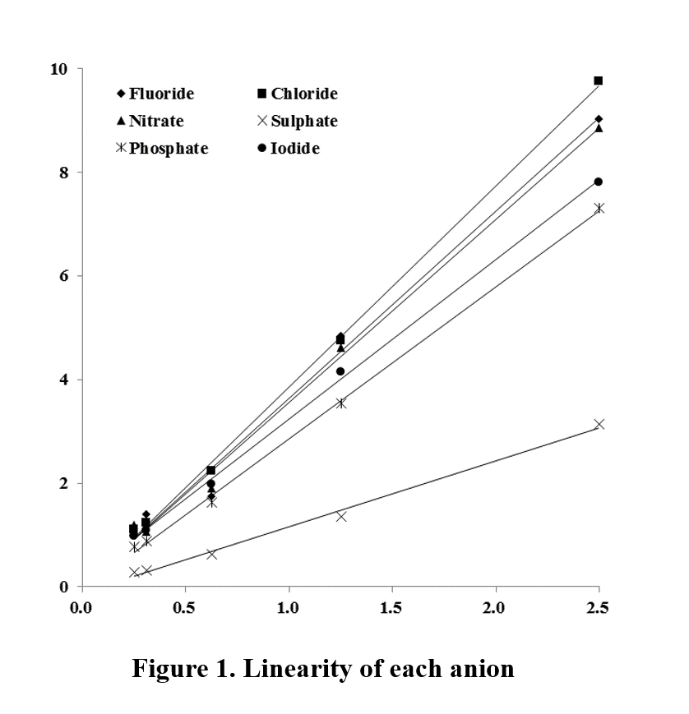

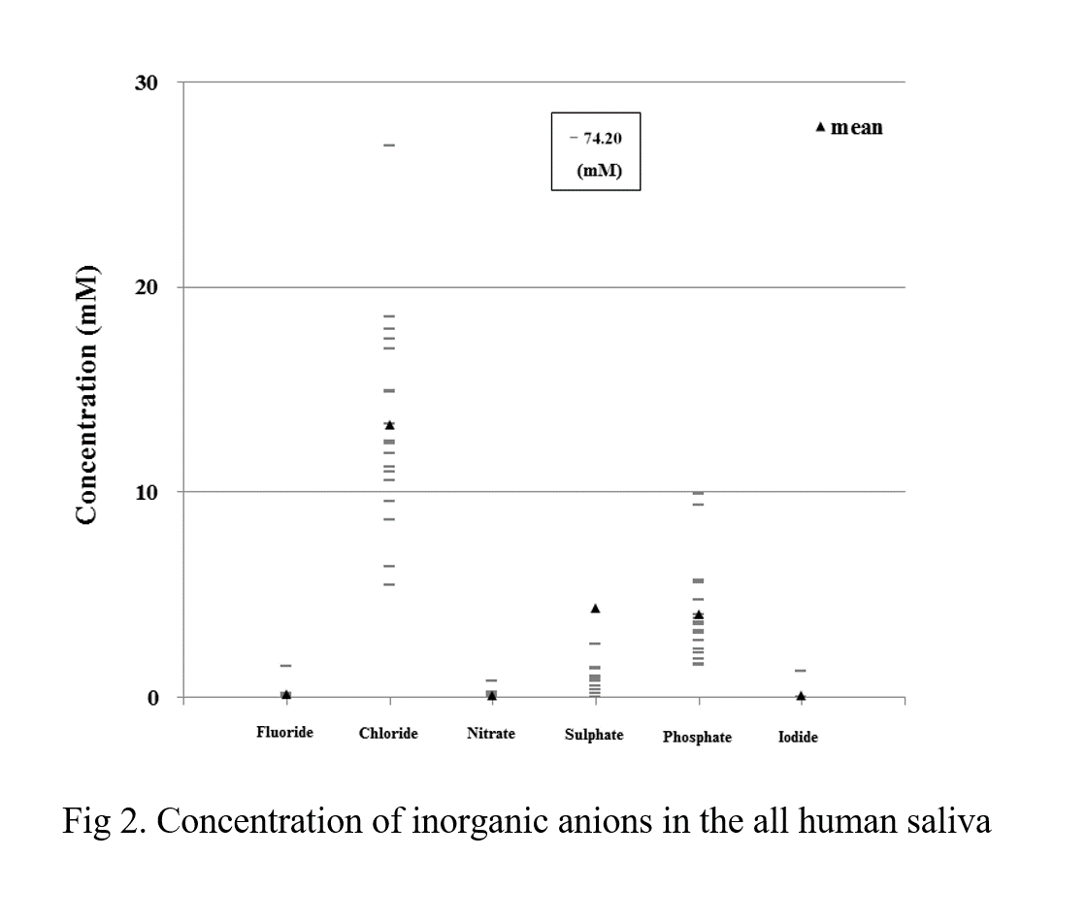

Recent Publications
- Amerongen AV, Veerman EC (2002) Saliva-the defender of the oral cavity. Oral Diseases 8:12-22.
- Chiappin S, Antonelli G, Gatti R, De Palo EF (2007) Saliva specimen: A new laboratory tool for diagnostic and basic investigation. Clinica Chimica Acta 383:30-40.
- Van Nieuw Amerongen A, Bolscher JG, Veerman EC (2004) Salivary proteins: protective and diagnostic value in cariology?, Caries Research 38: 247-253.
- Lawrence HP (2002) Salivary markers of systemic disease: noninvasive diagnosis of disease and monitoring of general health. Journal of the Canadian Dental Association 68:170-174.
- Ramautar R, Mayboroda OA, Somsen GW, de Jong GJ (2011) CE-MS for metabolomics: Developments and applications in the period 2008-2010. Electrophoresis 32:52-65.

 Jong-Hwa Jang has professional knowledge on saliva, epidemiology, and oral health promotion. She is an experienced researcher with several years of experience in research, teaching, and assessment from both clinical and research institutions, and currently performing several studies on the analysis of the components of human saliva.
Email: jhj@dankook.ac.kr

Notes/ Comments: Acknowledgment

This work was supported by the National Research Foundation of Korea(NRF) grant funded by the Korea government(MSIP) (No. 2017R1A2B4012865).

