The effect of erythritol on suppressing organic acids that induce dental caries

Jung-Eun Park, RDH PhD, Kyunghee University, Korea
Jong-Hwa Jang, RDH DrPH, Dankook University, Korea

Abstract
Statement of the Problem: Erythritol, a tetrytol among sugar alcohols, is a low-calorie and tooth-friendly sweetener, which is recently being highlighted for its ability to manage dental caries by preventing microbial fermentation in the oral cavity. Thus, by analyzing saliva samples, we aimed to assess organic acids produced by oral microbes, which induce dental caries. Methodology & Theoretical Orientation: To collect the control saliva, a fasting sample (- 0.5 mL) was collected from each individual before the sugar rinse. Twenty five milliliters of sucrose (10%, w/v) or each concentration sugars and erythritol mixture solution were administrated and rinsed around the mouth for 30 seconds and then expectorated. Next, the sucrose and each sugar alcohol mixture solution stimulated saliva sample (- 0.5 mL) was collected at 0, 1, 5, 10, 30, and 60 min after the sugar rinse. Findings: We measured the acid concentrations after 5–10 minutes of glucose intake, when the pH hit the minimum level. The average concentration in the Erythritol group was 6.12, 5.72 mM, lower than that in the control group, which was 9.76, 10/76 mM. Conclusion & Significance: Considering the concentration of organic acids produced by oral microbes, Erythritol appears to have the capability to suppress dental caries.

Image
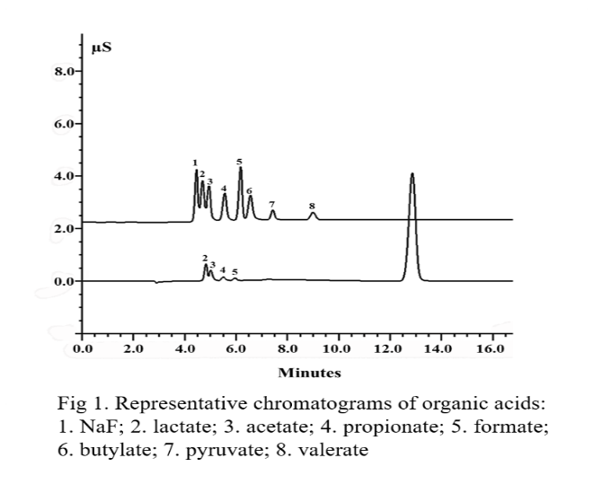

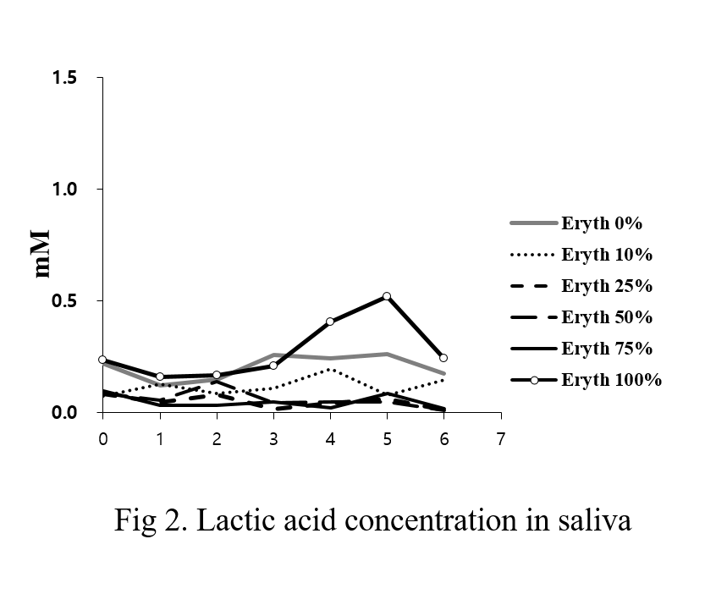

Recent Publications
- Park YD, Jang JH, Oh YJ, Kwon HJ (2014) Analysis of organic acids and inorganic anions and their relationship in human saliva before and after glucose intake. Arch Oral Biol 59:1-11.
- Ly KA, Milgrom P, Rothen M (2006) Xylitol, sweeteners, and dental caries. Pediatr Dent 28:192-198.
- Miyasawa-Hori H, Aizawa S, Takahashi N (2006) Difference in the xylitol sensitivity of acid production among Streptococcus mutans strains and the biochemical mechanism. Oral Microbiol Immunol 21:201-205.
- Almstahi A, Lingstrom P, Eliasson L, Carlen A (2013) Fermentation of sugar and sugar alcohols by plaque Lactobacillus strains. Clin Oral Investig 17:1465-1470.

 Jong-Hwa Jang has professional knowledge on saliva, epidemiology, and oral health promotion. She is an experienced researcher with several years of experience in research, teaching, and assessment from both clinical and research institutions, and currently performing several studies on the analysis of the components of human saliva.
Email: jhj@dankook.ac.kr

Notes/Comments: Acknowledgment

This work was supported by the National Research Foundation of Korea(NRF) grant funded by the Korea government(MSIP) (No. 2017R1A2B4012865).

