COMPARATIVE EVALUATION OF BETA TRICALCIUM PHOSPHATE WITH TYPE I COLLAGEN (RTR CONE) AND PLATELET RICH FIBRIN (PRF) IN EXTRACTION SOCKET PRESERVATION: AN IN-VIVO STUDY

Dr. Swati Das,MDS(Periodontology and Oral Implantology), India

Abstract (300 word limit)
Every tooth in a man’s mouth is more valuable than a diamond, but when the loss of such value becomes inevitable due to uninvited reasons like grossly carious tooth and/or periodontally compromised teeth, along with the morphologic and dimensional changes of the alveolar ridge that takes place after tooth extraction. The utmost need at this juncture is a method by which the preservation of the surrounding bone and soft tissue, with emphasis on doing a atraumatic extraction to deliver a healthy and sound alveolar bone for future restoration with an implant. Alveolar Ridge Preservation (ARP) using the Guided Bone Regeneration (GBR) technique has shown to improve ridge height and width dimensions when compared with tooth extraction alone.The ARP is indicated after extractions to preserve original ridge dimensions and contours (hard and soft tissues), when immediate implant placement is not possible. The resorbableβ-TCP has been used as a viable bone graft as it’sdesigned to maximize blood clot stability during early healing. The material has no organic components and therefore has no chance of antigenicity or allergic reactions.The alveolar maintenance provided by the β-TCP is comparable to ridge preservation, using autologous platelet derived product, Choukroun’s platelet – rich fibrin (PRF) that have a stimulatory effect on wound healing due to the presence of many growth factors such as fibroblast growth factor, platelet- derived growth factor (PDGF) and epidermal growth factor. It provides an excellent scaffold for angiogenesis and epithelialization. To test this hypothesis, a prospective randomized clinical trial study was designed to compare a total of 26 (13 males/ 13 females) nonalcoholic, non-smoker patients with no contributory medical history for socket preservation with PRF and beta tricalcium phosphate (RTR Cone) along with CT Scan imaging was done to evaluate the amount of bone volume at the post- operative period.

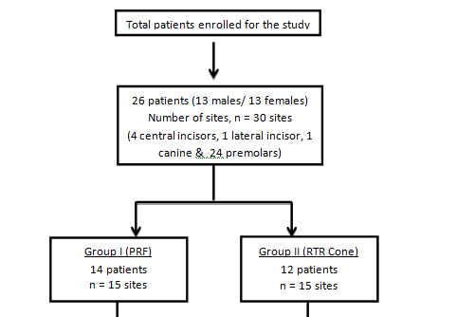

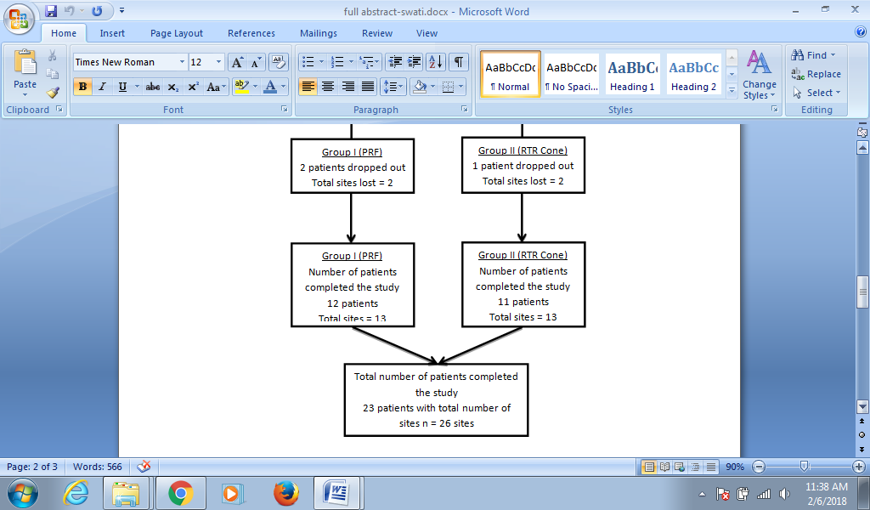

Recent Publications (minimum 5)

- Das S, Jhingran R, Bains VK, Madan R, Srivastava R, Rizvi I. Socket preservation by beta-tri-calcium phosphate with collagen compared to platelet-rich fibrin: A clinico-radiographic study.Eur J Dent. 2016;10:264-76.
- Maiti N, Maiti S. Flexing in canal with EDM. Heal talk.- a journal of clinical dentistry 2017:09
- Swati Das, Vivek Kumar Bains, Rajesh Jhingran, Rohit Madan, Vivek Gupta and Iram Rizvi. Virulence Factor Database (VFDB): Future in Dental Genomics. Asian Journal of Oral Health & Allied Sciences 2012: 2.
- Maiti N, Maiti S. The new view towards EDM files. J Dental Sci 2017; 2: 000144.
- Maiti N, Das S.. osseointegration- the backbone of implant dentistry. Heal talk.- a journal of clinical dentistry.

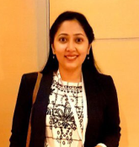Biography (150 word limit)
Dr. Swati Das has completed her BDS (Bachelor of Dental Surgery) from India and MDS(Masters of Dental Surgery) in Periodontology and Oral Implantology . She has received numerous training in esthetic dentistry and certified in Implant Prosthesis. She runs her own dental clinic in Kolkata ,India named as Helios Dental Clinic .
Email: drniladrimaiti@yahoo.com

