Bi-Cortical Implants : An Alternative to Conventional Dental Implants

Dr. Sandeep Mithapara
B.D.S. ( India )
Master In Immediate Functional Loading Implants , Munich ( Germany )

Abstract

The conventional crestal implants are indicated in situations when an adequate vertical bone supply is given. These crestal implants function well in patients who provide adequate bone when treatment starts, but prognosis is not good as soon as augmentations become part of the treatment plan. Augmentation procedures tend to increase the risks and costs of dental implant treatment as well as the number of necessary operations. Patients who have severely atrophied jaw bones paradoxically receive little or no treatment, as long as crestal implants are considered the device of first choice.
Image
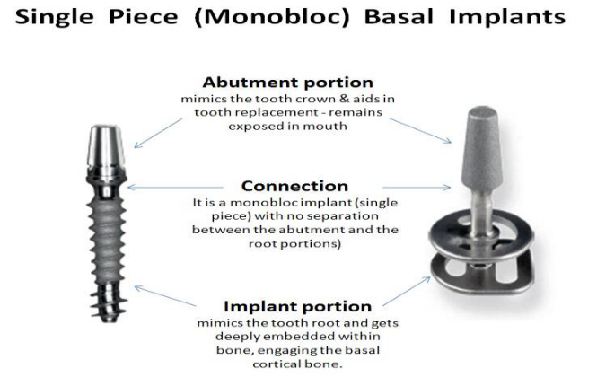
Recent Publications (minimum 5)

1. Ihde S. Restoration of the atrophied mandible using basal osseointegrated implants and fixed prosthetic superstructures. Implant Dent 2001;10:41–45.
2. Ihde S. Comparison of basal and crestal implants and their modus of application. Smile Dental Journal 2009;4:36-46.
3. Ihde S. Principles of BOI. Heidelberg: Springer. Germany. 2005;27.
4. Nair C, Bharathi S, Jawade R, Jain M. Basal implants - a panacea for atrophic ridges. Journal of dental sciences & oral rehabilitation. 2013:1-4.
5. Martin R, Burr D, Sharkey N. Skelettal Tissue Mechanics. 1st edition. New York: Springer; 1998.

Email: skmithapara@gmail.com

Notes/Comments:

