The socket-shield technique to for Ridge Preservation at immediate implant placement
Dr. Pedro Carvalho Feitosa
Coordinator of specialization courses in Implantology. Specialist in Oral and Maxillofacial Surgery and Traumatology, Master and doctor in Implantology, phd student of the Department of Biopathology of São Paulo University of São José dos Campos – UNESP.
Abstract
After extraction of the teeth, the alveolar bone goes through the remodeling process, which leads to horizontal and vertical bone loss. These reabsorption processes complicate dental rehabilitation, particularly in connection with implants. Careful management of post-extraction tissues is necessary to preserve the alveolar ridge. Several methods of guided bone regeneration have been described to retain the original bone size after extraction. Most procedures use filling materials and membranes to support the oral plaque and soft tissues, stabilize the clot and prevent epithelial growth. Instead of surgical augmentation to correct a defect peak, the socket-shield technique offers a promising solution. With this method, it will be demonstrated how the crest and the entire buccal bone are clinically preserved and the biological integrity of the buccal periodontium remains untouched. This method has also been described in connection with the immediate placement of the implant and the provisional crown. The immediate postoperative period, as well as the follow-up of one year, will be demonstrated as a functional and aesthetic result of the treatment. The socket-shell technique is a highly promising addition to clinical implant dentistry. We will discuss the possibilities, limitations, and guidelines for future research that we begin at our university.
Recent Publications

1. Medeiros JMF; SIQUEIRA, L. S.; FEITOSA PC; ROMEIRO, R. L.; FERNANDES, V. V. B.
Considerações sobre deformação e os efeitos da temperatura na superfície de corte de brocas de implante dentário. full dentistry in science, v.08, p.01366 -, 2016.

2. Feitosa, PC ; SILVA, F. P. B.; WOOD, P. F.; SIQUEIRA, L. S.; ROMEIRO, R. L.
Alterações das membranas paranasais de ratos submetidos à ação da fumaça do cigarro. Implant News, v. 11, p.153 -, 2014.

3. FERNANDES, V. V. B.; ROMEIRO, R. L.; Feitosa, PC
Association of custom-made zirconia abutments with emax crowns in implant rehabilitations: case report..Brazilian Dental Science. , v.17, p.443 - 450, 2014.

4. FREITAS, T; RODRIGUES, R. M.; Feitosa, PC ; LAIA, M.; ROMEIRO, R. L.
Utilização de osso homógeno em perdas ósseas horizontais e verticais unitárias - relato de caso. Full Dentistry in Science., v.5, p.409 - , 2014.

5. FEITOSA, Pedro Carvalho
PROTOCOLO IMEDIATO PROVISÓRIO RELATO DE CASO. Full Dentistry in Science, v.4, p.277 - , 2013.

Images

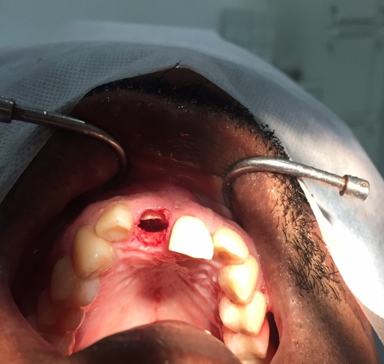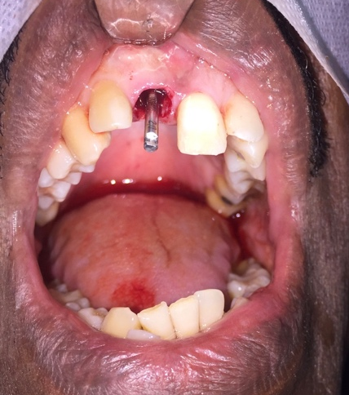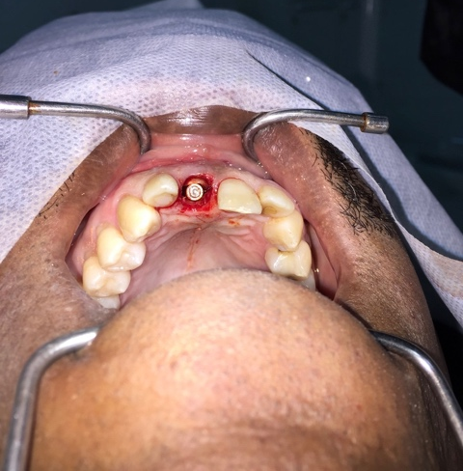
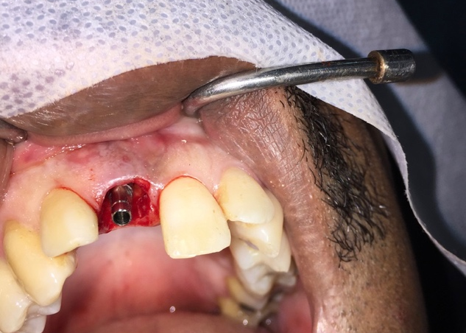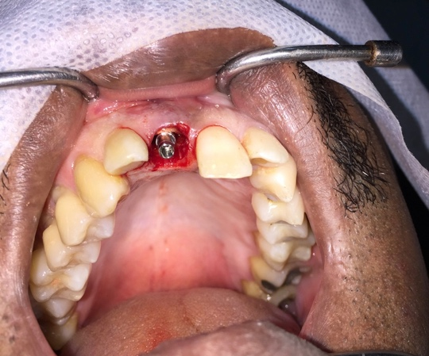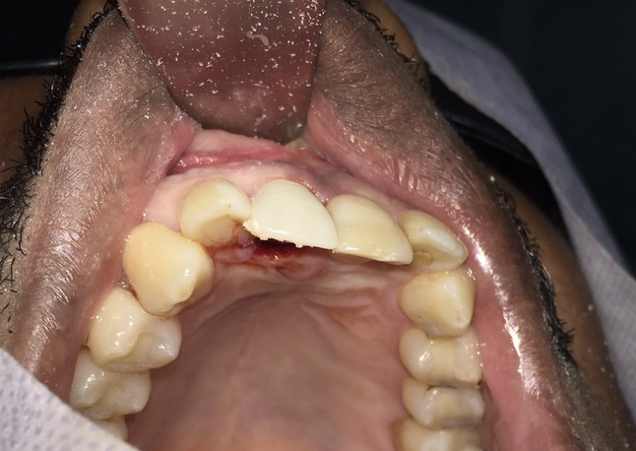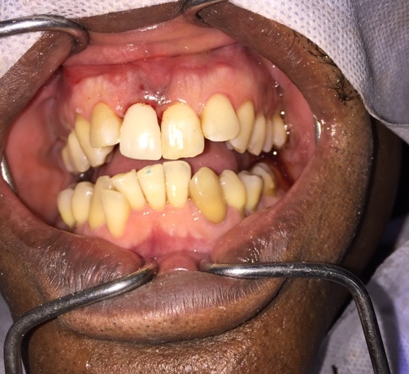

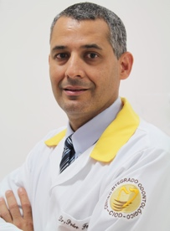 Biography

Graduated in Dentistry from the University of Santo Amaro, São Paulo -Sp (1995), specializations in Oral and Maxillofacial Surgery and Traumatology, Master in Implant Dentistry from the University of Santo Amaro - São Paulo -Sp (UNISA), PhD in Implantology (São Leopoldo Mandic - Campinas - Sp) , PhD in Biopathology from the Paulista University (UNESP), São José dos Campos - Sp. Qualified in Conscious Sedation. He is currently coordinator of the specialization course in Oral Maxillofacial Surgery and Traumatology at the Faculdade IPE (FAIPE) in Cuiabá - MT and the course of oral surgery at the same university. Coordinator of the specialization course in implantology at GRAAL, São Luís - Ma. Teacher of the specialization course in Oral and Maxillofacial Surgery and Traumatology at São Leopoldo Mandic University in Campinas - Sp. He has experience in Dentistry, with emphasis on Maxillofacial Surgery and Implantodontia.

Pedro Feitosa, Email: dr.pedrofeitosa@terra.com.br

