The importance of Functional appliance therapy
Dr. Golmoradizadeh Ali
Functional appliance therapy is one of the most important fragments in orthodontics. It is essential for treatment of patients with skeletal or dental malocclusions. A number of functional appliances have been developed, since the time of the “activator” developed by Andresen which offer definite advantages in growth modification to correct skeletal malocclusions. However Removable functional appliances have several disadvantages, as a result fixed functional appliances are replacing removable functional appliances, which can be attached/adapted to the fixed orthodontic appliances thus reducing treatment duration at the same time achieving orthopedic changes, followed by orthodontic changes.
In this review study, we would introduce appraise the different types of the functional appliances, and continue with different categories such as fixed or removable and the best time for starting of each appliance as well as the clinical approach and home care.
Sufficient knowledge on functional appliances with dental professionals can aid in saving patients from more intrusive and cumbersome corrective treatment modalities in the future. Knowledge in this specific matter from the beginning may be the only preventive measure to alleviate dental malocclusions from an early age and ultimately save patients from lessened self-confidence.
In conclusion, sufficient and appropriate knowledge on functional appliance therapy is necessary for dental practitioners who are exposed to young patients in order prevent any future problems in functional aesthetics, skeletal formation and stable occlusion
Keywords: Orthodontics, Functional Appliance, preventive Orthodontics
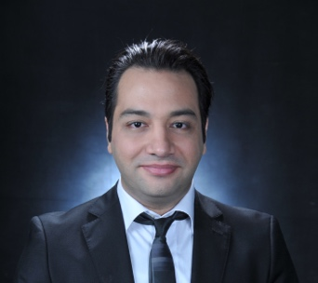
Biography:

Dr. Golmoradizadeh Ali, Graduated from Centro Escolar University on 2013 in Doctor of Dental Medicine, and MS Orthodontics from University of Philippines
- Faculty member of University of Hormozgan, Iran
- 7 presentation in ADA, FDI and other international congresses,
- Fellowship of Research
-Associated editor of Journal of Evaluation of Medical and Dental Sciences

Email :
Ali2ph@yahoo.com
agolmoradizadeh@up.edu.ph

