Title: The The use of silver diamine fluoride to prevent/treat enamel carious lesions

Rasha Numan AlSheikh¹
¹Restorative Dental Science Department, College of Dentistry, Imam Abdulrahman bin Faisal University, Dammam, Saudi Arabia

Abstract

This presentation will discuss the promising use of silver diamine fluoride (SDF) for the prevention and treatment of enamel carious lesions.
Dental caries continues to be of high concern globally reflecting a high burden on health institutes.¹ The prevalence of caries lesions both enamel and dentine continue to increase among primary and permanent teeth. A study stated that the prevalence of white spot lesions (enamel caries) was as high as 31% among children and young adults ² and another study stated a high provenance of enamel caries lesions as high as 99% in Finnish adults.³
Silver diamine fluoride is a minimally invasive, safe, effective, and economical agent that prevents and arrests dental caries in primary and permanent teeth.⁴
SDF has been approved by different international drug associations as a caries-preventing agent to be used on deep carious lesions (dentin). However, SDF can cause staining of exposed tooth structures. Furthermore, the effect of SDF on the bond of adhesives to the tooth structure is still being determined. This discussion explores various studies on the use of SDF to treat enamel carious lesions, highlighting its effectiveness and preventive action. The literature suggests that SDF inhibits bacterial growth, promotes remineralization, and does not negatively affect adhesive retentions. Potassium iodide (KI) or glutathione (GSH) can reduce staining and discoloration.^{5,6} Despite its limitations, SDF shows potential as a therapy for enamel caries prevention, remineralization, and use as an adjuvant to other dental treatments, warranting further investigation and the refinement of application methods.

(100-500 words)

References
- Ndagire B, Kutesa A, Ssenyonga R, Kiiza HM, Nakanjako D, Rwenyonyi CM. 2020. Prevalence, severity and factors associated with dental caries among school adolescents in Uganda: a cross-sectional study. Brazilian Dental Journal 31:171-178
- Massignan C, Ximenes M, da Silva Pereira C, Dias L, Bolan M, Cardoso M. 2016. Prevalence of enamel defects and association with dental caries in preschool children. European Archives of Paediatric Dentistry 17:461-466
- Laajala A, Pesonen P, Anttonen V, Laitala ML. 2019. Association of enamel caries lesions with oral hygiene and DMFT among adults.Caries Research 53:475-481
- Rosenblatt A, Stamford TC, Niederman R. 2009. Silver diamine fluoride: a caries silver-fluoride bullet. Journal of Dental Research88:116-125
- Sayed M, Matsui N, Hiraishi N, Nikaido T, Burrow MF, Tagami J.2018. Effect of glutathione bio-molecule on tooth discoloration associated with silver diammine fluoride. International Journal of Molecular Sciences 19(5):1322
- Sorkhdini P, Crystal YO, Tang Q, Lippert F. 2021. The effect of silver diamine fluoride in preventing in vitro primary coronal caries under pH-cycling conditions. Archives of Oral Biology 121:104950

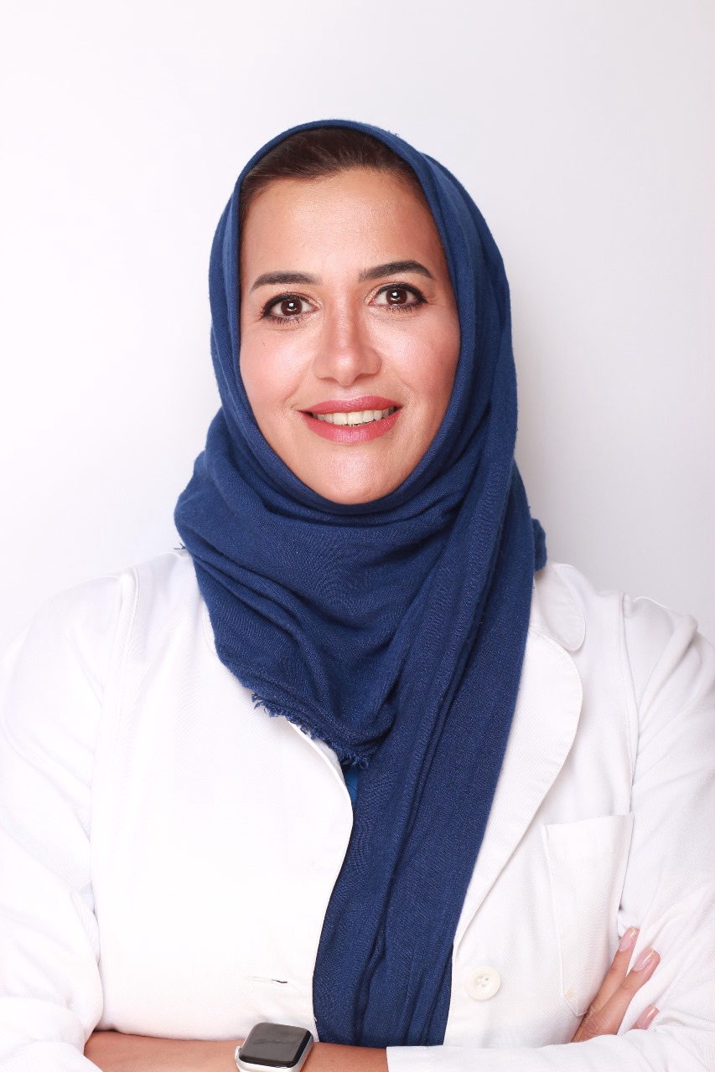
Biography: (100 -200 words)
Dr Rasha Numan AlSheikh is an Assistant Professor in the department of restorative dental science at College of Dentistry at Imam Abdulrahman bin Faisal University.
Got her bachelor's degree form Cairo University in 2002, Join King Faisal University in 2004 as a Demonstrator
She earned a clinical residency in operative dentistry certificate, a Master of Science from Indiana University in operative dentistry and a certificate in dental materials 2009 and the diplomate of American Board of Operative Dentistry in 2012
Since then, she is an active faculty member interested in caries prevention, adhesive dentistry and esthetics.

• Full Name: Rasha Numan AlSheikh
• Personal Email: ralsheikh@iau.edu.sa
• Mobile Number: +966506864814
• Category: (Oral presentation)
• Date of Birth: 02/11/1978
• Postal Address: Restorative Dental Science Department, College of Dentistry, Imam Abdulrahman bin Faisal University, Dammam, Saudi Arabia

Email: ralsheikh@iau.edi.sa

