In-vitro wear testing and evaluation of the advanced materials used for onlay dental restauration
Oana Gingu, PhD, University of Craiova, Romania
Veronica Mercut, PhD, University of Medicine and Pharmacy, Craiova, Romania
Mihaela S Popescu, PhD, University of Medicine and Pharmacy, Craiova, Romania
Horia O Manolea, PhD, University of Medicine and Pharmacy, Craiova, Romania
Cristina A Teisanu, PhD, University of Craiova, Romania
Leonard M Ciurezu-Gherghe, PhD, University of Craiova, Romania
Gabriela Sima, PhD, University of Craiova, Romania

Abstract (300 word limit)
Statement of the Problem: The oral cavity is an extremely complex tribological system controlled by various factors such as different load and pH values, dietary diversity, environmental factors, and teeth cleaning, among others. Understanding the mechanisms of tooth wear hinges on interpreting how these factors interact. Bio-engineered advanced materials are widely used for onlay restorations, not only for their functional benefits but also for aesthetic considerations. Tooth wear occurs when the mastication forces applied to dental restorations create tensions at the contact surfaces between the conjugated teeth, with stresses exceeding the mechanical strength of the biomaterials used in onlay rehabilitation. This study aims to test and evaluate in vitro the wear occurring in wet/dry environments between different friction couples formed from natural/restored tooth vs. restored tooth. Methodology & Theoretical Orientation: In-vitro testing of friction couples is conducted in both wet (artificial saliva) and dry (most aggressive) environments using a linear/circular tribometer and a rheometer. Wear evaluation involves measuring wear parameters (friction coefficient, wear rate, and worn trace profile), as well as conducting a macroscopic investigation of the worn traces. Findings: The study results confirm adhesive and abrasive wear mechanisms, evaluated by determining the profile and morphology of the worn traces, as well as through linear and surface measurements of the defects in the tested samples. These results are corroborated with the wear testing parameters (pressing force, sliding distance, sliding speed, etc.). Conclusion & Significance: The obtained experimental results can provide substantial support for researchers and specialists in the development of biomaterials for onlay dental restorations. Additionally, the study aims to contribute to increasing awareness and access for disadvantaged populations to high-quality services in onlay dental restoration. Furthermore, the study also targets the educational aspect for patients regarding oral hygiene.

Image
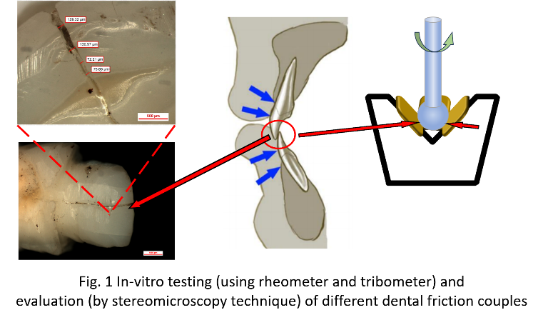
Recent Publications (minimum 5)
- Georgeanu VA, Gingu O, Antoniac IV, Manolea HO (2023), Current options and future perspectives on bone graft and biomaterials substitutes for bone repair, from clinical needs to advanced biomaterials research, Applied sciences-Basel, 13, DOI 10.3390/app13148471
- Draghici MA, Mitrut I, Salan AI, Marasescu PC, Caracas RE, Camen A, Ciocan LT, Gîngu O, Manolea HO (2023), Osseointegration evaluation of an experimental bone graft material based on hydroxyapatite, reinforced with titanium-based particles, Romanian Journal Of Morphology And Embryology, 64: 49-55
- Caracas AM, Marasescu PC, Mitrut I, Caracas RE, Gîngu O, Nistor CML, Târtea DA, Draghici MA, Manolea HO (2021), A microscopy evaluation of the prosthetic restorations outer surfaces made from four dental materials, Romanian Journal Of Oral Rehabilitation, 13: 95-103
- Gheorghe AG, Mercut V, Popescu SM, Tuculina MJ, Diaconu OA, Gheorghita LM, Gîngu O (2020), Microscopic study of the endodontic obturation sealing ability, Romanian Journal Of Oral Rehabilitation, 12: 32-40
- Popescu SM, Lascu L, Gingu O, Mercut V, Osiac E, Scrieciu M, Tuculina MJ, Draghici EC, Manolea HO, Moraru AI (2019), OCT application in direct dental restorations marginal fit evaluation, Revista De Chimie, 70: 1439-1444
- Manolea HO, Matei IM, Nistor CML, Lazar AC, Salan AI, Gîngu O, Cioatera N, Iacov-Craitoiu MM, Galbinasu BM (2019), A microscopic insight of the morphological changes induced by dental zirconia prosthetic structures, Romanian Journal Of Morphology And Embryology, 60: 875-881

Biography (150 word limit)
Prof. Oana Gingu graduated in 1991 the University of Craiova, Romania, Faculty of Mechanics. Since that time, she is member of the academic staff of the same university and faculty. The Ph.D. degree was achieved in 2001 at the Technical University of Cluj-Napoca, Romania, in the field of Materials Science and Engineering, and became specialist on composite materials processed by the powder metallurgy technology. Since then, Prof. Gingu has participated in specialization courses, such as "Ceramic Materials and Nanocomposites" 2009, CSIC Spain and "Nanosciences and Nanotechnologies" 2005, CNRS France. The research activity is concentrated in the field of design, development and characterization of biocomposite materials with ceramic matrix for small bone reconstruction, with publications in specialized books and journals with international quotation in the field. Prof. Gingu is part of multidisciplinary research teams, enjoying the collaboration and support of groups of researchers known nationally and internationally.
Email: oana.gingu@edu.ucv.ro

Notes/Comments:

