Title: Can We Improve The Autistic-Dentist Relationship: An investigation

Jihene Zaroui¹, Rym Jenni⁴, Imene Jazi² , Mohamed Ali Chemli³

¹Associate professor in pediatric dentistry, Faculty of dentistry of Monastir, La Rabta Hospital,Tunisia
²Assistant professor in pediatric dentistry, Faculty of dentistry of Monastir, La Rabta Hospital, Tunisia
³Professor in pediatric dentistry, Faculty of dentistry of Monastir, La Rabta Hospital, Tunisia
⁴General dentist, Faculty of dentistry of Monastir, La Rabta Hospital, Tunisia

Abstract

Background:
Autistic children (AC) are patients with specific needs and their management is a challenge for the dentist.
Aim:
The purpose of this work is to define the relationship AC-Dentist, identify the difficulties
in the management of these patients with specific needs and determine the factors that can improve it.
Methods:
This is a cross-sectional descriptive study that had been carried out over a period of 5 months covering 100 dentist and 60 AC who reside or work in the territory of Greater Tunis-Tunisia.
Results:
The results are broadly consistent with the literature data. Caries prevalence is high among AC (93%). Difficulties related to the AC, the attitude of his parents and also of the dentist make the access of these children to the dental care complex. The results of this study demonstrated that AC preparation, a good timing of the appointment, a good dentist training and a suitable environment can improve the care.
Conclusion:
Though the AC-dentist relationship is complicated, the solutions do exist. Still, this study emphasizes the importance of prevention and hygiene education among AC.

(100-500 words)

References:
- Du RY, Yiu CK, King NM. Oral health behaviours of preschool children with autism spectrum disorders and their barriers to dental care. J Autism Dev Disord. 2018. Sous Presse. doi: 10.1007/s10803-018-3708- 5.
- Delli K, Reichart PA, Bornstein MM, Livas C. Management of children with autism spectrum disorder in the dental setting: Concerns, behavioural approaches and recommendations. Med Oral Patol Oral Cir Bucal 2013;18 (6):862-8.
- Chandrashekhar S, Bommangoudar JS. Management of Autistic Patients in Dental Office: A Clinical Update. Int J Clin Pediatr Dent 2018;11(3):219-27.

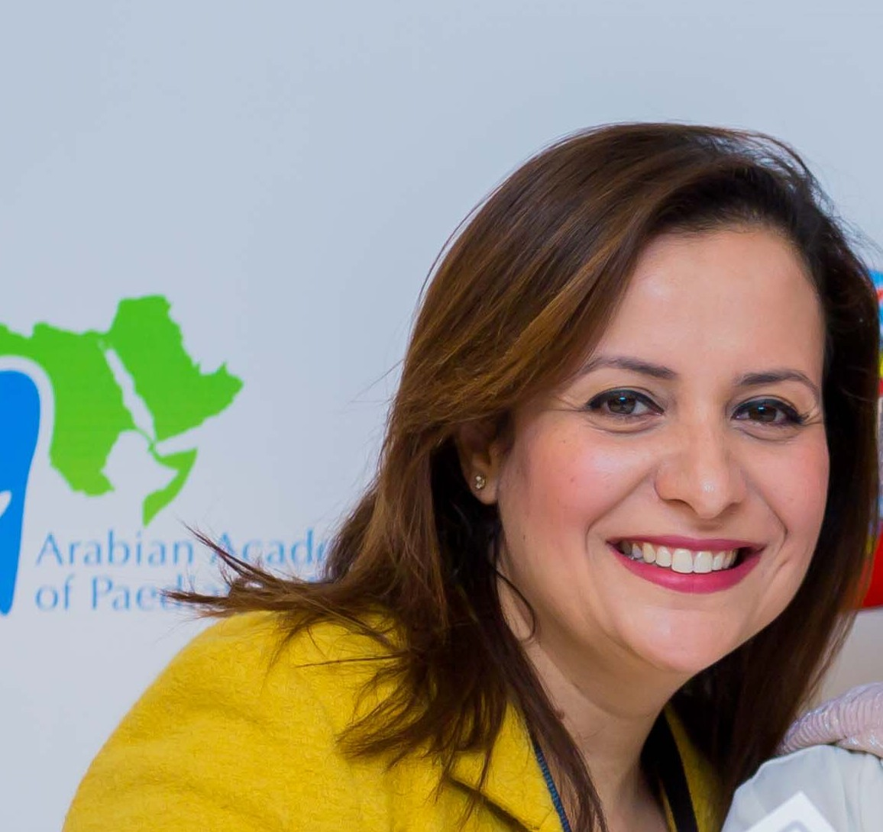
Biography: (100 -200 words)
Jihene Zaroui is an associate professor in pediatric dentistry in la Rabta Hospital in Tunisia.
She studied dentistry from 2002 to 2008 in the University of dentistry of Monastir. After that she obtained her doctor's degree in dentistry and passed the residency exam on 2009. She chose to specialize in pediatric dentistry. During this period she treated many children.
In 2013 she brilliantly passed her specialty exam and obtained her specialist diploma.
In order to deepen her knowledge and to have more experiences she got the assistant professor degree in pediatric dentistry ( she understands that young children, pre-teens, and teenagers all need different approaches in helping them manage or overcome their dental fears especially children with special needs).
In March 2015 she had the experience of being with French pediatric dentists in French hospitals ( Bretonneau Paris 17ème, Louis Mourier hospital in Colombes…) and to exchange his experience with the professors of the faculty of Paris Descartes in Mont Rouge.
In 2016, she had a training in conscious sedation (nitrous oxide sedation ) with UFSBD in Paris.
In 2018, she had associate professor degree in peditaric dentistry.

• Full Name: Jihene Zaroui
• Personal Email: dr-jihenezaroui@hotmail.fr
• Mobile Number: +21622535160
• Category: (Oral presentation)
• Date of Birth: 07/02/1984
• Postal Address: Oasis street, Ettaalok residence, Carthage, 2016, Tunisia

Email: dr-jihenezaroui@hotmail.fr

