Periodontitis Associated With Disease Activity, Immune Aging and Inflammatory Cytokine of Systemic Lupus Erythematosus Patients

Nanda Rachmad Putra Gofur¹, Nurdiana², Kusworini Handono³ and Handono Kalim⁴
¹Dept of Biomedical Science, ²Dept of Pharmacology, ³Dept of Clinical Pathology, ⁴Dept of Internal Medicine
Faculty of Medicine – Universitas Brawijaya, Malang Indonesia
Presenting autrhor : NRPG, email : nanda.gofur@gmail.com

ABSTRACT
Background: Periodontitis was reported more often found in SLE patients than healthy controls, 54.3% higher than that of patients with no systemic abnormality of 28.2%, and was estimated related to cytokine inflammatory because if the aging of immune system. Expression of IL-2 and IL10 associated with immune aging as T cell CD28, CD45RO, were associated with differentiation, cytotoxic activity, signaling and apoptosis of T cells were known as biomarker of immune aging.
Objectives: To analyze correlation between periodontitis severity with disease activity, IL-2, IL-10, CD28, and CD45RO expression in SLE patients.
Methods: Subjects were 45 patients with SLE ( age 17-54 years; SLEDAI score 0-42) collected from Dr. Saiful Anwar General Hospital, Malang Indonesia. Periodontitis severity was measured using Periodontal Index (PI) criteria. Expression of IL-2 and IL-10 using ELISA and CD28, CD45RO, were examined using flowcytometry.
Result: Clinical manifestations of periodontitis were bleeding gum 88.3%, high calculus index 44.9%, found periodontal pocket 73.8% and loose teeth 13.2% among patients. PI score patients was 2.45 ± 0.82. There were significantly positive correlation between PI score and SLEDAI score (r:0.798; p = 0.000), with IL-2 (r: 0.512; p = 0.000), with IL-10 (r: 0.720; p = 0.000) with CD28 expression (r: 0.634; p = 0.000), and with CD45RO expression (r: 0.354; p = 0.020).
Discussion : CD28 expressed specific CD8+ cells and Natural Killer cells during the latent period of chronic infection, especially on SLE patient. Repeated and persistent stimulation of the antigen leads to increased CD expression in CD8+ T. T cell CD28+ CD8+ cells are more susceptible to activated cell-induced cell death, stimulated by mitogen. The evidence shows that this cell can be used as a SLE marker. Differentiated CD8 + T cells experience loss of CD28 expression and CD45RO re-expression. This cell effector capacity is evidenced by its high capacity to produce perforin, granzymes, IFN-γ, IL-2 and IL-10. In periodontitis, tissue damage also results from the production of various irregular and unregulated production. inflammatory mediators and destructive enzymes, in response to the presences of bacterial biofilms and the process of periodontitis.
Conclusion: Our study showed that periodontitis were associated with SLE disease activity, and biomarker of immune aging. Furthermore, SLEDAI index and these marker could be predictor for periodontal condition, prognosis of periodontitis and best treatment for periodontitis on SLE patient.
Keywords: Periodontitis; SLEDAI; IL-2; IL-10 CD28; CD45RO.
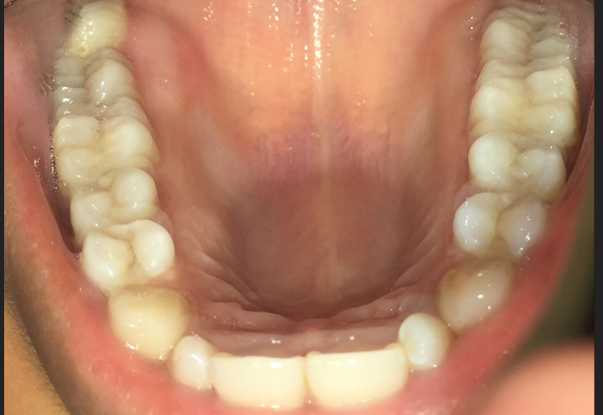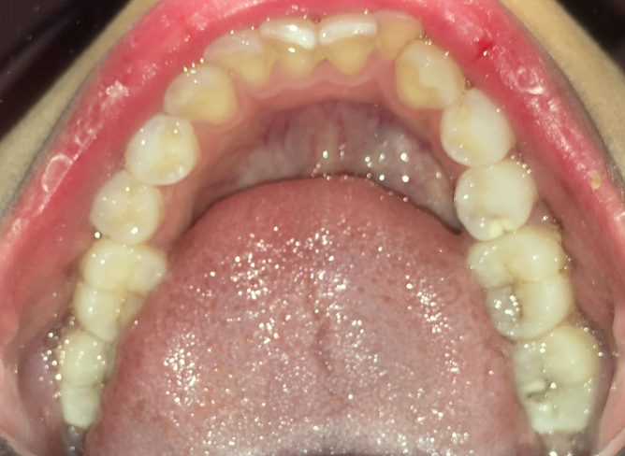
Figure 1. Clinical examination of SLE patients
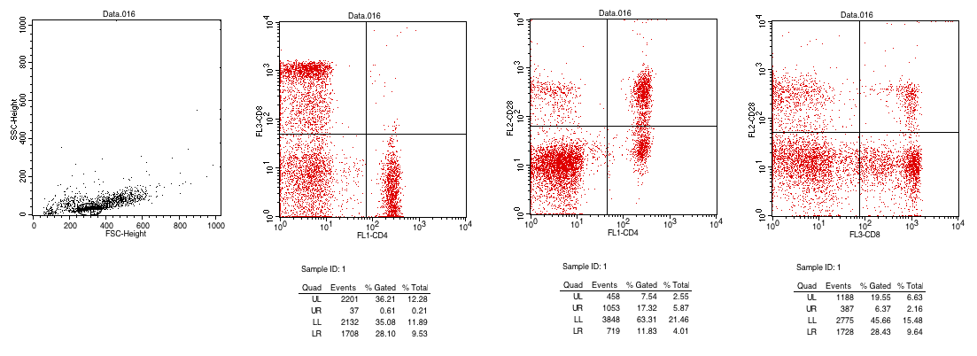
Figure 2. Flowcytometry of SLE patients on T cell CD8+CD28+
Reference :
1.Wu, Chen et al. 2017. ‘Association between a history of periodontitis and the risk of systemic lupus erythematosus: A nationwide, population-based, case-control study’, Annals of the Rheumatic Diseases, 72(7), pp. 1–11
2.. Al-Mutairi, K. D. et al. (2015) ‘Periodontal findings in systemic lupus erythematosus patients and healthy controls’, Saudi Medical Journal, 36(4), pp. 463–468. doi: 10.15537/smj.2015.4.10746.
3. Hajishengallis G. 2014. Aging and its Impact on Innate Immunity and Inflammation: Implications for Periodontitis. J Oral Biosci. February 1; 56(1): 30–37. doi:10.1016/j.job.2013.09.001.
4. Pandruvada SN, et al. . Bone biology-related gingival transcriptome in ageing and periodontitis in non-human primates. J Clin Periodontol 2016; 43: 408–417. doi: 10.1111/jcpe.12528.
5. Ebersole JL et al (2016) Transcriptome Analysis of B Cell Immune Functions in Periodontitis: Mucosal Tissue Responses to the Oral Microbiome in Aging. Front. Immunol. 7:272. doi: 10.3389/fimmu.2016.00272
6. Manjarrez-orduño N, et al. 2017. ‘A Systemic Lupus Erythematosus Endophenotype Characterized by Increased CD8 Cytotoxic Signature Associates with Renal Involvement Clinical and Translational Immunology A Systemic Lupus Erythematosus Endophenotype Characterized by Increased CD8 Cytotoxic Signature Associates with Renal Involvement’. doi: 10.4049/immunohorizons.1700028.

