Child Abuse and Neglect: Role of a dentist in diagnosis
Abstract- Child Abuse and Neglect is a global issue. A dental practioner has an important role when it comes to diagnosis and reporting of CAN. Majority of injuries in a child, is encountered in the oro facial region, making it important for the dentist to look through the abnormality and trace the origin of the injuries. All a dentist needs is proper training and awareness regarding the issue. If a child can be helped at the earliest stage, it can surely be of great contribution towards their life as well as the society.

Keywords: child abuse, neglect, dentist, diagnosis

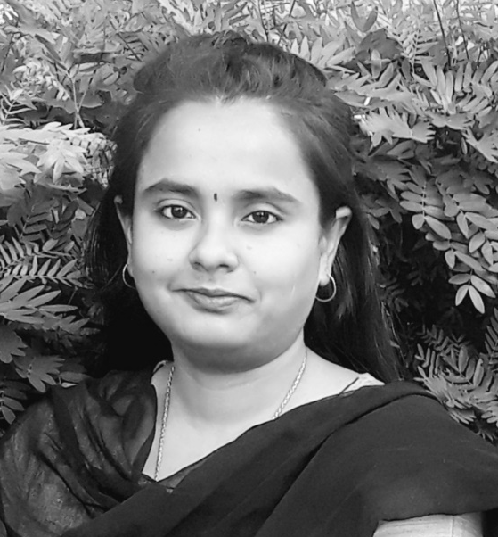
Biography: Biography
Dr. Pooja Chakraborty is a Forensic Odontologist by profession. She completed her bachelors of dental surgery in 2018 with outstanding marks.She achieved highest university marks in Orthodontics and Conservative dentistry. On her quest to do something different, she went on to pursue her masters in Forensic Odontology thereafter. To her credit she has numerous International and national Paper and Poster Presentations and also bagged few awards for the same. She has contributed articles in both national and international journals and has even co-authored a chapter on ‘Recent advances in Forensic Odontology’. She is trained in performing dental autopsies. She has keen interest for forensic archaeology and forensic facial reconstructions. She is actively involved in the field of forensics and has addressed various talks for the graduates, post graduates as well as security professionals. She has been invited as speaker on various platforms. She is actively involved with International agencies dealing with DVI Operations.

Full name Dr Pooja Chakraborty
+917908619181
https://www.linkedin.com/in/dr-pooja-chakraborty-b52665158/
oral presentation

