Is Pit and Fissure Sealant a Viable Option for Preventing Dental Caries in Schoolchildren？

Lin-Yang Chi, DDS PhD, Taipei City Hospital, Taiwan

Abstract (300 word limit)
Despite Taiwan’s significant achievements in cultural, economic, social, and political development, schoolchildren in Taiwan are not enjoying good oral health. Take the prevalence of dental caries experience as an example. The mean DMFT of 12 year-old schoolchildren was 2.50, according to a national survey at 2012. That was lagging far behind not only the OECD countries but also most of the countries in the world. Taiwan government has been well aware of this problem, and has been taking actions against dental caries in schoolchildren since the 1990s, including: national tooth-brushing campaign, free weekly fluoridated mouthrinse for schoolchildren, and free topical fluoride varnish application for preschool children. However, the caries experience of school children has not been brought under control. In 2014, our government launched another national program to combat dental caries – the free pit and fissure sealant (PFS) program for first molars of first graders in designated primary schools. Unlike fluoride products whose anti-caries effect is shown mainly for smooth tooth surfaces, PFS shows significant anti-caries effect on occlusal surfaces. However, PFS is also known for its highly technic- and equipment-sensitive requirements as well as its much higher cost as an option for public-funded programs. Our earlier study showed that the retention rate of PFS applied to schoolchildren of disadvantaged backgrounds could be much less than desired, if training/requirement of the dentists have not been done properly. Nowadays the government funded clinic-based PFS program has been expanded to cover all first graders of primary schools nationwide. This presentation will review the background, the current situation, and the prospects of this government-sponsored anti-caries oral health policy. .

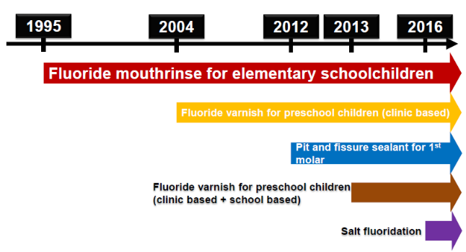

Image
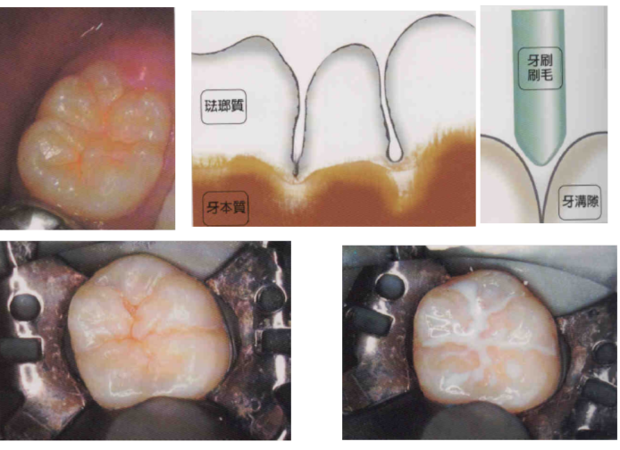
Figure 2 Pit and fissure sealant on molars
Recent Publications (minimum 5)
- Po-Yen Lin, Kuo-Liong Chien, Hong-Ji Chang*, Lin-Yang Chi*. Unfinished Root Canal Treatments and the Risk of Cardiovascular Disease. J Endod. 2015;41:1991-1996.
- Po-Yen Lin, Kuang-Wen Wang, Yu-Kang Tu, Hsin-Ming Chen, Lin-Yang Chi*, Chun-Pin Lin*. Dental service use among patients with specific disabilities: A nationwide population-based study. J Formos Med Assoc. 2016;115(10):867-875.
- Lin PY, Chiang YC, Chou YJ, Chang HJ, Chi LY*. Association of Unfinished Root Canal Treatments with the Risk of Pneumonia Hospitalization. J Endod. 2017 Jan;43(1):29-35.
- Lin PY, Wang J, Chiang YC, Lai CY, Chang HJ*, Chi LY* Risk of subsequent attention-deficit/hyperactivity disorder among children and adolescents with amalgam restorations: A nationwide longitudinal study. Community Dent Oral Epidemiol. 2018;46(1):47-53.
- Lin-Yang Chi*, Po-Yen Lin, Jui Wang, Yu-Roo Chu, Yung-Ming Chang. Can government-supported preventive fluoride varnish application service reduce pulp-involved primary molars? J Pub Health Dent 2019;xx:xx (SCI) (accepted) (corresponding author） DOI:10.1111/jphd.12319

Figure 1 Taiwan’s government funded anti-caries programs for children

Biography (150 word limit)
Dr. Chi completed his PhD training at the Cambridge University, UK. He is an associate professor at National Yang-Ming University, and the director of Education and Research Department of Taipei City Hospital, Taiwan. He has published more than 50 papers in reputed journals and has been serving as an editorial board member of Journal of Dental Sciences and other professional journals. Dr. Chi also serves as an advisor to Taiwan Government regarding oral health promotion..
Email: chily9@gmail.com

