Categorizing the scientific literature related to dementia obtained from the Cochrane Library

Deborah J Hilton, B Phty, MPH.

Deborah Hilton Statistics Online
http://sites.google.com/site/deborahhilton/

Research Gate
https://www.researchgate.net/profile/Deborah_Hilton

Abstract (300 word limit)
Introduction; The scientific literature related to Dementia is extensive. The Dementia Australia website includes a link to the document; Clinical Practice Guidelines and Principles of Care for People with Dementia [¹]. This document over 100 pages, was funded by the National Health and Medical Research Council (NHMRC) [²] Partnership Centre for Dealing with Cognitive and Related Functional Decline in Older People and endorsed by; Alzheimer’s Australia, Australian and New Zealand Society for Geriatric Medicine, Australian College of Rural and Remote Medicine, Exercise and Sports Science Australia, Occupational Therapy Australia, Speech Pathology Australia, The Royal Australian and New Zealand College of Psychiatrists and The Royal Australian College of General Practitioners.
Methods; In order to analyze the scientific literature on dementia, much of which is utilized when formulating professional guidelines, a Pubmed and Cochrane Library search was performed. A Pubmed MESH database search utilizing the term dementia resulted in 41 MESH terms [³]. The first seven entered as a PubMed search string combination; ((((((("Dementia"[Mesh])) OR "Frontotemporal Dementia"[Mesh]) OR "AIDS Dementia Complex"[Mesh]) OR "Dementia, Multi-Infarct"[Mesh]) OR "Dementia, Vascular"[Mesh]) OR "Mental Status and Dementia Tests"[Mesh]) OR "Alzheimer Disease"[Mesh]))))))) retrieved 172,295 results [⁴]. Selecting search filters [last year] and trial type [clinical trial, randomised controlled trial, systematic review or meta-analysis] resulted in 212 records. 139 were systematic reviews or meta-analysis. The Cochrane Library search
- search term; ‘dementia’ resulted in 195 records [⁵] however 29 were not directly on dementia, although some topics such as delirium maybe related. 166 dementia records identified from the Cochrane library search were categorized.
Results; Categorization of the records from the Cochrane library search resulted in the following categorical breakdown; diagnostic [13.5%], medicinal [42.5%], alternative or other treatments [18.5%], natural or herbal therapies [14.5%], psychological [9.0%], and exercise [2.0%].
Conclusions; The scientific literature related to dementia is complex and vast.

Image

Recent Publications (minimum 5)
- Guideline Adaptation Committee. Clinical Practice Guidelines and Principles of Care for People with Dementia. Sydney. Guideline Adaptation Committee; 2016. https://cdpc.sydney.edu.au/wp-content/uploads/2019/06/CDPC-Dementia-Guidelines_WEB.pdf
- National Health and Medical Research Council https://www.nhmrc.gov.au/
- National Library of Medicine - The MeSH Database https://www.ncbi.nlm.nih.gov/mesh
- National Library of Medicine – PubMed.gov https://pubmed.ncbi.nlm.nih.gov/
- Cochrane Library https://www.cochranelibrary.com/

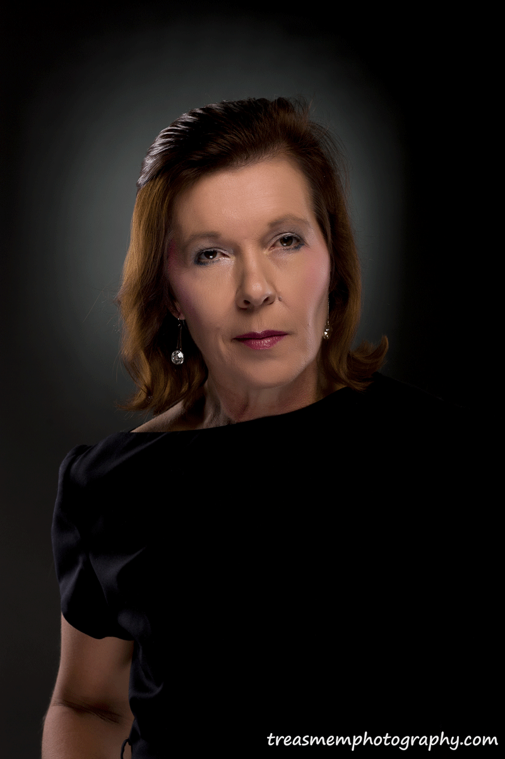 Biography (150 word limit)
I have the qualifications of a Bachelor of Physiotherapy from the University of Queensland (UQ) [1987] & a Master of Public Health [MPH] from the tripartite consortium of Universities [UQ, Griffith Uni & Queensland Institute of Technology] [2000]. My MPH dissertation was an analysis of the Australian Diabetes Screening Study, published in the Medical Journal of Australia. My research gate profile is https://www.researchgate.net/profile/Deborah_Hilton, listing 18 research items, which have been read over 1500 times & there have been approximately 250 citations. My website is at; Deborah Hilton Statistics Online: http://sites.google.com/site/deborahhilton/. My CV lists 16 peer reviewed publications, 6 non peer reviewed publications, 1 manuscript acknowledgement, I grant, 31 poster presentations, 1 book acknowledgement, 10 paper conference presentations, other adhoc work projects including 17 short articles written, & 2 workshop seminars at conferences. In 2020, one poster I created was selected as an Award Finalist - Best e-Poster Award.
Email: deborah.hilton@gmail.com

Notes/Comments:

