A review on Advanced pharmacological therapies to treat Alzheimer’s dementia
Dr. Surendra Adusumalli,⁎ Dr. Sivareddy Challa, Dr. Ajay kumar Guptha

Abstract:
Alzheimer’s dementia (AD) is increasingly being recognized as one of the most important medical and social problems in older people in industrialized and non-industrialized nations Alzheimer’s disease is characterized by the development of senile plaques and neurofibrillary tangles, which are associated with neuronal destruction, particularly in cholinergic neurons. To date, only symptomatic treatments exist for this disease, all trying to counterbalance the neurotransmitter acetyl choline degradation within synapses are the mainstay of therapy. Donepezil, rivastigmine, and galantamine are safe but have potentially bothersome cholinergic side effects. Three acetylcholinesterase inhibitors appear to be effective, currently available and have been approved for the treatment of mild to moderate AD. A further therapeutic option available for moderate to severe AD is memantine, an N-methyl-D-aspartate receptor noncompetitive antagonist. Treatments capable of stopping or at least effectively modifying the course of AD, referred to as ‘disease-modifying’ drugs, are still under extensive research. To block the progression of the disease they have to interfere with the pathogenic steps responsible for the clinical symptoms, including the deposition of extracellular amyloid β plaques and intracellular neurofibrillary tangle formation, inflammation, oxidative damage, iron deregulation and cholesterol metabolism In this review we discuss current symptomatic treatments and new potential disease-modifying therapies for AD that are currently being studied in phase I–III trials.
Keywords:
Alzheimer’s disease, amyloid fibrils, senile plaques, acetylcholinesterase inhibitors, disease-modifying drugs, inflammation, tau protein, therapeutic targets.

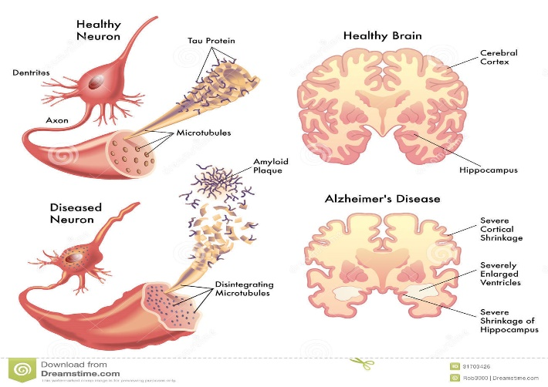
II. Image:
III. References:
1. Aisen, P., Saumier, D., Briand, R., Laurin, J., Gervais, F.,Tremblay, P. et al. (2006) A phase II study targeting amyloid-beta with 3APS in mild-to-moderate Alzheimer disease. Neurology 67: 1757–1763.

2. Blesa, R., Ballard, C., Orgogozo, R., Lane, J. and Thomas, S. (2007) Caregiver preference for rivastigmine patches versus capsules for the treatment of Alzheimer disease. Neurology 69: 23–28.

3. Farlow, M., Alva, G., Meng, X. and Olin, J. (2010) A 25-week, open label trial investigating rivastigmine transdermal patches with concomitant memantine in mild-to-moderate Alzheimer’s disease: a post hoc analysis. Curr Med Res Opin 26: 263–269.

IV. Brography:
Dr. Surendra Adusumalli has completed his PhD at the age of 32 years from Kanpur University Uttar Pradesh, India. He has been working as an associate professor since 2010 in the department of Pharmacology and Toxicology, Anatomy and physiology, Clinical Pharmacy and therapeutics. He has published more than 10 papers in reputed journals and has been serving as a review member of Journal of Food and Chemical Toxicology

V.Presenting author details


Full Name: Dr. Surendra Adusumalli
Contact number: +91 8096535184
Twitter account:
Linked In account:
Session name/ number: Treatment and Cure
Category: (Oral presentation/ Poster presentation): Oral presentation
Passport Number: R8525221

