Abstract

Title: A Therapeutic Approach to Dementia Care

Anyone who works in health care knows the reality of the statistics: the incidence of dementia is on the rise and the number of people living at home with later stages of the disease is also increasing. We are all hopeful for a cure, but what do we do in the meantime? This highly interactive and hands-on session will introduce renowned dementia care expert Teepa Snow’s Positive Approach to Care™ philosophy and associated care skills. These skills combine care techniques that match what is known about brain function changes through dementia, with the ability to complete a dynamic assessment “in the moment” for all caregivers. Using these tools has been shown to reduce the incidence of responsive behaviours, which can delay institutionalization but more importantly, enhance quality of life both for people living with dementia and, also their formal and informal care partners. Additional benefits are increased efficiency and effectiveness by shifting focus from task-driven to patient-driven care. This session will include how using these techniques in a prepared environment can change life for people living with dementia and everyone on the journey with them.
The ultimate goal is to encourage positive outcomes, maintain positive relationships and decrease the incidence of responsive behaviours by doing tasks “with” the resident instead of “to” the resident.
Participants will have the opportunity to experience the visual processing changes of dementia and how this impacts residents’ perception of common care practices. At the end of the session, participants will have a toolkit of simple, practical, hands on skills that can be used immediately to aim for excellence in care. In the words of Teepa herself, “Until there’s a cure…there’s care.”

BIO

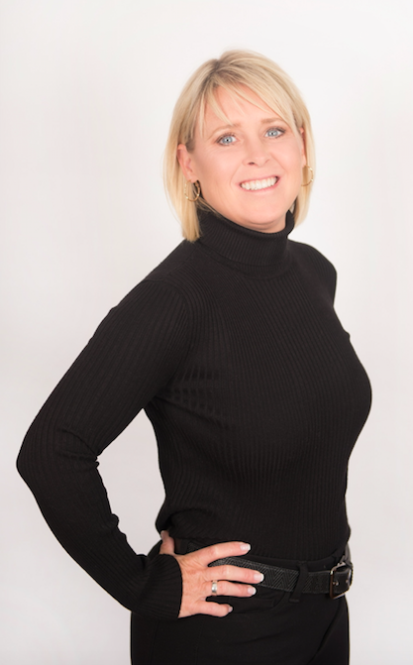
Dawn Wiggins RPN, Certified PAC Consultant, Trainer and Mentor (Teepa Snow), Certified Dementia Practitioner, Keynote speaker, Author and President and Director of Operations of: ‘New Dementians Professional Healthcare’.

Dawn a registered nursing professional in the province of Ontario and has over 20 years of frontline healthcare experience. Dawn is currently working towards her master’s degree in dementia studies. She leads a dynamic team of healthcare experts dedicated to one thing-making a positive impact in the lives of people living with dementia and their care partners. Rather than focusing on “tasks” like most people, Dawn focusses on “caring” and bringing as much joy as possible to the lives of each and every client, every day.

Dawn has served in a number of different capacities over the years and has a wealth of experience in acute care, long term care, psychiatric care, home care, rehabilitation and palliative care.
She has built and managed world class dementia care neighborhoods at the institutional level.
Her greatest passion, however, is caring for people living with dementia and their care partners. PAC skills help her have a deep and unique understanding of the disease that allows her to connect with her clients and their families in a very special way. New Dementians tm Memory Care Revolutionized is working with expert TEEPA SNOW http://teepasnow.com/ on her Positive Approach to Care Team.

Full Name: Dawn Wiggins
Contact number: 705-529-4998
Website: www.newdementians.com

