IONIS - Indoor and outdoor solution for dementia challenges

Neja Samar Brenčič, Maja Kern,
IZRIIS Institute, Ljubljana Slovenia
University Clinical Centre, Ljubljana, Slovenia

Keywords: Dementia, ICT based services, e-health, e-care

I. Abstract
Demographic changes and the aging population in Europe increase the demand for some particular ICT services – including e-health and e-care services. The reasons are multiple: we want to address specifically the increase of symptoms related to dementia. In Slovenia we have 33.000 diagnosed patients. Many professionals at the clinics recognize that there is no connection between the care at the clinic and home care. What to do with the patient with dementia after they leave the hospital?

IONIS project financed within the EU-AAL program perspective aims at developing a European-wide service concept specifically for people with dementia and their families.

At the moment in some countries in EU, patients at home use bracelets, watches and fitness bands connected to smart phones to give caregivers some idea of what is going on with the patient. In Slovenia this is almost non-existent. Currently IONIS is developing solutions to fill the gaps with integrated and validated health monitoring, home automation, and personal agenda with reminders, alerts, caregiver administrative tools and profile specifically for dementia patients. The IONIS platform will offer integration of services and technology to benefit both patients and caregivers.
IONIS will create the network of support for the patients, families and health professionals.
Such programs as IONIS will help to support the continuation of care form the clinical environment to the home care environment.

II. Image

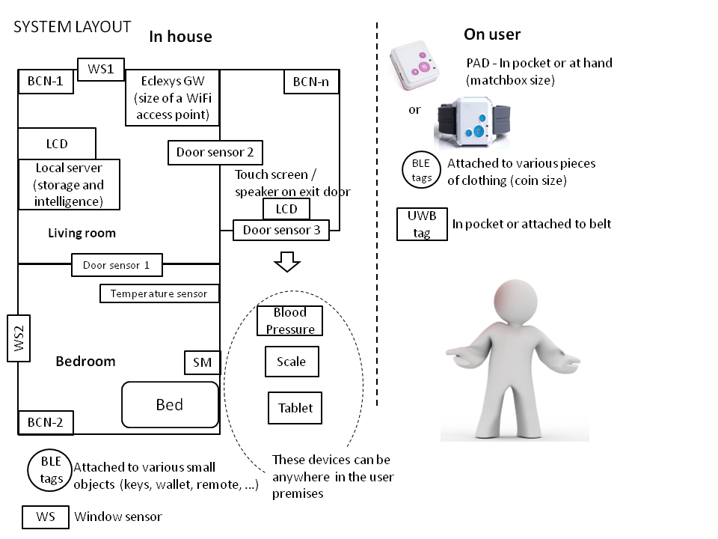
Layout of system components – indoor & user environment.

SM =sleep monitoring device; BCN=static beacon.

III.
Cohen-Mansfield J., Rachel Gavendo R., Blackburn E., Activity Preferences of persons with dementia: An examination of reports by formal and informal caregivers, Sage pub., November 10, 2017; http://journals.sagepub.com/home/dem
Dovgan, E., Luštrek, M., Pogorelc, B., Gradišek, A., Bruger, H., & Gams, Intelligent elderly-care prototype for fall and disease detection. Slovenian Medical Journal, 80(11).),
Dima Catalina, Legal Officer ICT for Health Unit, DG Information Society and Media, EC. Introduction to legal framework for eHealth. SEeHealth Seminar: The Roadmap from Concept to Practice (LJ 20-21.1.10)
Directive on a transparency mechanism for Information Society services. http://ec.europa.eu/internal_market/e-commerce/transparency_en.htm (dostopno 2011-07-11)
European Commission. Communication on eHealth – making healthcare better for European citizens: „An action plan for a European eHealth Area”, COM(2004) 356 final, 2004.
Fisk MJ. Telecare and Telehealth: Social Change and Service Developments in the UK and the European Union. Global Telehealth 2010 Conf., Perth, Australia.
ICT & Ageing: Users, Markets and Technologies; Compilation Report on Ethical Issues; (Deliverable No. 11). Empirica. 2009.
Samar-Brencic N., 2015, System elements integration and field trial report for AAL project NITICS Slovenia. [in] Information Society IS 2015, Proceedings of the 18th International Multiconference. IJS: Ljubljana.
Samar-Brencic N., 2014, Service requirements for supporting daily activities of elderly people living at home - multi-national survey within AAL project NITICS. [in] Information Society IS 2014, Proceedings of the 17th International Multiconference. IJS: Ljubljana.
Samar-Brencic N., 2013 New ICT-based services in long-term home-care for elderly persons. [in] The future of Slovenia as a long-living society: Proceedings of the expert program of the 12th Festival of the Third Age. Proevent: Ljubljana.
Samar-Brencic N., 2013. Networked infrastructure for innovative home care solutions. [in] Information Society IS 2013, Proceedings of the 16th International Multiconference. IJS: Ljubljana.
Samar-Brencic N., 2013, Social exclusion and suicide in the elderly population [in] Facing genocide and suicide: international conference, Celje. TEOF: Ljubljana.
Samar-Brencic N., 2012, Demographic change, aging population and an increase of fear and anxiety in the population of elderly due to inequalities in health. [in] Proceedings of the International conference Celje. TEOF: Ljubljana.
Samar-Brencic N., 2012, Demographic change, aging population and a decrease of inequalities in health at the elderly population through the implementation of the ICT services. [in] Proceedings of the 15th International Multiconference. IJS: Ljubljana.
Samar-Brencic N., 2011, Elderly persons in Slovenia - their use of ICT in communication with each other and prevention of their social exclusion. [in] Information Soicety IS 2011, Proceedings of the 14th International Multiconference. IJS: Ljubljana.
Samar-Brencic N., 2011, Efforts for the social inclusion of elderly as part of the answer for reconciliation between generations and intergenerational solidarity – a contribution to sustainable development. [in] Proceedings of the International conference Celje. TEOF: Ljubljana.
Rudel D, Breskvar M. Nacionalna strategija zdravja na daljavo (telemedicina) - izhodišče za strokovni dialog.
Rudel D, Fisk M, Roze R. Definitions of terms in Telehealth. Inform Med Slov Print ed 2011; 16(1):28-46. http://ims.mf.uni-lj.si/archive/16%281%29/21.pdf (dostopno 2011-10-12).
Rudel D, M.J. Fisk, State-of-the-Art in Telemedicine-Telehealth in Slovenia. 8th Annual Conf. Med-e-Tel 2010. http://www.medetel.eu/download/2010/parallel_sessions/presentation/day2/Stat e-of-the-Art.pdf ) (dostopno 2011-10-11).
Rudel D., Informacijsko-komunikacijske tehnologije za oskrbo bolnika na daljavo. Rehabilitacija, 6(Supl.I); 2007: 94-100.
Whitehouse P. J, Wella Burrows T., Stephenson D., Global perspectives on dementia and art: An international discussion about changing public health policy
Sage pub., November 8, 2017; http://journals.sagepub.com/home/dem

IV. Biography

Neja Samar Brenčič is a researcher and developer at the IZRIIS institute. She holds a Masters in psychology degree at the University of Ljubljana. She has dedicated last 15 years to develop end-user experience and validation programs in Slovenia in EU.
Maja Kern is a physiotherapist at the University Clinical Centre in Ljubljana. For 35 years of experience with clinical practice including patients with dementia.

V. Authors details

Full Name: Maja Kern
Contact: IZRIIS, Triglavska 47, 1000 Ljubljana | 00 386 (0)31 691 119| www.izriis.si | https://www.facebook.com/zavod.izriis/ |@igzavodizriis

Session name/ number: Dementia Care & Awareness
Category: Oral presentation

