Detection of severity in Alzheimer’s disease (AD) using computational modeling
Hyunjo Kim¹ & Hyunwook Han ^{2,3*}

1Department of Medical Informatics, Ajou Medical University Hospital, Suwon, Kyeounggido province, South Korea; 2Department of Informatics, School of Medicine, CHA University, Seongnam, South Korea; 3Institute of Basic Medical Sciences, School of Medicine, CHA University, Seongnam, South Korea; Hyunwook Han – E-mail: hyunjokim@hotmail.com; *Corresponding author

Keywords: Alzheimer’s disease; acetyl cholin esterase inhibitors; MRI; K-means: algorithm simulation

- Abstract:
The prevalent cause of dementia - Alzheimer's disease (AD) is characterized by an early cholinergic deficit that is in part responsible for the cognitive deficits (especially memory and attention defects). Prolonged AD leads to moderate-to-severe AD, which is one of the leading causes of death. Placebo-controlled, randomized clinical trials have shown significant effects of Acetyl cholin esterase inhibitors (ChEIs) on function, cognition, activities of daily living (ADL) and behavioral symptoms in patients. Studies have shown comparable effects for ChEIs in patients with moderate-to-severe or mild AD. Detection of changed regional cerebral blood flow in mild cognitive impairment and early AD by perfusion-weighted magnetic resonance imaging has been a challenge. We designed an automated system for the determination of AD severity. It is used to predict the clinical cases and conditions with disagreements from specialist. The model described is useful in clinical practice to validate diagnosis.
II. Image:
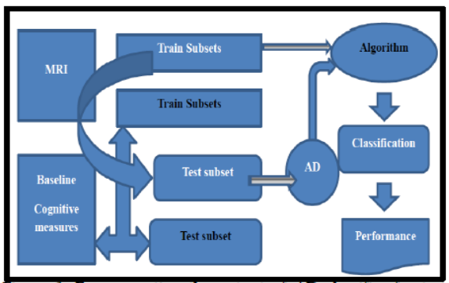
Figure 1: For computing the output of AD classifier for testsubjects, the test subset is used in the algorithm and learning procedure without any label information (shown with whitegrayed arrow).

III. References:
[1] Prolo P et al. Bioinformation. 2007, 1:363. [PMID: 17597922]
[2] Birks J. Cochrane Database Sys Rev. 2006, 25:CD005593.
[3] Connelly PJ et al. J. Neurol. Neurosurg. Psychiatry. 2005, 76:320. [PMID: 15716519]

IV. Biography:
Hyunjo Kim has completed his PhD from Temple University, USA and Postdoctoral Studies from School of Medicine, Ajou University, Korea. She is the Director of Bio-R&D organization. She has published more than 40 papers in reputed journals

V. Presenting author details



Full Name: Hyunjo Kim
Contact number: 82-010-6563-9755
Twitter account: Hyunjo@KoBIA
Linked In account: hjkim2001us@yahoo.com
Session name/ number: AD
Category: (Poster presentation)
Passport Number:M25527469

