Abstract

Dementia: Current Status in Indonesia and Future Trends

Fine Farhani Muliati
Medical Faculty of Halu Oleo University, Kendari, Southeast Sulawesi, Indonesia. Email: fyne.farhani@gmail.com

Keywords: Dementia, Prevalence, Alzheimer’s disease, Yogyakarta, Indonesia.

- Abstract (up to 250 words)

The Global burden of dementia has been estimated that 35.6 million people are living with dementia worldwide and projected to increase to 65.7 million by 2030 and 115.4 million by 2050. In Indonesia, the dementia prevalence increased twice every 5 years after passes 60 years old and reached to the sixth place of nine countries in Asia. It was estimated in 2010 that around 7.2% of population of aged people more than 60 years old in Indonesia. Yogyakarta was one of province in Indonesia with the highest aged people prevalence. Prevalence was counted from wide scale survey of aged people in Yogyakarta which was representative in describing population such as dementia survey in Yogyakarta. Dementia prevalence calculation was specifically done by using three mesaurement tools such as MMSE, AD8, and IADL. Dementia prevalence of 60 years old and more aged people in Yogyakarta achieved 20.1%. People living with age over 65 years could have increase dementia prevalence. Women had higher dementia prevalence than man because of the hormone estrogen’s effect and longer life span than men. From the environmental perspective point of view, aged people lived in urban area have lower dementia prevalence than in rural area. This happened because of activity and education factor which stimulated more brain using in the city than countryside. In conclusion, prevalence rate of dementia depends on age, sex, and environment factors.

- Image:

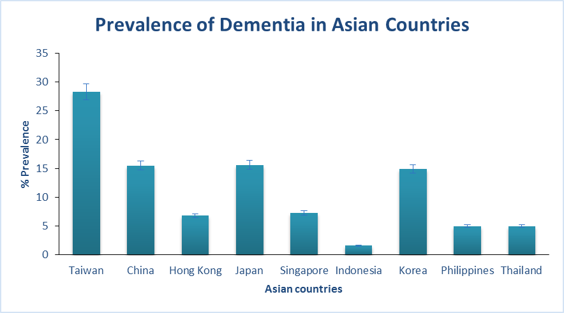

- References:
- Yuan-Han Yang, et al. Impact of Alzheimer’s Disease in Nine Asian Countries. Gerontology. Experimental Section. 2016; 1-9.
- Kemenkes. Populasi Lansia Diperkirakan Terus Meningkat Hingga Tahun 2020. Artikel. Jakarta: Kementrian Kesehatan RI; 2015.
- Kemenkes. Lansia yang Sehat, Lansia yang Jauh dari Demensia. Artikel. Jakarta: Kementrian Kesehatan RI; 2016.
- Suriastini, Yuda Turana, Firman Witoelar, Bondan Supraptilah, Teguh Y Wicaksono, Endra Dwi M. Angka Prevalensi Demensia. Policy Brief. 2016; 1-4.

- Biography:
Fine Farhani Muliati Rahman, S.Ked. a medical student from the Medical Faculty of Halu Oleo University, Kendari, Southeast Sulawesi, Indonesia. She has completed her program bachelor of medicine in 2016 and now she was doing her internship at Bahteramas Hospital, Indonesia as a young doctor. Her interest lies in the field of geriatrics patient with neurological disorders.

- Presenting author details


Full Name: Fine Farhani Muliati Rahman
Contact number:
Twitter account:
Linked In account:
Session name/ number:
Category: (Oral presentation/ Poster presentation)
Passport Number:

