NEXT GENERATION SECURE COMMUNICATION
Stephanos Mavromoustakos, Assistant Professor, University of Windsor, Canada

Abstract
The Transport Layer Security (TLS) and its predecessor Secure Sockets Layer (SSL) which in now deprecated by the Internet Engineering Task Force are cryptographic protocols that provide communications security over a computer network. Variations of these protocols are used to secure different types of applications such as, email, web browsing, and communication between websites and servers. Currently, TLS is considered the most secure method for protecting web applications. However, there were several cases where hackers managed to penetrate these “secure” applications. The main vulnerabilities lie to the TLS itself, as well as to the Certificate Authorities (CAs). Edward Snowden in 2013 has revealed the existence of programs used by the United States National Security Agency, such as the Bullrun software that cracks encryption of online communication, as well as the Edgehill a software similar to Bullrun created by the British Government Communications Headquarters. Certificate Authorities have also been hacked in the past which means TLS and CAs are still vulnerable.
This paper presents a novel method of securing a communication over a computer network without the use of TLS and CAs, called Next Generation Secure Communication (NGSC). The advantages of NGSL is that it provides a secure connection without the need for SSL certificates from CAs. It provides defense for all Man-In-Middle (MITM) attacks and pass the possibility of cloning websites. All communication uses advanced encryption algorithms, multi-factor authentication techniques and our unique Human-Browser Tracking process. The NGSC can be used by itself or with TLS for enhanced security. Initial penetration testing have shown that NGSC provides a highly secure communication.
Image
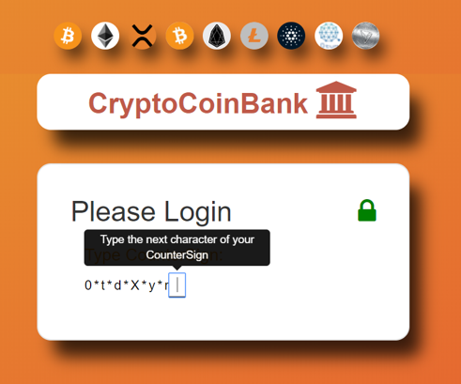
Figure 1: The NGSC system
Recent Publications
- Buchanan, B. (2016). SSL/TSL is broken…full stop. [Accessed August 15, 2018]
https://www.linkedin.com/pulse/ssltls-broken-full-stop-william-buchanan/
- Wikipedia, Bullrun (Decryption Program). [Accessed August 15, 2018]
https://en.wikipedia.org/wiki/Bullrun_(decryption_program)
- Mandalia, R. (2012). Security Breach in CA Networks: Comodo, Diginotar, Globalsign [Accessed August 15, 2018]
http://blog.isc2.org/isc2_blog/2012/04/test.html
- Nohe, P. (2018). In 2018 Certificate Authorities could become a major target. [Accessed August 18, 2018]
https://www.thesslstore.com/blog/2018-certificate-authorities-target/
- Metodieva, M. (2017). Chrome and Firefox to Distrust Symantec's SSL Certificates by the End of 2018. [Accessed August 18, 2018]
https://blog.superhosting.bg/en/chrome-firefox-to-distrust-symantec-ssl-in-2018.html
- Paganini, P. (2017). The controversial certificate authority StartCom will go out of business on January 1, 2018. [Accessed August 18, 2018]
https://securityaffairs.co/wordpress/65765/digital-id/startcom-ca-shut-down.html
- Cimpanu, C. (2018). 23,000 Users Lose SSL Certificates in Trustico-DigiCert Spat. [Accessed August 18, 2018]
https://www.bleepingcomputer.com/news/security/23-000-users-lose-ssl-certificates-in-trustico-digicert-spat/

 Biography
Dr. Mavromoustakos has a PhD in Computer Science, an MSc and BSc in Computer Information Systems and a second Master in International Business. He is currently with the School of Computer Science at University of Windsor teaching primarily at the Master of Applied Computing program. His research interests are in Web Engineering and Cybersecurity. He has also worked many years in the industry in various roles such as a CEO, Consultant, Project Manager and Software Engineer. Dr. Mavromoustakos has published many articles in international refereed conferences and academic journals. He has been involved in various funded projects and has served in the scientific board of several international conferences and journals. Finally, he is passionate about high-tech entrepreneurship and he has been a co-founder of many start-up companies, a mentor and an investor.
Email: stepano@uwindsor.ca

