Use of dexmedetomidine in intubated and non-intubated patients of critical care and its outcome

Dr. Shamim Kausar

M.B.B.S., FCPS

Critical Care Physician

National Medical Center Karachi Pakistan.

Abstract
Critically ill patients frequently encounter delirium. Dexmedetomidine has been approved by FDA and is being prescribed by clinician for delirium. We decided to conduct a study to assess the frequencies of different outcomes of dexmedetomidine in both intubated and non-intubated patients of critical care. The study was conducted on 212 participants in Laiquat National Hospital and Medical College Karachi, Pakistan. All intubated and non-intubated patients with more than 12 h of critical care stay and more than 4 h of dexmedetomidine use were included. Data was collected for presence or absence of successful weaning, days on mechanical ventilation, days in critical care and mortality or clinical improvement. In intubated patients 78(70.9%) patients were successfully weaned and then extubated on dexmedetomidine while 2 patients (1.8%) self extubated their selves. Days on mechanical ventilation ranged from 2 to 6 day. While mortality rate was 22 (20.0%). In non-intubated patients mortality rate was 34(33.3%). Length of stay in critical care in all intubated and non-intubated patients ranged from 3 to 8 days. Dexmedetomidine achieved light sedation which helped in better tolerance of patients to wean from mechanical ventilation. This helped in reduction in duration of mechanical ventilation and critical care stay.
Recent publications
- Kausar S, Latif A, Ahsan I, Sehar M, Zoya M, Masroor M. Use of dexmedetomidine in intubated and non-intubated patients of critical care and it’s outcome.TACC 2020;35:51-54
- Kausar S, Rida-e-Zehra S, Latif A, Jafferi S.A,Hussain S.N.F, Azim S.N et al. Prevalence of different severities of hypoxia in COVID-19 patients admitted in critical care unit. International journal of anesthsia and clinical medicine 2020;8(2):62-64
- Latif A, Rafaey W, Kausar S, Rida-e-zehra S, Rafay M. Outcome of COVID-19 pandemic In Pakistan. J infet Dis Preve Med 2020;8(4):206
Biography

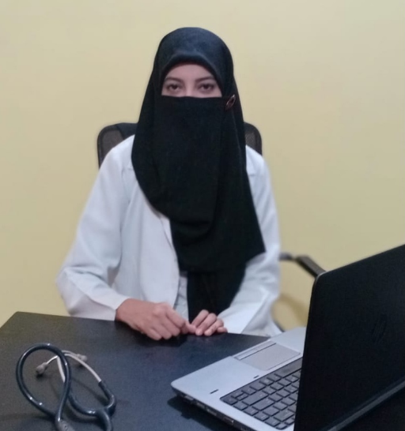

Dr. Shamim Kausar’s journey in critical care started at very beginning of her medicine training where she got an extensive exposure of Medical Intensive Care Unit. Very soon she was recognized as having high potential and capacities of managing difficult events and successfully extubating difficult to wean patients. She completed her Fellowship of College of Physician and Surgeon (FCPS) in internal medicine from College of Physician and Surgeon Pakistan (CPSP).
After FCPS she worked as senior registrar in a 25 bedded ICU of Liaquat National Hospital and Medical College where she not only completed her training requirement for European Diploma of Intensive Care (EDIC) but also remained busy in training Undergraduate and post graduate medical students, Nurses physiotherapist and Bachelor of Science of critical care student.
Currently she is working at National Medical Center where she is an Intensive care consultant physician in a 28 bedded Intensive Care Unit.
Email
Shamim.kausar@nmc.net.pk

