Title: SEO For Doctors: The Challenges & Tactics to Address in 2020

VLAD MKRTUMYAN
Logic Inbound, USA

Keywords: Healthcare marketing, Medical marketing, SEO for Doctors

- Abstract Body
This sessions goal is to demonstrate successful & reproducible tactics that will increase search traffic, conversions, & improve your rankings in Google.

Looking at our campaigns & experiments in 2019, we'll review examples of SEO tactics that have increased rankings, how much traffic improvement was seeing over 3, 6, and 12 month timelines. I will present the processes and documentation we used so that attendees can replicate and perform the work independently with their teams as they are able. This session will be targeted to those with mid-tier knowledge of SEO who want to increase results

- Learning Objectives:

1. It will deliver actionable information and assets that attendees can use to grow their online presence and earn more traffic

2. Attendees will be able to create high value content for any keyword target with specific recommendations on how to optimize the content and what related targets the page can be optimized to

3. and create a list of high value outreach targets that already connect to their competitors and related entities in their target market.

- Biography:
Vlad Mkrtumyan is a serial entrepreneur, search engine marketing evangelist and a passionate networker, responsible for running five meetups including the Seattle Marketing and Demand Leaders Meetup – the largest marketing meetup in Seattle.

Vlad began his entrepreneurial odyssey as a teenager, when he launched the Shoplletes app which went on to have 30,000 active monthly users and 300,000 downloads on the Google Play Store. Just a few years after his first venture, Vlad started Skyreal, a real estate recruitment CRM for fast growing brokerages, growing to 13 brokerages across three states.

Each company that Vlad has started has been bigger and more ambitious, and Logic Inbound is his biggest, most ambitious venture. The SEO business is highly competitive, but running a team of 25 talented individuals, Vlad has propelled Logic Inbound into a fast growing SEO agency in Seattle.

Vlad has landed coverage on online media outlets such as TechCrunch, Blind Entrepreneur Podcast and the Business Marketing Engine Podcast. He has also been featured on Shopify, Geekwire and has appeared on the 1590 AM Lifestyle Business Owner radio show, among many others..
- Presenting author details

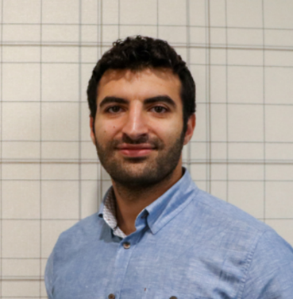

Full Name: Vlad Mkrtumyan
Contact number: 206-753-8926
Linked In account: https://www.linkedin.com/in/vladimir-mkrtumyan/
Category: (Oral presentation/ Poster presentation) Oral presentation

