Developing salt tolerant rice varieties using CRISPR/Cas9 based genome editing
approach
Jaganathan D¹ , Gothandapani Sellamuthu¹ , Ramalingam S² , Venkataraman G¹*
¹M S Swaminathan Research Foundation (MSSRF), Chennai, India
²CSIR-Institute of Genomics and Integrative Biology (IGIB), New Delhi, India
* E mail: gayatri@mssrf.res.in
Abstract
Cultivated rice, Oryza sativa is a primary cereal crop of South East Asia and is highly sensitive to salinity. MicroRNAs (miRNA) are small non-coding RNAs and play important role in plant development and stress responses. In order to develop transgene-free saline tolerant rice varieties, we attempt to knock out two miRNAs, namely miR393a and miR396c that are negative regulators during various stress conditions. To achieve this, we followed, CRISPR/Cas9 based genome editing approach. Two independant guide RNAs (gRNA) for each miRNA were designed and cloned into a CRISPR-Cas9 binary vector (pRGEB31) suitable for rice transformation. Rice protoplasts were isolated from Pusa basmati, to test the functionality of the CRISPR-miRNA constructs prior to transformation. Agro-bacterium mediated transformation was carried out for both miRNA constructs and the T₀ transgenic lines are under regeneration stage. Positive mutant lines will be identified through genotyping followed by whole genome re-sequencing on T₀ lines. Physiological characterization will be carried out for the selected mutant rice lines for salinity tolerance on T₁ and T₂ lines. This study will bring an insight into rice salinity tolerance mechanism and rice crop improvement program.

Key words CRISPR, microRNA, protoplast, salinity, crop improvement

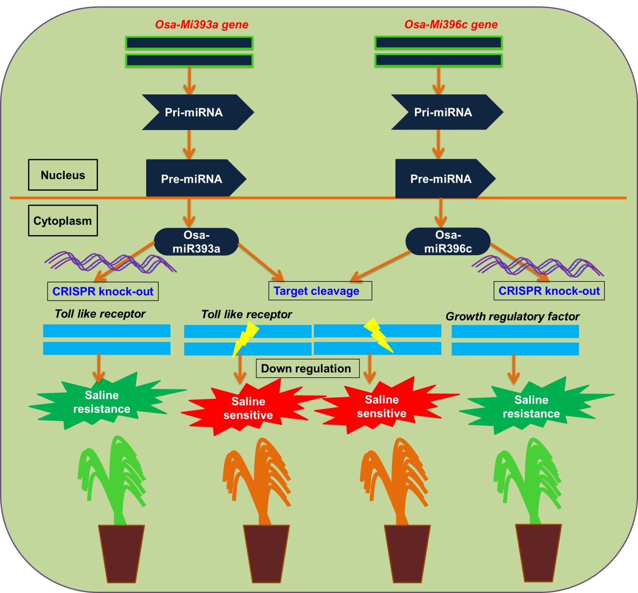

Figure 1: Schematic diagram representing the role of miRNAs (miR393a and miR396c) in salinity tolerance and development of saline tolerant rice varieties using CRISPR/Cas9

Recent Publications
PUBLICATIONS
1. Deepa Jaganathan # , Karthikeyan Ramasamy, Gothadapani Cellamuthu, Shilpha
Jayabalan and Gayatri Venkataraman # (2018), CRISPR for crop improvement – An
update review. Front. Plant Sci. 9:985. doi: 10.3389/fpls.2018.00985. # corresponding
author.
2. Kaliamoorthy Sivasakthi, Mahendar Thudi, Murugesan Tharanya, Sandeep M Kale,
Jana Kholová, Mahamat Hissene Halime, Deepa Jaganathan, Rekha Baddam,
Thiyagarajan Thirunalasundari, Pooran M. Gaur, Rajeev K. Varshney, Vincent Vadez
(2018) Plant vigour and water saving traits contributes to water stress adaptation in
chickpea: Use of advanced phenotyping facilities and QTL analysis to assist chickpea
breeding programs. BMC Plant Biology 18:29 DOI 10.1186/s12870-018-1245-1
3. Singh VK, Khan AW, Jaganathan D, Thudi M, Roorkiwal M, Takagi H, Garg V,
Kumar V, Chitikineni A, Gaur PM, Sutton T (2016) QTL‐seq for rapid identification
of candidate genes for 100‐seed weight and root/total plant dry weight ratio under
rainfed conditions in chickpea. Plant biotechnology journal.
4. Jaganathan D, Thudi M, Kale S, et al (2015) Genotyping-by-sequencing based intra-
specific genetic map refines a ‘‘QTL-hotspot” region for drought tolerance in chickpea.
Mol Genet Genomics. DOI 10.1007/s00438-014-0932-3
5. Kale S*, Jaganathan D*, Pradeep Ruperao, Charles Chen et al (2015) Prioritization of candidate genes in “QTL-hotspot” region for drought tolerance in chickpea (Cicer
arietinum L.). Nature Scientific Reports 5, Article number: 15296. *equal
contribution.

Biography
Deepa Jaganathan works as Post Doctoral Fellow at M S Swaminathan Research foundation, Chennai, India. She obtained her PhD in Genetics from Osmania University, Hyderabad, India. She has eleven years of expertise in genomics assisted breeding for crop improvement. Her current research focuses on developing salinity tolerance rice varieties using CRISPR/Cas9 approach.

