The effect of polysaccharide rich in rhamnose, glucose and glucuronic acid on PGE2 factor secretion in ultraviolet radiation type B in human keratinocyte in vitro

Hamidreza Ahmadi Ashtiani, Department of Basic Sciences, Faculty of Pharmacy, Pharmaceutical Sciences Branch, Islamic Azad University, Tehran-Iran(IAUPS).

Ali Salavati, D.V.M Student, University of Tehran, Iran

Hadi Rajabloo, D.V.M Student, University of Tehran, Iran

Abstract

Ultraviolet radiation is one of the most important causes of skin aging and cell damage, which ultraviolet radiation type B‌‌(UVB) has more damage power among other types. Skin inflammation is the first effect of UVB induction in the skin. This effect is due to UVB ability to induce PGE2 secretion. In the process of inflammation, ‌PGE2 has many roles and one of the them is vasodilator action. Among skin cells, ‌keratinocytes are very important in exogenous damages, because they are the most abundant cells in the epidermis. In this study, the effect of a polysaccharide which has rhamnose, glucose and glucuronic acid in its structure on PGE2 secretion amount from cultured keratinocytes treated with UVB is investigated. Five groups were presented in this study. 1th group has culture medium without cells, 2nd group cultured keratinocytes, 3rd group cultured keratinocytes treated with UVB (50mJ/cm2),4th group cultured keratinocytes treated with UVB and 1% polysaccharide and 5th group cultured keratinocytes treated with UVB and Indomethacin treatment as positive control, which primary culture of keratinocyte in DMEM medium with 10% FBS and 2 mM L-glutamine and 100μg/ml streptomycin antibiotics and 100IU/ml penicillin in 24-well plates were done. ‌20 seconds of UVB treatment at a distance of 21cm from the lamp, ‌ followed by polysaccharide treatment in group 4 and indomethacin treatment in group 5 were done, ‌ and supernatants of the plates were collected in all groups to measure PGE2 by ELISA method. ‌The results indicate that ‌UVB causes inflammation and increases PGE2 secretion. ‌ In the group treated with polysaccharide, ‌ PGE2 decreased 76% compared to the positive control group. If we select different part of this polysaccharide, it may show different effects, like producing free radicals and inflammation exacerbation. When these sugars fit into polysaccharide structure, unlike acting alone, they decrease PGE2 secretion and prevent inflammation.
Image
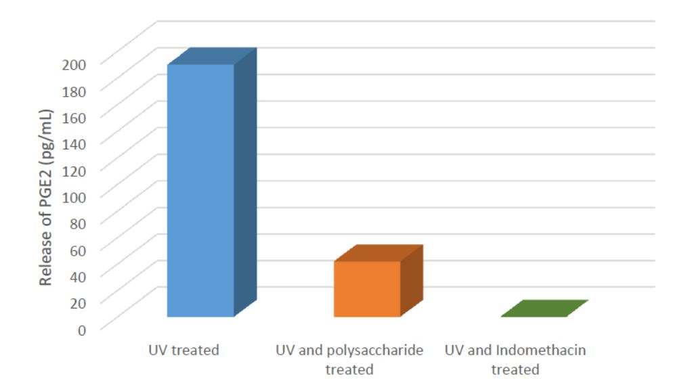
Recent Publications
- Hyun, Y. J., Piao, M. J., Ko, M. H., Lee, N. H., Kang, H. K., Yoo, E. S., . . . Hyun, J. W. (2013). Photoprotective effect of Undaria crenata against ultraviolet B-induced damage to keratinocytes. Journal of Bioscience and Bioengineering, 116(2), 256-264.
- Jang, J., Ye, B.-R., Heo, S.-J., Oh, C., Kang, D.-H., Kim, J. H., . . . Choi, I.-W. (2012). Photo-oxidative stress by ultraviolet-B radiation and antioxidative defense of eckstolonol in human keratinocytes. Environmental Toxicology and Pharmacology, 34(3), 926-934.
- Jeayeng, S., Wongkajornsilp, A., Slominski, A. T., Jirawatnotai, S., Sampattavanich, S., & Panich, U. (2017). Nrf2 in keratinocytes modulates UVB-induced DNA damage and apoptosis in melanocytes through MAPK signaling. Free Radical Biology and Medicine, 108(Supplement C), 918-928.
4. Lee, J., Cho, J. Y., Lee, S. Y., Lee, K.-W., Lee, J., & Song, J.-Y. (2014). Vanillin protects human keratinocyte stem cells against Ultraviolet B irradiation. Food and Chemical Toxicology, 63(Supplement C), 30-37.
5. Zheng, J., Piao, M. J., Kim, K. C., Yao, C. W., Cha, J. W., Shin, J. H., . . . Hyun, J. W. (2014). Photo-protective effect of americanin B against ultraviolet B-induced damage in cultured human keratinocytes. Environmental Toxicology and Pharmacology, 38(3), 891-900.
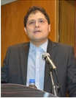

Biography
Dr. Hamidreza Ahmadi Ashtiani is the boss advisor, member of scientific and founder association of research center of cosmetics laboratory of food and drug laboratories of ministry of health, academic member of Azad University, faculty of pharmacy and vice president of IFSCC.
He earned his Ph.D. in clinical biochemistry, diploma of pharmacology and is now the student of level 2 master of cosmetics sciences in Ferarra University, Italy; He worked almost 7 years in cosmetics industry and has held many workshops in cosmetics fields such as regulatory, Global standards, rules and of cosmetics, and formulations. He is activate also as the manager of a cosmetics company which manufactures cosmetics and hygienic products such as shampoo, lotion and cream. :
Oxidative stress and aging, growth factors and cellular senescence, the role of vitamins and herbal ingredient to revive the cells and REDOX system, role of inflammation in wound healing and aging, glutathione system in epidermal stem cells and dermal fibroblasts.
Email: Ahmadihr@yahoo.com

Notes/Comments

