Effect of Solanum tubersum extract on human keratinocyte proliferation in vitro
Hamidreza Ahmadi Ashtiani, Department of Basic Sciences, Faculty of Pharmacy, Pharmaceutical Sciences Branch, Islamic Azad University, Tehran-Iran(IAUPS).
Emadeddin Mobedi, DVM Student, Faculty of Veterinary Medicine, University of Tehran, Tehran, Iran
Ali Salavati, DVM Student, Faculty of Veterinary Medicine, University of Tehran, Tehran, Iran

Abstract
Lectins are a group of glycoprotein substances which have the role of stimulating growth similar to growth factors. Sarcolectin is an endogenous lectin that plays an essential role in regulating cell proliferation in most tissues. In skin tissue, 95% of epidermal consists of keratinocytes, which their most important task is creating a protective layer against external factors. These cells are continuously replicating to renew generation the skin's formation or wound healing, thereby stimulating the proliferation of these cells is important. the effects of Solanum tubersum extract on the proliferation of cultured human keratinocyte cells were investigated. Cells of the 4th passage keratinocytes were cultured in 6 well plates and in HAMF 12 medium plus 10% FBS and streptomycin and penicillin antibiotics with the density of 100,000 cells per house. In this study, the two groups were investigated which first group was treated with plant extract and the second group was untreated and considered as the control group. After 72 hours, the cells were trypsinised and counted in Malassez cells under inverse microscope. The results show that the number of cells in the first group was 2.7 times higher than the day zero and 1.17 times more than in the control group. Sarcolectin awaken the cells in order to make them ready to respond to growth factor signals and that increase growth factors indirectly by inhibiting Interferons. Ultimately that stimulate proliferation of cells. The glycoprotein of this extract had stimulation effect on keratinocyte’s proliferation too. Therefore, these process of stimulation look approximately similar. In other hand availability of the plants, absence (lack) of toxicity and stability of the extracts produced by this plant is characteristic for this plant to have a good potential to applicate in growth-promoting products.

Image
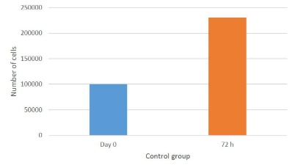
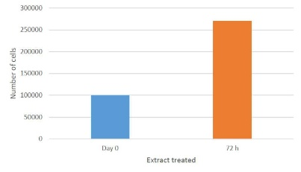
Recent Publications

Pereira, P. R., Del Aguila, E. M., Vericimo, M. A., Zingali, R. B., Paschoalin, V. M., & Silva, J. T. (2014). Purification and characterization of the lectin from taro (Colocasia esculenta) and its effect on mouse splenocyte proliferation in vitro and in vivo. Protein J, 33(1), 92-99.Zhang LW1, Monteiro-Riviere NA. (2010). Lectins modulate multi-walled carbon nanotubes cellular uptake in human epidermal keratinocytes. 10.1016/j.tiv.2009.11.007
- Coriolano, M. C., de Melo, C. M., Silva Fde, O., Schirato, G. V., Porto, C. S., dos Santos, P. J., . . . Coelho, L. C. (2014). Parkia pendula seed lectin: potential use to treat cutaneous wounds in healthy and immunocompromised mice. Appl Biochem Biotechnol, 172(5), 2682-2693.
- do Nascimento-Neto, L. G., Carneiro, R. F., da Silva, S. R., da Silva, B. R., Vassiliepe Sousa Arruda, F., Carneiro, V. A., . . . Nagano, C. S. (2012). Characterization of isoforms of the lectin isolated from the red algae Bryothamnion seaforthii and its pro-healing effect. Mar Drugs, 10(9), 1936-1954.
- Neto, L. G., Pinto Lda, S., Bastos, R. M., Evaristo, F. F., Vasconcelos, M. A., Carneiro, V. A., . . . Teixeira, E. H. (2011). Effect of the lectin of Bauhinia variegata and its recombinant isoform on surgically induced skin wounds in a murine model. Molecules, 16(11), 9298-9315.
- Zhang, L. W., & Monteiro-Riviere, N. A. (2010). Lectins modulate multi-walled carbon nanotubes cellular uptake in human epidermal keratinocytes. Toxicol In Vitro, 24(2), 546-551.

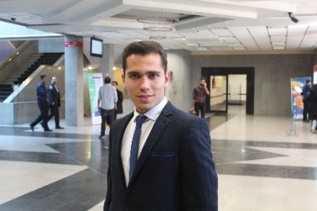
Biography
Emadeddin Mobedi is DVM student of university of Tehran. he has started researching in cosmetology and dermatology field since his second year of university. in that year he had a lecture about animal skin modeling as first Scientific activity. During his second year of DVM he presented a poster about Synchronic effect of burdock and lemon peel extract on sebaceous glands activity in 13th Asian Societies of Cosmetic Scientists Conference. Now in third year of his studying he works on human keratinocyte proliferation.
Email: emadmobedi@ut.ac.ir

