Abstract

Title: A young child of African origin with tinea capitis and multiple kerions

Avneet Singh Kalsi1, Rameshwari Thakur²
1Department of Dermatology, Muzaffarnagar Medical College, India
2Department of Microbiology, Muzaffarnagar Medical College, India

Keywords: Trichophyton violaceum, dermatophyte, arthrospores, endothrix, KOH mount

- Abstract
Tinea capitis (TC) is a common dermatophyte infection of the scalp that can also involve the eyebrows and eyelashes. Tinea capitis especially due to Trichophyton violaceum (TV) is common in children of African descent in sub-Saharan Africa. TC is the most common dermatophyte infection in children, with the highest incidence in children aged 3–7 years old. ¹ This age predilection may partly result from the fungi static properties of fatty acids in post pubertal sebum.² We present a 12-year old child from southern Africa, who was borne HIV positive. Antiretroviral Therapy (ART) was started at the age of one month. He presented to the dermatology clinic with history of itching, scaling, patches of baldness and multiple boggy swellings over the scalp. He was investigated for tinea capitis by taking scalp scrapings using sterile toothbrush and the scalp was rubbed with a gauze piece to collect infected hairs. All these samples were collected after instructing the child to come after head wash with an ordinary shampoo. Potassium hydroxide (KOH) mounts were prepared for the scalp scales and scalp hairs. KOH mount showed endothrix invasion of the hair shaft with long chains of arthrospores. The culture was set up on Derm agar, which grew multiple waxy violet colonies after two weeks of incubation at 37⁰C. Lactophenol cotton blue mounts were prepared from the culture plate. Isolates were identified based on macroscopic and microscopic features (Figure). Patient was prescribed higher doses of oral griseofulvin, which adequately penetrate the shaft of the hair to eliminate the infection.^{3,4} Adjunct therapy was also given by advising the patient to use Selenium Sulfide shampoo 2.5% twice weekly. After two weeks of treatment with griseofulvin, patient developed vesiculo-papular rashes on forehead and right pinna. After 8 weeks of treatment, few colonies grew in the culture. The treatment was extended for four weeks, after which the mycological cure was achieved.

Image:
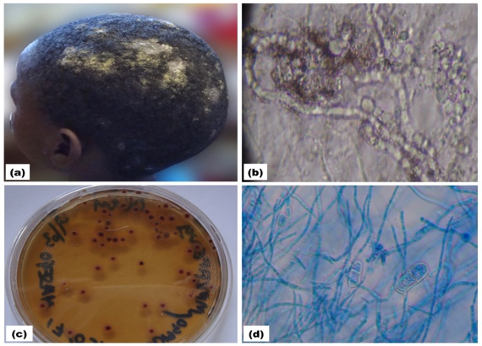

Figure: (a) A young child with tinea capitis and multiple kerions (b) KOH mount showing long chains of arthrospores (c) Culture on derm agar showing multiple waxy violet colonies (d) Lactophenol Cotton Blue (LPCB) mount.
- Reference:

- Elewski BE. Tinea capitis: a current perspective. J Am Acad Dermatol. 2000;42(1 Pt 1):1-20.

- Shy R. Tinea corporis and tinea capitis. Pediatr Rev. 2007;28(5):164-74.

- Ali S, Graham TA, Forgie SE. The assessment and management of tinea capitis in children. Pediatr Emerg Care. 2007;23(9):662-5.

- Chan YC, Friedlander SF. New treatments for tinea capitis. Curr Opin Infect Dis. 2004;17(2):97-103.

Biography:
Avneet Singh Kalsi graduated from Chaudhary Charan Singh University, Meerut. Presently, he is working as a research scholar. His research fields mainly focus on dermatophytic infections, its epidemiology and diagnostic challenges associated with them. He has published several research papers in peer-reviewed international journals such as tinea genitalis in males and females, clinical manifestations and diagnostic challenges of tinea faciei, extensive tinea corporis and tinea cruris et corporis due to Trichophyton interdigitale.

Presenting author details



Full name: Avneet Singh Kalsi

Contact number: 0091-7087403020

ResearchGate ID:

https://www.researchgate.net/profile/Avneet_Singh_Kalsi

Session name/ number:

Category: Oral presentation

Passport number: Z3699441

