Title: Photodynamic therapy for skin rejuvenation

Dr Lara el Hayderi¹ ²
¹ Department of Dermatology, CHU Liège, Belgium
² Dermamed Clinic, Dubai, United Arab Emirates

Keywords: Photodynamic therapy, Skin Rejuvenation, non invasive

Abstract
Therapeutic benefits of Photodynamic therapy (PDT) are known to treat actinic keratosis, basal cell carcinoma, and Bowen disease. More scientific studies now show the benefits on skin rejuvenation. The limit of conventional Photodynamic therapy is the pain associated. Since a few years, the alternative of Day light Photodynamic therapy has been recommended. It is an efficacious alternative to traditional PDT, it is simple to perform and it is not a painful treatment.
All skin types may be treated with day light PDT in case of actinic photodamage of the skin. The treatment scheduling may be performed in most weather conditions except in case of rain or extreme temperature conditions. Depending on the geographical localization, it will be performed all year long in Australia, Latin America and South Europe, but only from March/April to September/ October in Northern Europe.
This technique may also be coupled with other esthetic treatments for better outcomes.
Chemical peels, mechanical peels, curetage, Ablative lasers and microneedling may be associated before or after the day light PDT treatment.
The overall benefits of day light PDT will show on overall skin rejuvenation and quality, fines wrinkles, pigmentation or telangiectasia.

Reference:
1.Valerie Peeters, Samira Baharlou. Therapie photodynamique à la lumière du jour : une alternative indolore pour le rajeunissement de la peau. SKIN, 2017 (3) : 6-9.
2. Philipp-Dormston WG. Photodynamic therapy for aesthetic-cosmetic indications. G. Ital. Dermatol. Venereol 2018; 153 (6): 817-826.
3. Glynis Ablon. Phototherapy with light emitting Diodes: Treating a broad Range of medical and aesthetic conditions in Dermatology.

Biography:
Dr Lara el Hayderi has completed her PhD at the age of 31 years from Liège University and is currently clinical chief at University of Liège in Belgium. She has published more than 20 papers in reputed journals and has given numerous national and international conferences. She has done clinical research in the field of viral infectious diseases on herpes simplex and varicella zoster virus. She actively gives lectures on cosmetic and dermatology at the University and develops the field.

E-mail:laraelhayderi@hotmail.com

Presenting author details:

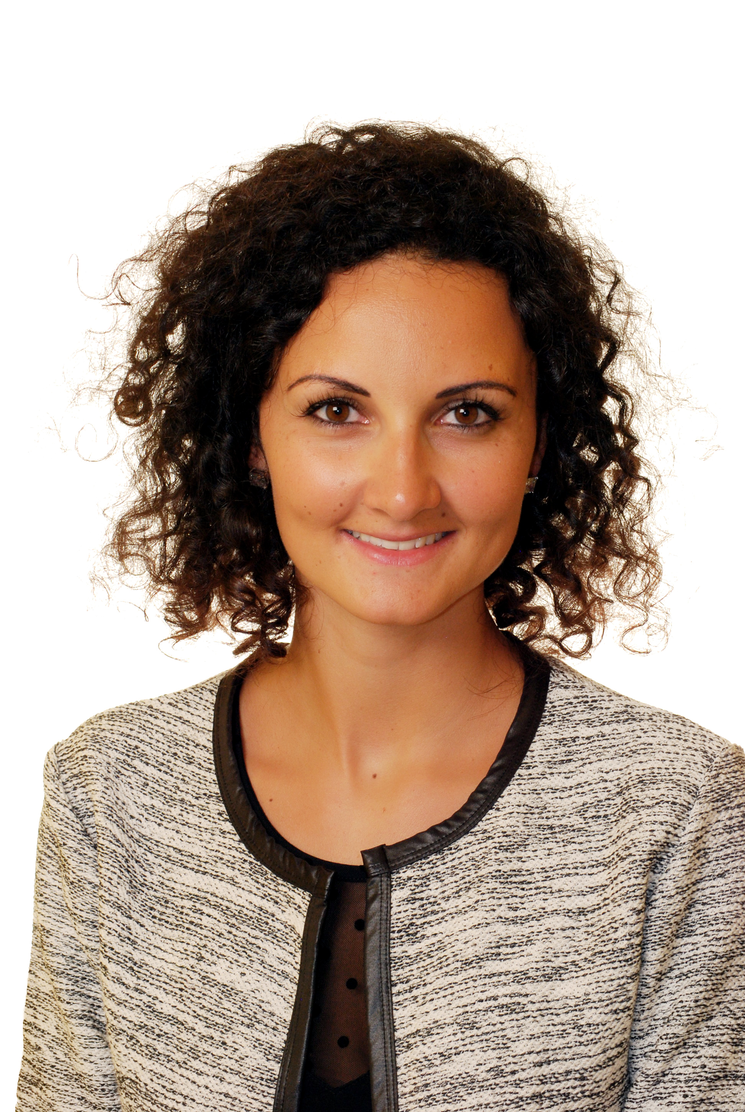
** Full name: Lara el Hayderi
**Mobile Number:00 32 497 887 566 and 00971 50 2490071
**Twitter account:/
**Linked In account : Lara el Hayderi
**Session name/ number:
**Category: (Oral presentation/ Poster presentation) Oral presentation
**Date of Birth: 12/06/1985

