Methimazole In Treatment of Patients with Melasma: A Clinical and Dermascopic Study.

Azza GA Farag*, Mostafa A Hammam* , Nada F Alnaidany**, Wafaa A shehata* and Aliaa F El- Swah*
*Department of Dermatology, Andrology and STDs, Faculty of Medicine – Menoufia University, Egypt.
** Faculty of Pharmacy, Clinical Pharmacy,MSA University, 6 October City, Egypt.

Key words: Methimazole, Melasma, Dermapen.
- Abstract Body
Melasma is a chronic challenging hypermelanotic disorder. Till now, there is no single effective therapeutic agent for it. Methimazole, an oral antithyroid drug, has skin depigmenting effect when used topically through inhibition of peroxidase enzyme. Aims and Objectives: To evaluate the efficacy and safety of methimazole in treatment of melasma through its dermapen delivered microneedling sessions plus its topical use in between sessions. Patients and methods: This study was carried out on 30 Egyptian female patients who had melasma. Each patient received dermapen microneedling sessions followed by topical methimazole on the right side of face and placebo on the left side, once per week for 12 weeks. In between the sessions, the patients were instructed to use topical methimazole twice per day on the right side and placebo on the left side. Assessment was done clinically using Melasma Area and Severity Index (MASI) improvement percent, patient satisfaction and dermoscopical study. T4 serum level was measured before and at the end of the study. Results: There was a significant clinical improvement and a significant improvement in dermoscopic findings (p<0.001 for both). MASI scores mean values showed significant decrease after 8 sessions of methimazole treatment in the right treated side (P< 0.001). The percent of MASI score improvement was significantly associated with the malar pattern (P= 0.031) and epidermal type (P= 0.04) of melasma. About 70% of our studied patients were satisfied with treatment response (7% excellent, 33% good, 30% fair satisfaction). No significant local or systemic side effects were observed. Per and post-treatment T4 serum levels were in normal range in all treated cases. Conclusion: Methimazole could be considered a new safe promising therapeutic agent for treatment of melasma through its dermapen delivered microneedling sessions plus its topical use in between sessions.

- Image:
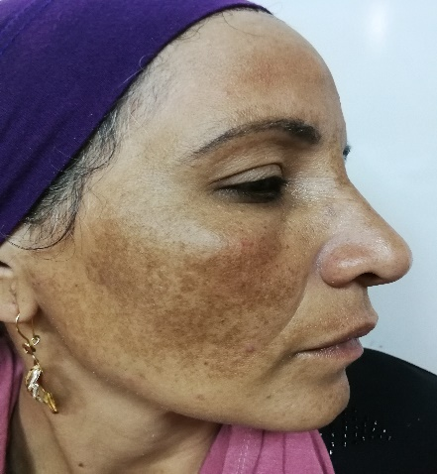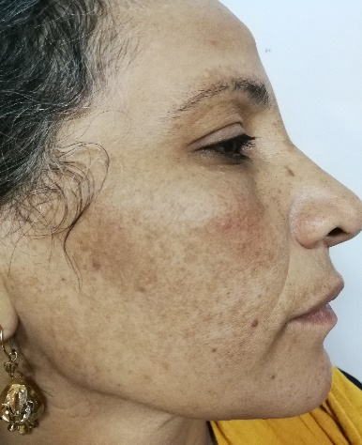
B
A
Photo (1): MMI treated side of patient no.1
A: Before treatment: very severe degree of melasma (MASI score = 23.1).
B: After treatment: moderate degree of melasma with a significant decrease in MASI score (7.2) and good degree of improvement (68%).

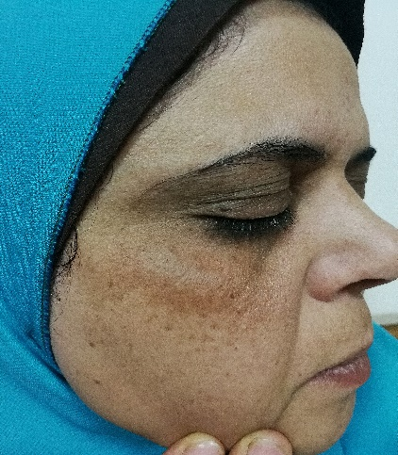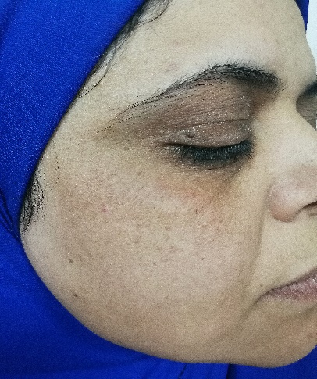
B
A
Photo (2): MMI treated side of patient no.2
A: Before treatment: severe degree of melasma (MASI score = 10.8).
B: After treatment: mild degree of melasma with a significant decrease in MASI score (2.4) and very good degree of improvement (77%).
B
A
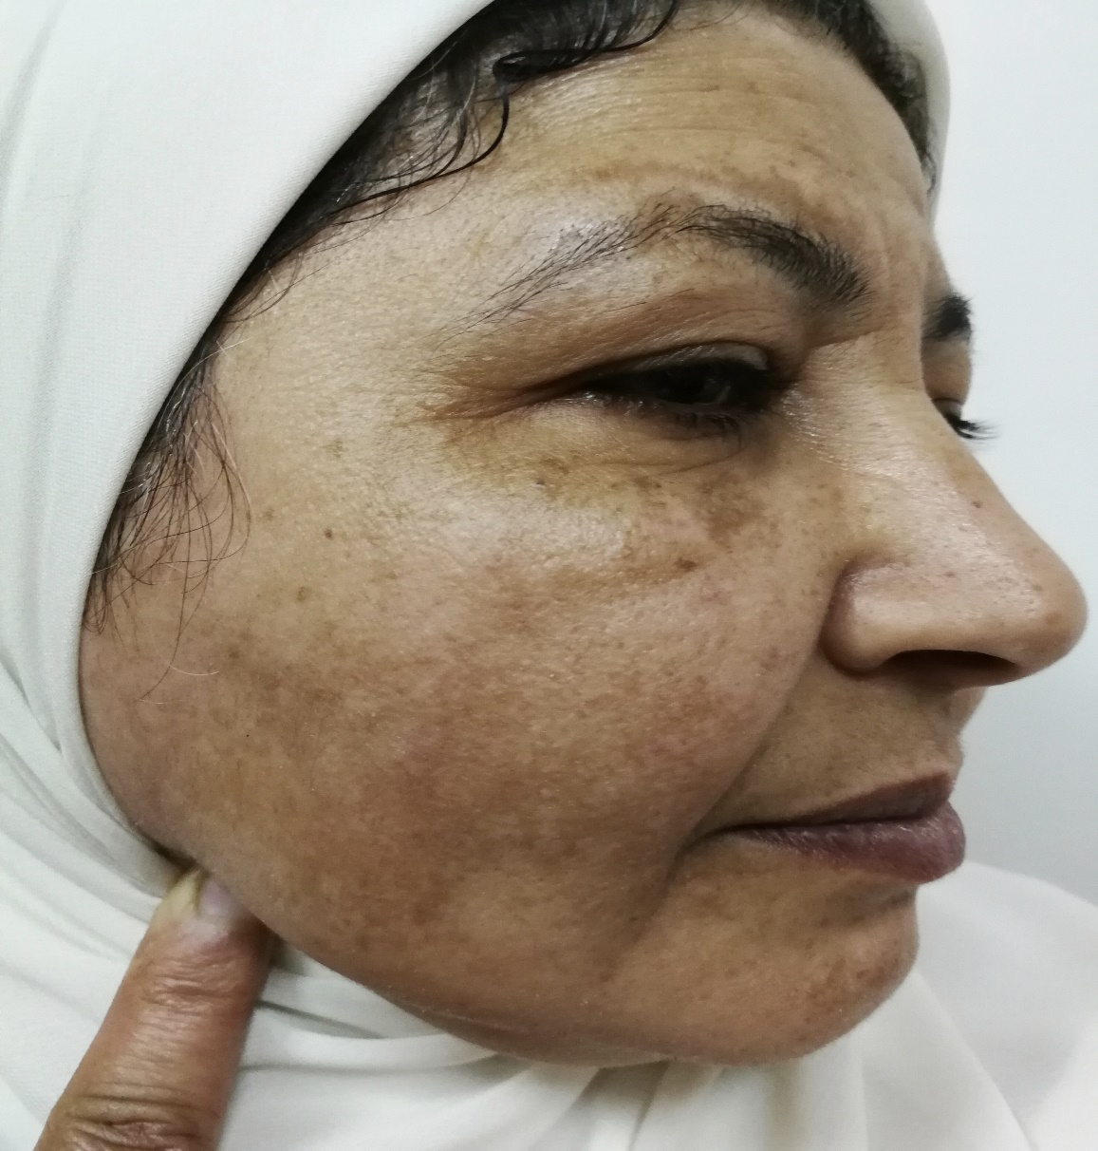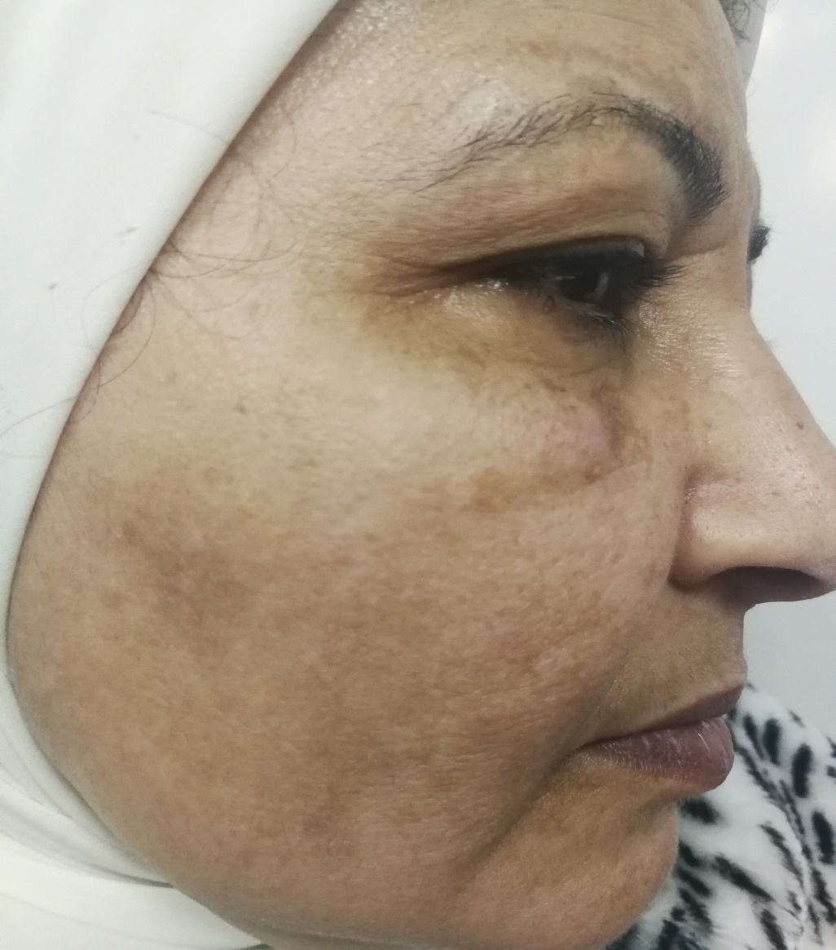
B
A
Photo (3): MMI treated side of patient no.3
A: Before treatment: very severe degree of melasma (MASI score = 22).
B: After treatment: severe degree of melasma with a significant decrease in MASI score (10) and good degree of improvement (55%).

- Reference:
- Atefi N, Behrangi E, Nasiripour S, et al. (2017). A Double Blind Randomized Trial of Efficacy and Safety of 5% Methimazole Versus 2% Hydroquinone in Patients with Melasma, J Skin Stem Cell; 4(2): e62113. doi: 10.5812/jssc.62113.
- Gheisari M, Dadkhahfar S, Olamaei E, et al. (2019). The efficacy and safety of topical 5% methimazole vs 4% hydroquinone in the treatment of melasma: A randomized controlled trial. Journal of Cosmetic Dermatology; 12987. doi.org/10.1111/jocd.12987.

- Grimes PE, Ijaz S, Nashawati R, et al. (2019). New oral and topical approaches for the treatment of melasma. International Journal of Women’s Dermatology; 5(1), 30–36. doi.org/10.1016/j.ijwd.2018.09.004.

- Kasraee B, Safaee Ardekani GH, Parhizgar A, et al., (2008). Safety of topical methimazole for the treatment of melasma. Transder-mal absorption, the effect on thyroid function and cutaneous adverse effects. Skin Pharmacol Physiol; 21: 300– 305. doi: 10.1159/000148222.

- Biography:
Azza Gaber Antar Farag has completed her PhD at the age of 24 years from Menoufia University and Postdoctoral Studies from Menoufia University, Egypt. She is professor, Dermatology, Andrology & STDs department, Faculty of Medicine, Menoufia University. She has published more than 20 papers in reputed journals and has been serving as an editorial board member of repute.
- Presenting author details:

