RETROGRADE TRACHEAL INTUBATION IN NATIONAL CANCER CENTER OF MONGOLIA
(CASE REPORTS)

Bolormaa Batnasan ¹, Denis.S, Gan-Erdene.B, Battsengel.B
²¹Anesthesiology department, ²Head and neck surgery department NCC of Mongolia,

The patient's back and place the O2 mask using the 20 G intravenous IV Fentanyl 100 μg and Propofol 80-150 mg. We are reported successful four cases retrograde tracheal intubations and two unsuccessful case (we put tracheostomy) in NCC of Mongolia. The surgical team was ready to put tracheostomy - all NCC retrograde intubation cases.

Case I. 03 June 2015. A 30 year-old male patient was posted for elective surgery head and neck department. The surgery required to recurrent tumor (d= 6cm) of Rt. Sub mandible gland T2N1M0 do MND tumor remove. On examination
of the airway, all parameters such as mouth not opening, temperomandibular joint subluxation and thyromental and mentohyoid distance were within abnormal limits (he had big car accidence and neck surgery in 2002, 2007, 2012). Chin thyroid distance: less than 2 cm. Dentures, removable teeth.

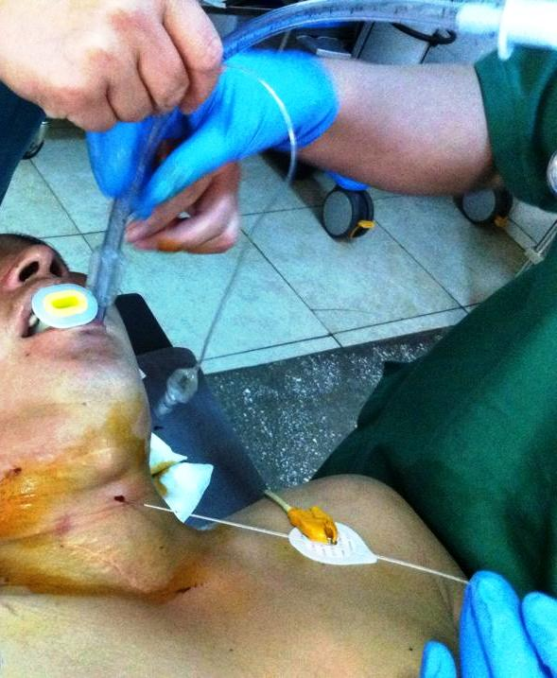
Picture1. (Case I.)

Case II. 19 Sep 2015. A 66 year-old male patient posted for emergency case head and neck surgery department. The patient had two surgeries NCC.
1. Elective surgery was 17 Sep 2015 (required to big tumor resection and reconstruction by ALTFF in cancer mandibles) with normal intubation.
2. Emergency surgery was 19 Sep 2015(free plat to restore the blood supply and airway oxygen supply to increase) with retrograde intubation.
Symptoms: Breathing periodically interrupted. PS: 125-150 times/min, SpO2 68-82%, breathing 6-8 times/min.
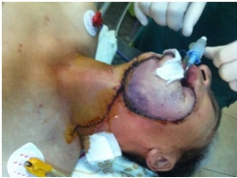
Picture2. (Case II.)

Case III. 21 Apr 2016. A 36 year-old male patient posted for case head and neck surgery department. The patient had planed surgeries NCC. We trying retrograde intubation and guide successful out in mouse but № 5.5 (change № 4) cannot put with retrograde and bronchoscope intubution tube. Our surgery team put emergency tracheotomy.
Elective surgery was 21 Apr 2016 (required to big tumor resection in cancer tongue bias.) with tracheotomy.
Symptoms: Illustrated in FIG devastation difficult to breathe. PS: 115-119 times/min, SpO2 83%, breathing 10-18 times/min.
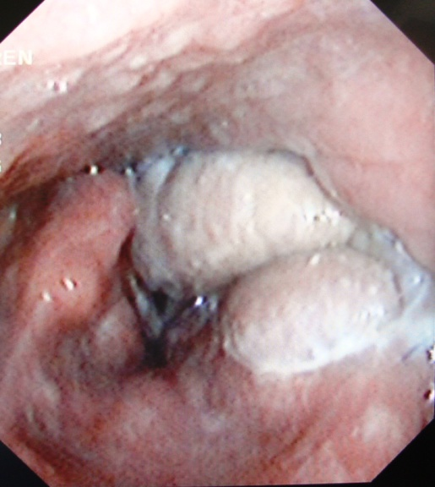
Picture bronchoscope 3. (Case III.)

Case IV. 27 June 2016. A 69 year-old female patient for planed case head and neck surgery department in NCC. The tumor was highly exophytic inside.
Chin thyroid distance: less than 2 cm. Dentures, removable teeth. Elective surgery was (required to big tumor resection cancer maxillaries) with retrograde intubation.
Symptoms: Breathing normally. PS: 78 times/min, SpO2 96%, breathing 18 times/min.
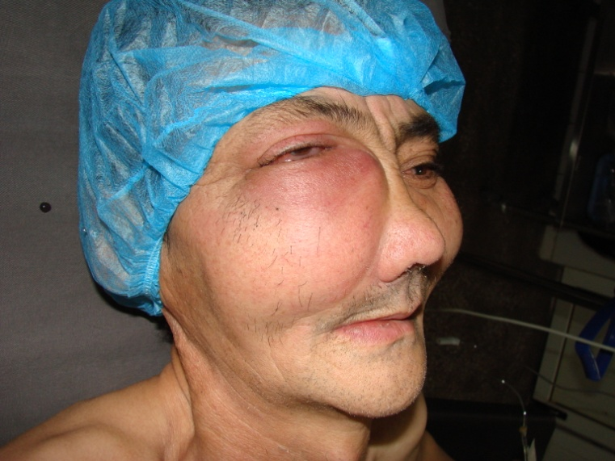
Picture 4. (Case IV.)

Case V. Nov 2017. A 49 year-old male patient for planed case Liver resection V, VI segment, HBPS department in NCC.
He had left cheek and jaw fixture for industrial accidents, all parameters such as mouth not opening. Chin thyroid distance: less than 2 cm. Dentures, removable teeth. Elective surgery was not success retrograde intubation, we are used tracheostomy.

Case VI. Video present. D.M A 60-year-old male patient weighing 53 kg. Soft palate huge *hard* tumor. Elictive surgery 10 Apr 2018.

Preanesthesia process: On examination of the airway, all parameters such as mouth opening normal. ASA III. Tempero mandibular joint subluxation and thyromental and mentohyoid distance were within normal limits and were Mallampati score-IV, Ps -67, BP- 160/100, other condition stable.

The patient was pre-medicated with Droperidol 1%-2 ml. The patient's back and place the O₂ mask using the 20 G intravenous IV Fentanyl 100 μg.

Anesthesia process: 1% Dicaine -3 ml mouth flushed. Sringe with 1% Dicaine -3 ml, 18 G needle and gude, 7 Fr ET tube. Anesthesia saturation was (SpO₂) 89-100%, Ps 68-105, BP 130/90- 160/100.

Cricothyriod membrane puncture was performed with a 18 G needle , in syringe seen airbuble after that a guide wire used in angiograpy venous cannulation was advanced cephalad through the needle, the larynx and out of the mouth; the tracheal tube was passed over the guide wire. Test for correct placement 7 Fr ET tube.

After induction with Propofol 100 + 100 mg IV, 25 mg of Tracruim IV was given ventilation was normal.

Postanesthesia process: PICU and extubated after full recovery of consciousness.

