Evaluation of Tyrosinase Inhibitory activity of Four Medicinal Plant Extracts as herbal depigmenting agents

Payam Khazaeli, Fariba Sharififar,
Faeze Ghandadi, Marzieh Sajadi bami
School of pharmacy, Kerman University of Medical sciences, Kerman, Iran

Abstract
Melanin formation is important factor in skin saftey but hyperpigmentation would be an unwanted skin reaction. Melanin is biosynthesized from tyrosine by enzymatic oxidation as well as an auto oxidation process. Tyrosinase is a rate-limiting enzyme, catalyzes tyrosine to L-DOPA and them to Dopaquinone, which is used for the ultimate formation of melanin. Therefore, Tyrosinase inhibitors can have a main role to treat hyperpigmentation disorders and can be as skin-whitening agents in cosmetics. Several Tyrosinase inhibitors including Hydroquinone, Arbutin and Kojic acid have been widely used. Considering the adverse effects of synthetic substances and public trend to use natural products, the current research was designed and carried out.
In the present study, Zataria multiflora, Nigella sativa, Tripleurospermum disciforme, Tanacetum parthenium, were extracted with methanol, then freeze dried and stored for evaluation of Tyrosinase inhibition with L- tyrosine substrate. Each experiment was done three times and the IC50 were calculated. It seems poly phenols, such as flavonoids, may cause this effect.The Tyrosinase inhibitory activity test, showed all of the extracts were effective. Zataria multiflora and Nigella sativa had IC50 at concentration of 200 mcg/ml But Tripleurospermum disciforme and Tanacetum parthenium at concentration 100 mcg/ml.
Considering inhibitory effects of these plants at above mentioned concentrations, there are good choices as active ingredients to prepare topical formulations for inhibiting melanogenesis.

Key Words: Tyrosinase, Melanin, Zataria multiflora, Nigella sativa, Tripleurospermum disciforme, Tanacetum parthenium
Image

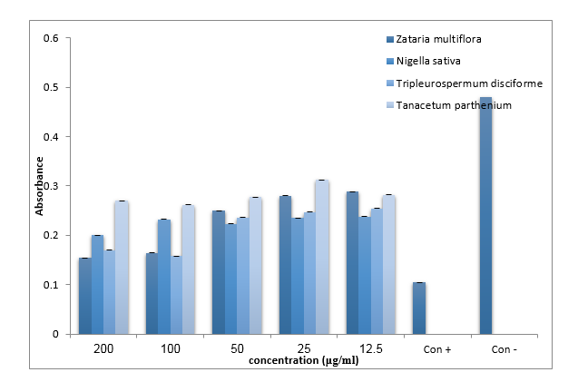
Recent publications
- Chen YS, Liou HC, Chan CF. Tyrosinase inhibitory effect and antioxidative activities of fermented and ethanol extracts of Rhodiola rosea and Lonicera japonica. The Scientific World Journal. 2013; 2013:612739.
- Momtaz S ., Mapunya B.M, Houghton P.J,et al. Tyrosinase inhibition by extracts and constituents of Sideroxylon inerme L. stem bark, used in South Africa for skin lightening.
- J Ethnopharmacol 2008; 507-512.
- Khazaeli, P., Goldoozian, R., Sharififar, F. An evaluation of extracts of five traditional medicinal plants from Iran on the inhibition of mushroom tyrosinase activity and scavenging of free radicals. International Journal of Cosmetic Science 2009 31(5), pp. 375-381.
- Ansari M., Etelaei F., Sharififar F. Tyrosinase kinetic in the presence of three inhibitory medicinal plants. International Journal of Green Pharmacy 2011, 5,103-106.
- Sariri R, Sabbaghzadeh R, Poumohamad F. In-vitro antioxidant and anti-tyrosinase Activity of methanol extracts from Crocus sativus flowers. J Pharmacologyonline 2011,3,1-11

Biography

Payam Khazaeli

PharmD, PhD of Pharmacutics, Professor
Areas of interest: Basic physicochemical properties of materials
Novel drug delivery systems, Liposome and niosome vesicle technology
Colloidal and Coarse dispersions, Drug stability,Drug Analysis

Notes/Comments:

