Formulation and physicochemical evaluation of extract of Punica granatum var.pleniflora mucoadhesive paste for treatment of recurrent aphthous stomatitis (RAS)
Marzieh Sajadi Bami, Payam Khazaeli,
Mitra Mehrabani, Siavash Rakhtshah
Pharmaceutical research center,
Kerman Unversity of Medical Sciences,Kerman, Iran

Abstract
Recurrent aphthous stomatitis (RAS) is common worldwide illness. In many cases there is not absolutely effective treatment and therapy, often merely to ease the pain and irritation symptoms and reduce the duration of illness occurs. Iranian Pomegranate Flower is one of the most important medicinal plants in northern of Iran. flowers of this plant known to heal and treat skin infected wound, in Iranian traditional medicine, use of this herb to control local inflammation of the mouth which are bacterial or fungal source is very useful and effective. Mucoadhesive drug delivery systems because of their ability to extend the presence of drug, release the drug slowly and consequently. The aim of this study is formulation and physicochemical evaluation of Pomegranate flower extract in mucoadhesive base.Methods: Methanolic extract of dried petals has been prepared. A mixture of Low density polyethylene and liquid paraffin used to provide plastibase which used as base of Mucoadhesive formulation. Mucoadhesive oral paste was prepared from combination of sodium carboxymethyl cellulose, pectin and gelatin in plastibase. Formulations with different percentages of the above components prepared and were evaluated for visual properties, discrete particles, uniformity and thumb tests. Five formulations were favorable. These formulations were examined for secondary control tests : adhesion force , Occlusivity, Rheology and release. For selected formulation The occlusivity is about 70% with high adhesion force and also 80% release of total

Image
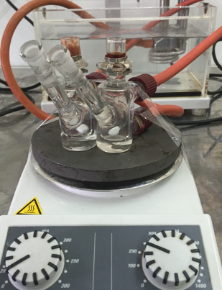
Franz diffiusion cell
Recent publications
- Derakhshandeh K, Abdollahipour R. Oralmucoadhesive paste of Triamcinolone Acetonide and Zinc Sulfate: Preparation and in vitro physicochemical characterization.J Rep Pharm Sci 2014;3:115-25
- Hajimahmoodi M, Moghaddam G, Ranjbar AM, Khazani H, Sadeghi N, Oveisi MR, et al. Total phenolic, flavonoids, tannin content and antioxidant power of some Iranian pomegranate flower cultivars (Punica granatum L.). American Journal of Plant Sciences 2013;4:1815
- Khazaeli P., Ajilchi H., Formulation and physicochemical evaluation of Diphenhydramine mucoadhesive paste. Ahvaz Sci Med J. 2006 4 341-52.
- Salamat-Miller N, Chittchang M, Johnston TP. The use of mucoadhesive polymers in buccal drug delivery. Advanced drug delivery reviews 2005;57:1666-91.
- Gavanji Sh,Bakhtari A. comparative analysis of extract of punica granatum var. pleniflora (golnar-e-farsi)to some antibiotics on pathogens. essential oil-bearing plants.2015:168-78.

Biography

Marzieh sajadi bami PharmD
She was graduated from school of pharmacy and experted in hospital pharmacy

Email: marzieh.sajadi.b@gmail.com

Notes/Comments:

