Technique for improved aesthetic reconstruction of nasal alar defects in Oriental patients with a modified bilobed-nasolabial flap
Dr Priya Tiwari, Dr Ong Wei Chen, A/Prof Lim Thiam Chye, Dr Jane Lim
National University Health System, Singapore

Abstract
Introduction
The bilobed flap is a double transposition flap commonly used in reconstruction of facial skin defects. The flap allows for the movement of more skin over a longer distance than with a single transposition flap. It is especially useful in areas where skin is less mobile such as the nasal tip. Zitelli’s bilobed flap enables aesthetic nasal reconstruction of Caucasians but in Oriental noses the outcomes are less desirable with nasal alar retraction seen. The Oriental nose differs from the Caucasian nose in terms of size, subunit definition, texture and thickness of the skin. Hence, we describe a modification of Zitelli’s bilobed flap incorporating nasolabial skin for a single stage nasal reconstruction with reduced nasal alar retraction to improve the cosmetic outcome of nasal reconstruction for patients of oriental ethnicity.
Methods
We modified the bilobed flap based on Zitelli’s bilobed flap and the aesthetic subunit principle, as modified for Orientals by Yotsuyanagi in 2000. The modified bilobed flap was designed to have a primary lobe that was 10% longer than the length of the distal defect edge from the flap’s pivot point, and the width of the primary lobe was equal to the width of the defect. The length of the secondary lobe was 130% of the length of the distal defect edge to the flap’s pivot point, and the width of the secondary lobe was two-thirds the width of the primary lobe.
Results
Post-operative outcomes showed good nasal contour and appropriate symmetry of the nasal tip with reduced nasal alar retraction.
Conclusion
The modification of Zitelli’s bilobed flap results in reduced nasal alar retraction and an improved cosmetic outcome in the oriental patient.

Figure
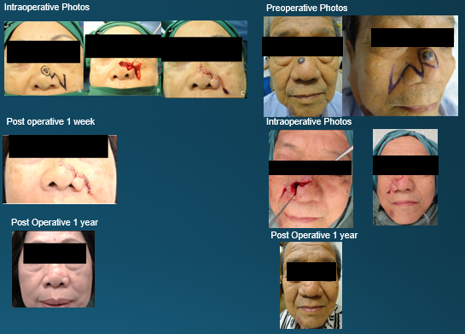
References
- Fujiwara M, One-Stage Reconstruction of an Alar Defect Using a Bilobed Nasolabial–Nasal Tip Flap Based on the Aesthetic Subunits in Orientals: Case Report, Aesthetic Plastic Surgery. 28:13-16, 2004
- Wu WT. The Oriental nose: an anatomical basis for surgery. Ann Acad Med Singapore. 1992;212:176-189
- Zitelli JA: The bilobed flap for nasal reconstruction. Arch Dermatol 125:957, 1989
- Yotsuyanagi T, Yamashita K, Urushidate S, Yokoi K, Sawada Y: Nasal reconstruction based on aesthetic subunits in Orientals. Plast Reconstr Surg 106:36–44, 2000
- Kannan, R., and Reena John. “Reconstruction of Ala of Nose with Bilobed Flap: A 2 Year Follow-Up.” Journal of Maxillofacial & Oral Surgery 10.1 (2011): 57–59.

 Biography (150 word limit)
Dr Priya Tiwari graduated with an M.B.B.S from the National University of Singapore. She is a Member of the Royal College of Surgeons, Edinburgh (MRCS). She is currently undergoing post-graduate training as a Plastic Surgery Registrar at the National University Hospital of Singapore. She has published previously in the areas of peritoneal repair utilizing rectus abdominis myocutaneous flap autologous dermal grafts and treatment protocols for concomitant major burn and trauma patients. She is a member of the hospital patient safety committee and is heavily involved in undergraduate medical education.
Email:priya_tiwari_perdit_k_t@nuhs.edu.sg

