PRP Nomenclature Review– How to determine the most effective PRP system for Best Practice.

Jeannie Devereaux BchHlthSc Dermal Sciences

Abstract
PRP point-of-care devices vary from commonplace laboratory tubes to highly advanced automated cell separating apparatuses, and inconsistent centrifugation parameters. Final platelet counts range from 3 x 10⁵ - 1.5 x 10⁶ plt /μl with inconsistent leukocyte concentrations and plasma volumes. In clinical practice, such variances prevent precise dosing and may well affect the PRP quality, and incidentally damage the platelets, limiting their capacity to release GFs and thus, reducing their regenerative effects. To assess clinical efficacy, it is essential that researchers record and translate data accurately for the clinician to distinguish between PRP formulation variances. Hence, representing a substantial gap in PRP research. Magalon et al. (2014), for example, advised that the platelet concentration is directly linked to the PRP volume and neither should be interpreted alone. Soon after, Magalon et al. (2016) proposed the DEPA; DeLong et al. (2012) developed the PAW classification: platelet number; the manner of platelet activation and the presence of white blood cells and Duarte et al. (2017) developed the schematic MARSPIL. Recent Systematic Reviews concluded supportively for PRP therapy, however they likewise expressed their uncertainties, for the missing data limited their evaluations. Systematic Reviews too have injudiciously presumed the broad view approach in categorising all PRPs as analogous and excluded their clear differences. This lack of standardisation permits the term “PRP” to be marketed equivocally, irrespective of the concentrations, volumes and quality of the product. Coupled with a lack of comprehensive data records, this renders the studies difficult for interpretation and represents a considerable gap in the research. The lack of standardisation allows for PRP distributors to implement emotive nomenclature thus confusing the clinician. This presentation will review studies and promotional material in order to provide knowledge on choosing the most efficacious PRP system for Best Practice.

Haynesworth et al. (2002)

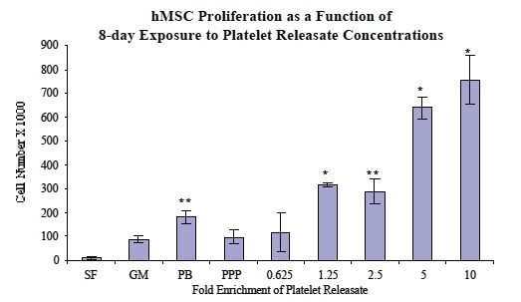

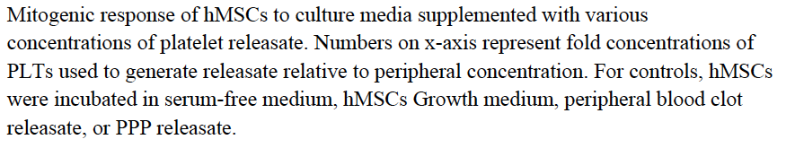

DeLong, M.J., Russell R.P. & Mazzocca, A.D. (2012). Platelet Rich Plasma: The PAW Classification System. Arthoscopy: The Journal of Arthoscopic and Related Surgery, 28 (7), pp. 998-1009.

Dohan Ehrenfest, D.M., Zumstein, M.A., Zhang, C.Q., Pinto, N.R. & Bielecki, T. (2014). Classification of platelet concentrates (Platelet-rich Plasma- PRP, Platelet-rich Fibrin-PRF) for topical and infiltrative use in orthopaedics and sports medicine: current consensus, clinical implication and perspectives. Muscles Ligaments Tendons Journal, 4 (1), pp.3-9.
Fitzpatrick, J., Bulsara, M.K., McCrory, P.R., Richardson, M.D. & Zheng, M,H. (2017) Analysis of Platelet Rich Plasma Extraction. Variations in Platelet and Blood Components Between 4 Common Commercial Kits. The Orthopedic Journal of Sports Medicine, 5(1). doi: 10.1177/2325967116675272

Haynesworth, S., Kadiyala, S. & Bruder, S.P. (2002). Platelet Rich Plasma stimulates stem cell chemotaxis, proliferation and potentiates osteogenic differentiation. The Spine Journal, 2 (5), p.68.

Magalon, J., Chateau, A.L., Bertranr,B., Louis, M.L., Silvestre, A., Giraudo, L. & Sabatier, F. (2016). DEPA classification: a proposal for standardising PRP use and a retrospective application of available devices. BMJ Open Sport Exercise Medicine, 2(1). doi:10.1136/brnjsem-2015-000060

 Jeannie Devereaux has 25 years experience in corporate entities with a high proficiency in regenerative medicine and dermal science. Jeannie has pioneered the use of PRP Cell Biology in Australia, introducing Cell Biology Therapy to be the most exciting era in medicine since the introduction of penicillin. Jeannie has developed dermal regeneration therapies that have changed the course of dermatology, reconstructive surgery and aesthetic medicine utilising a variety of cellular therapies including platelets, monocytes, bone marrow cells and adipose cells. Jeannie's career has been actively engaged in the professions of Dermatology, Plastic and Reconstructive Surgery, Bio Cellular Sciences, Regenerative Medicine, Orthopaedic Sciences during which time she obtained significant knowledge and expertise across a multiple of medical disciplines.

Email:jeanniedvrx@gmail.com

