ENVIRONMENTAL STRAIN ON BEACH ENVIRONMENTS RETRIEVED AND MONITORED BY SPACE-BORNE SYNTHETIC APERTURE RADAR
¹Valeria Di Biase: Technische Universiteit Delft - Faculty of Civil Engineering and Geosciences; 2628 CN Delft / 2600 GA Delft, The Netherlands; v.dibiase@tudelft.nl
²Ramon Hanssen: Technische Universiteit Delft - Faculty of Civil Engineering and Geosciences; 2628 CN Delft / 2600 GA Delft, The Netherlands; r.f.hanssen@tudelft.nl

Abstract

How exactly do more intense storms, precipitation and tidal condition affect beaches? The aim of this innovative work, which is part of a collaboration between the Technische Universiteit Delft and Mitsubishi Electric Corporation, is- for the first time- answering to this question by performing an extensive analysis of coastal areas at a high spatiotemporal resolution using remote sensing instruments.

Remote sensing provides a unique ability to monitor and map coastal areas with complete, repeated, and frequent coverage of the Earth’s surface. Among the newest satellite remote sensing systems, Synthetic Aperture Radar (SAR) is able to provide continuous and all-weather monitoring (independent of cloud cover) over the entire world with daily repetition. We intend to gain insight into the potential of SAR data for the retrieval and monitoring of soil properties over a sandy area, to establish a causal empirical relationship between the SAR amplitude and wind, precipitation, tidal condition.

The present study has been performed on the beach of Noordwijk, located on the central Dutch coastline, and it has been carried out by using Sentinel-1 images. The dataset includes a two-years stack of Single Look Complex (SLC) data, VH and VV polarization, with six-days temporal resolution. These data have been pre-processed and co-registered, then compared to ancillary data as local weather and environmental conditions (wind speed and direction, precipitation accumulation, tide level). Dedicated codes have been implemented in order to understand the relationship between the SAR amplitude with the considered phenomena. The most relevant result is a strong correlation between the amplitude evaluated on the sandy area and wind, in particular for specific wind directions (Fig.1). The innovative aspect is the focus on a beach environment, where no previous studies focused their attention, for understanding to what extent can SAR data detect its characteristics in terms of environmental conditions.
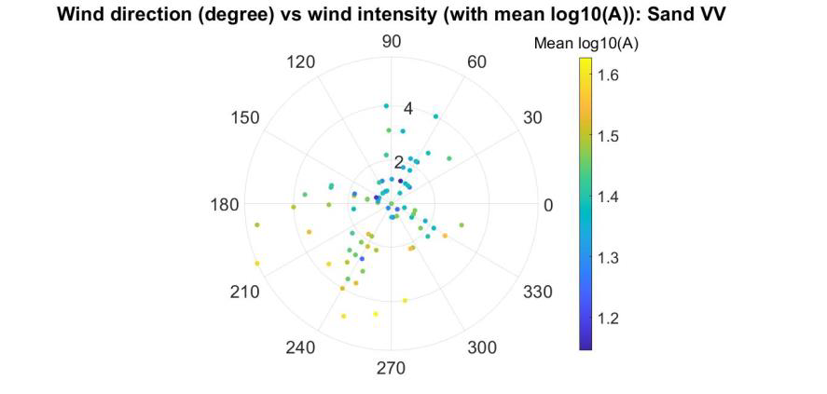
Figure 1: Scatter plot of the wind direction (degree, 0°=Nord; 90°=East) versus wind speed (m/s) at the time of the satellite acquisitions. SAR amplitude (VV polarization) retrieved on the study area (beach of Noordwijk) is represented in the colorbar. Low and high amplitude values are respectively associated to specific wind directions.
Recent Publications
- Attarzadeh, R., Amini, J., Notarnicola, C., Greifeneder, F., 2018. Synergeticuse of sentinel-1 and sentinel-2 data for soil moisture mapping at plotscale. Remote Sensing 10, 1285.
- Guo, Q., Xu, X., Zhang, K., Li, Z., Huang, W., Mansaray, L.R., Liu, W.,Wang, X., Gao, J., Huang, J., 2018. Assessing global ocean wind energyresources using multiple satellite data. Remote Sensing 10, 100.
- Zecchetto, S., De Biasio, F., Della Valle, A., Quattrocchi, G., Cadau, E.,Cucco, A., 2016. Wind fields from c-and x-band sar images at vv polar-ization in coastal area (gulf of oristano, italy). IEEE Journal of Selected Topics in Applied Earth Observations and Remote Sensing 9, 2643–2650.
- Monaldo, F., Jackson, C., Li, X., Pichel, W.G., 2016. Preliminary evalua-tion of sentinel-1a wind speed retrievals. IEEE Journal of Selected Top-ics in Applied Earth Observations and Remote Sensing 9, 2638–2642.
5. Smit, Y., Ruessink, G., Brakenhoff, L. B., & Donker, J. J., 2018. Measuring spatial and temporal variation in surface moisture on a coastal beach with a near-infrared terrestrial laser scanner. Aeolian Research, 31, 19-27.

Biography
Valeria Di Biase is a researcher in Geoscience and Remote Sensing at Delft University of Technology. She studied aerospace engineering and astronautical engineering at La Sapienza University of Rome. Her relevant expertise in remote sensing and earth observation starts during an internship at the European Space Agency (ESA-ESRIN), where she works on the Long-Term Data Preservation program. After graduating with a M.Sc. thesis on the groundbreaking “mission recovery” activity at ESA-ESRIN, she starts working as a research doctor at La Sapienza University of Rome, granted by the Italian Space Agency, working on detection and monitoring of forest fires algorithms. At present, she is working in the field of radar remote sensing at the Faculty of Civil Engineering and Geosciences.
Email: v.dibiase@tudelft.nl

