Using virtual immersive 3D geospaces to gain understanding of and support for responsible management of coastal ecosystems
Linda Morris Kelley (aka Delia Lake), Transitioning to Green, USA
Hajime Nishimura (aka Yan Luria), JAMSTEC (Retired), Japan
Kenneth Y T Lim (aka Veritas Raymaker), National Institute of Education, Singapore

Abstract (300 word limit)
The scientific research about coastal ecosystems and their importance to humanity is both solidly founded and ongoing. Scientists share the facts widely. Yet human activity is destroying these coastal ecologies and marine habitats, and officials with authority to protect these environments significantly undervalue them by law and policy. Knowing the facts and information is seldomly sufficient to move people to responsible action.

People say they care about coasts and oceans but their actions belie that. Though protection and livelihoods of millions of people around the world depend on coastal ecosystems resources, people treat these resources carelessly. Shorelines are awash with plastic trash. Untreated sewage and agricultural fertilizer runoff encourage algal blooms with seasonal eutrophication damaging ecosystems adjacent to highly populated coastal areas worldwide. Trawling and overfishing destroy coastal ecosystems, sometimes beyond recovery. Climate change is adding to the already present stresses these ecosystems suffer. How can we change this?

Unfortunately, most people have never had an opportunity to experience and enjoy any of these amazing socio-ecological spaces. While we cannot show them all the world’s physical coastal ecosystems, we can do that in immersive 3D virtual geospaces.

Our virtual tour of eight simulated coastal ecosystems at The Abyss Observatory, an educational resource on the 3D interactive platform of Second Life® gives people a sense of “being there” and produces lasting memories of real, meaningful feelings of engagement. Caring is built on memories of experiences that touch people. People protect things they care about.

The featured builds are two Tropical habitats – a mangrove forest and a coral reef, four Temperate habitats – an oak and holly forest, a Temperate rainforest, ocean banks, and a kelp forest, and two Arctic and Subarctic habitats – coastal tundra and cold-water coral reef, all key ecosystems for global sustainability.

Abyss Observatory at Farwell in Second Life® http://maps.secondlife.com/secondlife/Farwell/75/81/95

Image
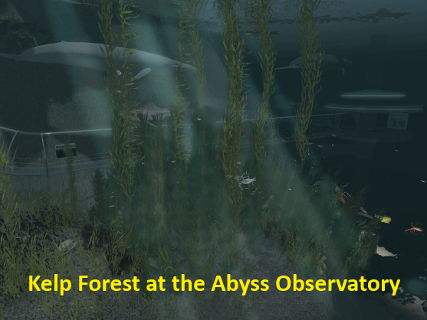
Recent Publications (minimum 5)
- Wirtenberg J, Kelley LM, Lipsky D, Russell W (2018) The Sustainable Enterprise Fieldbook, Building New Bridges.

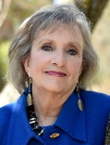Biography (50 word limit)
Linda Morris Kelley, Curator, Abyss Observatory. Enterprise Ecologist, Transitioning to Green. Focused at the nexus where big picture vision meets practical implementation to produce sustainable enterprise. Using a whole-systems approach, clients navigate difficult issues producing meaningful results. A leader in virtual technologies for collaborative problem-solving, immersive learning, and collective ingenuity.
Email: ld366496@gmail.com

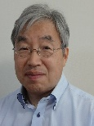 Biography (50 word limit)
Hajime Nishimura, Curator, Abyss Observatory. International Spaceflight Museum, Climate Change Learning Portal, Virtual World Teacher Training Center. Curations and remote classrooms on Ocean, Earth and Space science; education, interdisciplinary collaboration using Virtual World, multi-user immersive 3D geospace. Retired from the Japan Agency for Marine-Earth Science and Technology (JAMSTEC), 03/ 2020.
Email: nishimuraya146@gmail.com

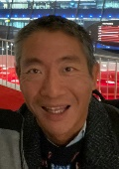 Biography (50 word limit)
Kenneth Y T Lim, Research Scientist, National Institute of Education, Singapore. Works with teachers across varieties of disciplines to design learning environments which surface students’ intuition from phenomenological perspectives. Kenneth and team have developed the Socially Responsible Behaviour through Embodied Thinking (SORBET) Project, a learning activity in response to COVID-19.
Email: voyager@mac.com

Notes/Comments:

