Intra-annual coastal dynamics through remote sensors and photogrammetry morphosedimentary patterns, Reñaca beach, Central Chile

Idania Briceño, PhD©, ¹Hémera Centro de Observación de la Tierra, Facultad de Ciencias, Universidad Mayor, Santiago, Chile.
Elena Sánchez-García, PhD, ²Geo-Environmental Cartography and Remote Sensing Group, Universitat Politècnica de València, Valencia, Spain.
Jesús Palomar-Vázquez, PhD, ²Geo-Environmental Cartography and Remote Sensing Group, Universitat Politècnica de València, Valencia, Spain.
Josep Pardo-Pascual, PhD, ²Geo-Environmental Cartography and Remote Sensing Group, Universitat Politècnica de València, Valencia, Spain.
Paulina Vidal PhD© ¹Hémera Centro de Observación de la Tierra, Facultad de Ciencias, Universidad Mayor, Chile.
Waldo Pérez-Martínez, PhD© ¹Hémera Centro de Observación de la Tierra, Facultad de Ciencias, Universidad Mayor, Chile.

Abstract
The Reñaca Beach, located in the Valparaíso Region, Central Chile, is a place of special interest to understand the influence of oceanic, atmospheric and anthropic agents in the coastal dynamics. This study aims to determine the evolution of the coastal area, with survey studies were carried out with a differential GPS according to the revisit dates of the Landsat 8 satellite and photogrammetry to obtain accurate information of beaches and characterize evolutionary trends along the coast of Chile. In addition, the shoreline was automatically extracted with SHOREX, using images captured from the same satellite, considering data from January 2016 to December 2018. Sedimentological analyzes with transversal beach profiles were also carried out. Samples for season’s summer were collected in the profile. These samples were sieved and granulometric curves were constructed. In addition, oceanographic data for tide and wave height were compiled for the Landsat 8 satellite revisit dates. Also, a high-definition digital elevation model was generated from images captured by DRONE. The preliminary results show that the coastline advances landwards in winter and seawards in summer. The shoreline extracted with SHOREX provides a quantitative description of the short-term change (measured in three years), and the seasonal change in the coastline. In addition, sediment transport is dominated by saltation at the beginning of summer, while the dominant transport is saltation and suspension at the beginning of autumn. The variability will depend on the intensity of the dynamic agents that are present, be it wind, waves, tides, and the recurrence of extreme weather events such as storms. Continuous monitoring is vital for coastal use policy generation, as well as for the local management of coastal resources.

Image
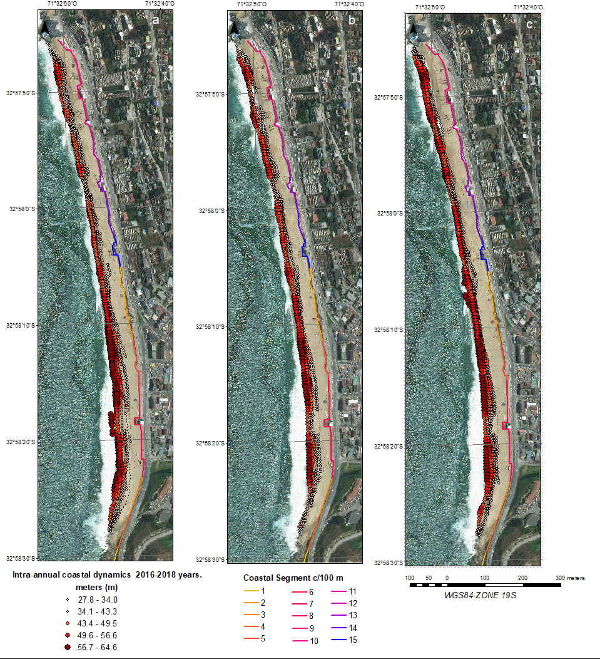
Figure 1. a) Intra-annual coastal dynamics 2016; b) Intra-annual coastal dynamics 2017; c) Intra-annual coastal dynamics 2018.
Recent Publications
- Almonacid-Caballer J (2014) Extraction of Shorelines with Sub-Pixel Precision from Landsat Images (TM, ETM+, OLI) [Obtención de Lineas de Costa con Precisión Sub-Pixel a Partir de Imágenes Landsat (TM, ETM+ y OLI)]. Ph.D. Thesis, Universitat Politècnica de València, Valencia, Spain.
- Bayram, B., Erdem, F, Akpinar, B, Ince, A. K., Bozkurt, S, Reis, HC, & Seker, DZ. (2017). The Efficiency of Random Forest Method for Shoreline Extraction from LANDSAT-8 and GOKTURK-2 Imageries. ISPRS Annals of the Photogrammetry, Remote Sensing and Spatial Information Sciences, 4, 141. DOI: 10.5194/isprs-annals-IV-4-W4-141-2017.
- Palomar-Vázquez, J, Almonacid-Caballer, J, Pardo-Pascual, JE, & Sánchez-García, E. (2018). Shorex : a New Tool for Automatic and Massive Extraction of Shorelines From Landsat and Sentinel 2 Imagery. Proceedings of the 7 Th International Conference on the Application of Physical Modelling in Coastal and Port (Coastlab18), 1–8.
- Pardo-Pascual, JE., Almonacid-Caballer, J, Ruiz, LA, & Palomar-Vázquez, J. (2012). Automatic extraction of shorelines from Landsat TM and ETM+ multitemporal images with subpixel precision. Remote Sensing of Environment, 123, 1-11. https://doi.org/10.1016/j.rse.2012.02.024
- Pardo-Pascual, JE., Sánchez-García, E, Almonacid-Caballer, J, Palomar-Vázquez, J.M., de los Santos, E.P., Fernández-Sarría, A., & Balaguer-Beser, A. (2018). Assessing the accuracy of automatically extracted shorelines on microtidal beaches from Landsat 7, Landsat 8 and Sentinel-2 imagery. Remote Sensing, 10 (2), 326. https://doi.org/10.3390/rs10020326
- Rabadán, CC, & Pascual, JE. (2017). Monitorizando la anchura de las playas mediante imágenes Landsat 8 en costas micromareales mediterráneas. Jornadas de Geomorfología Litoral, Menorca, España (17), 159–162.

Biography

Idania Briceño
Geographer, Universidad de Los Andes, Mérida, Venezuela / Diploma in Geomatics and Satellite Technology, Universidad Mayor, Chile / Master Scientiarium in Spatial Analysis and Territory Management, Central University of Venezuela / Master in Remote Sensing, Universidad Mayor, Chile / Ph.D . © in Geomatic Engineering, Polytechnic University of Valencia, Spain. Research lines: Monitoring water quality of continental surface and oceanic; Geomorphology and coastal sedimentary dynamics; Changes in land use and landscape ecology.

Email: idania.briceno@umayor.cl

Notes/Comments:

