Moving forward to a multiscale approach to improve the management and conservation of Peruvian MPAs: Using EUNIS habitat classification in the study of RNIIPG- “Islote Grupo de Pescadores”

Diego N Campos, Divepersea Programe, Aquatic Ecology Lab, UNMSM, Peru
Rosa-Maria Cañedo, Divepersea Programe, Aquatic Ecology Lab, UNMSM, Peru

Abstract (300 word limit)
In Peru, there are three Protected Natural Areas (PNA) that include a marine component. One of this PNA is Reserva Nacional Sistema de Islas, Islotes y Puntas Guaneras (RNSIIPG) comprising of 33 subareas (islands, islets and rocky ledges). However, even when the main component (90%) is comprised of the marine area, there are just a few studies about it and an incipient effort to manage it. From its creation to the present, the approaches used to manage the biodiversity and marine resources have been focused on target species and communities and other important habitats that host valuable resources (e.g. razor clams, clams, crabs, sea cucumbers) have been ignored due to the gap of knowledge and wrong spatial representation. In this study, we applied the European nature information system (EUNIS) habitat classification for the first time in the RNSIIPG and we took as a case study one of the subareas: Islote Grupo de Pescadores located on the central coast of Peru and part of the Humboldt Current Ecosystem. We could identify 11 types of habitats, 2 habitats types at Level 2 and 9 habitats at Level 4. In the case of habitats with mobile sediment, we could reach the Level 4 with bathymetric data and type of sediment (i.e. find sand). Nerveless, we couldn’t reach the Level 5 due to the lack of information regarding the biological component. In the case of no-mobile sediment (i.e. hard substrates) we could only reach the Level 2 due to the lack of information of exposure degree and energy level the habitats are subjected. The application of EUNIS classification allow us to have an improved spatial overview of marine habitats in RNSIIPG. This is an evidence of the potential use this tool can provide in Peruvian PNA to define conservation elements with a hierarchical approach.

Image
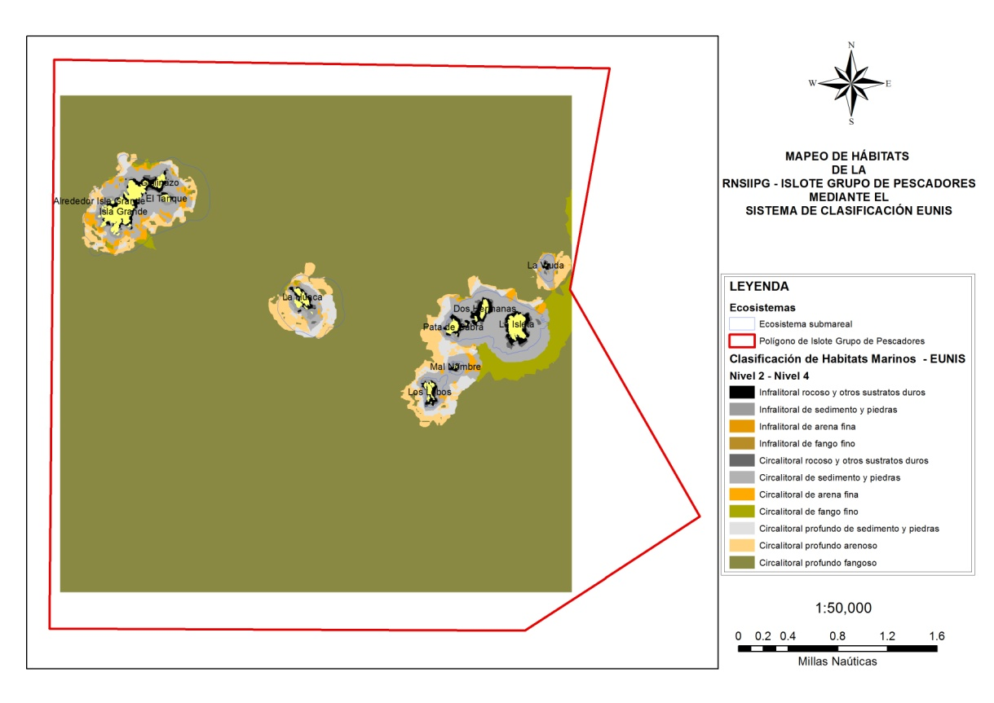
Recent Publications (minimum 5)
- Santos, CF, Ehler, CN, Agardy, T, Andrade, F, Orbach, MK, Crowder, LB (2019). Marine spatial planning. In World Seas: An Environmental Evaluation (pp. 571-592). Academic Press.
- Servicio Nacional de Áreas Naturales Protegidas por el Estado. (2016). Plan Maestro de la Reserva Nacional Sistema de Islas, Islotes y Puntas Guaneras 2016-2020. Lima, Peru.
- Evans, D. (2012). The EUNIS habitats classification-past, present & future. Revista de Investigación Marina, 19(2), 28-29.
- Diesing, M, Ware, S, Foster-Smith, R, Stewart, H, Long, D, Vanstaen, K, Foster, R, Morando, A (2009). Understanding the marine environment: seabed habitat investigations of the Dogger Bank offshore draft SAC. Joint Nature Conservation Committee, Peterborough.
- Davies, CE, & Moss, D (2004). EUNIS habitat classification marine habitat types: revised classification and criteria, September 2004. Centre for Ecology & Hydrology, 84.
- Sullivan SK, Bustamante, G (1999). Setting geographic priorities for marine conservation in Latin America and the Caribbean. The Nature Conservancy, Arlington, Virginia.

Biography (150 words limit)
Diego Campos is a young consultant who has worked for both public and private organizations in Peru. His expertise is focused on research in applied ecology for conservation and fisheries management of benthic organisms and marine habitats. He has also worked in spatial data management and analysis for zoning of RNSIIPG. His work has left a report that will let the protected area make decisions about the implementation and application of the hierarchical approach in previously zoned marine areas, as well as its consideration in potential new MPAs. Currently, he is working as a consultant for The Nature Conservancy, and leading research for monitoring of the success of self-management in order to ensure the conservation of benthic resources and biodiversity in the diving artisanal fishery in Islote Grupo de Pescadores, a subarea of RNSIIPG in Peru.
Email: camposdiegonahuel@gmail.com

