Portus Vadorum. New data after recent dredging
Frida Occelli, Studium sas, Italy
Simon Luca Trigona, Soprintendenza Archeologia, Belle Arti e Paesaggio della Liguria, Italy

Abstract (300 word limit)
The occupation of the natural harbor of Vado Ligure since the Republican age was already known during the last century.
The preventive archaeology work and assistance carried out between 2014 and 2018 in the natural harbour of Vado Ligure, Liguria, Italy, for the realisation of a large multipurpose port platform has brought to the acquisition of an enormous mass of finds datable between the Roman and Modern age. The different investigative methodologies have allowed the acquisition of complex information which rendered necessary, in addition to the classification of finds, a functional data management system which could contextually meet the study, conservation and enhancement needs.
For the realization of the systematization activities of the archeological data acquired and the filing of materials a computer information system was planned which would link the information contained in the relational finds database with geo-stratigraphic GIS information; the result of the interaction of these two data management systems enables us to manage and organize information from several points of view for analytical needs (qualitative, distributive, geographic).

Image
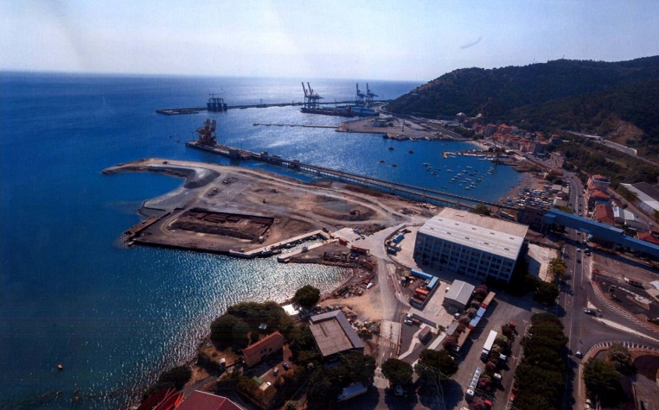
Recent Publications (minimum 5)
- S.L. TRIGONA, F. OCCELLI, Portus Vadorum. Archeologia preventiva nella rada di Vado Ligure, in Archeologia Subacquea 2.0, Atti del V Convegno nazionale di Archeologia Subacquea, Udine, 8-10 settembre 2016.
- S.L. TRIGONA, F. OCCELLI, Vado Bay. Dredging through the long life of an ancient harbor, in “Celebrating our share heritage”, Proceedings of the Sixth International Congress of Underwater Archaeology (Ikuwa VI), Fremantle 28 November – 02 December 2016, c.s.
- F. OCCELLI, Il potenziale archeologico del territorio e la pianificazione paesaggistica, in “Atti e Rassegna Tecnica”, LXXII, N.3. Il Piano paesaggistico del Piemonte, Torino, 2018, pp. 133-136
- F. OCCELLI, Augusta Taurinorum and the relationship with its rivers. Topographic reflection, Actas del V Congreso Internacional de Arqueologìa Subacuàtica (Ikuwa V), Cartagena (Spagna), 15 - 19 ottobre 2014, pp. 653-654
5. S.L. TRIGONA, L’archeologia subacquea in Liguria: recenti esperienze di ricerca e valorizzazione, in Archeologia Subacquea. Storia, organizzazione, tecnica e ricerche, Bordighera 2017, pp. 271-280

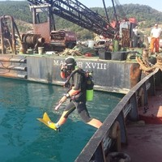 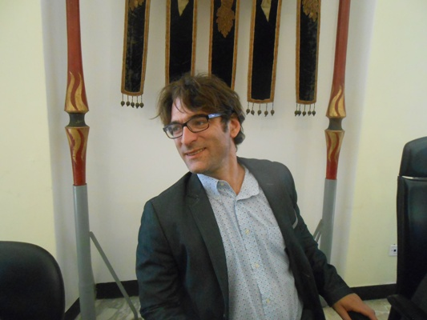 Biography (150 word limit)
Frida Occelli has been working as a field archaeologist since 1993. She has directed hundreds of prestigious archaeological underwater and inland excavations. As archaeologist, she is involved in many infrastructural project, such as the high speed train connecting Turin and Lyon or the underground lines 1 and 2 of Turin

Simon Luca Trigona is a state official of the Soprintendenza Archeologica, in charge of underwater archaeology in Liguria (North Italy)
Email: studium.occelli@libero.it

Notes/Comments:

