Role of Geospatial Technology in Mangrove Forests Management: A Critical Review
Naveen V., College of Forestry, Ponnampet, Karnataka, India

Abstract

Mangrove forests are one of the most important carbon-dense coastal ecosystems on the earth in terms of productivity and coastal area protection from soil erosion. It is globally distributed in intertidal tropical and subtropical regions between latitude 24⁰N to 38⁰S. Global mangrove forests are now under stress mainly due to increasing demographic pressures. Therefore, management of mangrove ecosystem is very much essential. As Peter Drucker once said – ‘What gets measured, gets managed.’ here geospatial technology plays a vital role in measuring the coastal ecosystem and helps us to take decision for its better management. Geospatial technology includes a) remote sensing - satellite sensors are eye in the sky which keeps on taking the images of the earth, b) Geographic Information Systems (GIS) are the computer based tools which helps us to visualize, analyze, store, and retrieve varies types of remotely sensed data very quickly, and c) Global Navigation Satellite System (GNSS) adds the location information for both the remote sensing and GIS data. Recently, this technology was used in i) mangrove species identification using multispectral or hyperspectral remote sensing data, ii) mapping at different resolutions to know the spatial coverage at a particular time, iii) repetitive coverage of the satellites over the same area helps in monitoring the changes in the mangrove forest such as expansion or loss, phonological changes, iv) and it helps in modeling of mangrove forest such as spatial distribution of the above ground biomass or carbon, and 3-D modeling etc. Concluding, geospatial technology is an advanced tool which helps to study, map and monitor the large area in less working time with more accuracy.
Image
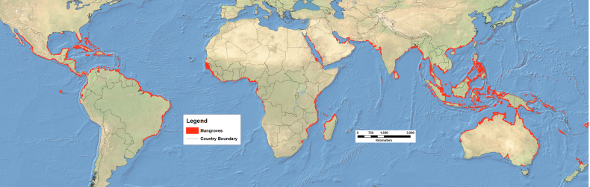
Global mangrove forests distribution @2000 (Giri et al., 2011). Map redrawn by UNEP/DEWA
Recent Publications
- Friess D A, (2019) Where the tallest mangroves are. Nature Geoscience 12:4-5 DOI: https://doi.org/10.1038/s41561-018-0280-8DO
- Omar H, Misman M A, Musa (2019) GIS and Remote Sensing for Mangroves mapping and monitoring. IntechOpen 1-15 DOI: http://dx.doi.org/10.5772/intechopen.81955
- Murray N J, Phinn S R, DeWitt M, Ferrari R, Johnston R, Lyons M B, Clinton N, Thau D, Fuller R A (2019) The global distribution and tregectory of tidal flats Nature 565:222–225 DOI: https://doi.org/10.1038/s41561-018-0279-1DO
- Pastor-Guzman J , Dash J, Atkinson P M (2016) Remote Sensing of Mangrove forest Phenology and its environmental drivers. Remote Sensing of Environment 205:71–84 DOI: https://doi.org/10.1016/j.rse.2017.11.009
- Giri C, Ochieng E, Tieszen L, Zhu Z, Singh A, Loveland T, Masek J, Duke N (2011). Status and distribution of mangrove forests of the world using earth observation satellite data. Global Ecolology. Biogeography. 20:154-159.

Biography
Naveen V. has doing Masters in Forestry. He is expertise in the field of Remote sensing and GIS specialization in Forest Resources and Ecosystem Analysis, Forestry and Ecology. He is very much interested in doing research in the Forestry and Ecology field.
Email: vnaveen034@gmail.com

Notes/Comments:

