ASSESSING THE IMPACT OF PORTS ON COAST FOR DEVELOPING A SUITABLE
PROTECTION MEASURE

Subburaj S, PhD Scholar, Anna University, chennai
Dr.M.V.Ramana Murthy Scientist G & Director, National Centre for Coastal Research, Chennai

Abstract

The Coastal areas are more prone and vulnerable to natural and human made hazards which leads to Coastal Erosion. The Shoreline retreat is identified as one of the burgeoning threat worldwide. Coastal erosion mainly occurs due to natural processes and manmade interruptions along the coast. The impact of Erosion is seen after months or years; therefore, this is generally classified as a Long Term Coastal Hazard.
Coastal stretches from Ennore creek to Pulicat of Tiruvallur district of Tamil Nadu, India is being focused on the study, this particular study area is selected because lot of developmental activities have taken place for the last two decades such as construction of ports and thermal power plants. The selected stretch has unique significance due to neighboring estuarine ecosystem. Shoreline change would be migrating severely due to port and other structures, so analysis has been done using DSAS and hotspots of erosion are identified and appropriate protection measure need to be suggested. Therefore, a best solution is identified for our stretch of coastline by studying various alternatives with help of GENCADE response model and it is found that detached offshore breakwater holds good for our study area. The Potential impact due to the construction of such protection measures on coastline is also identified in the present study.

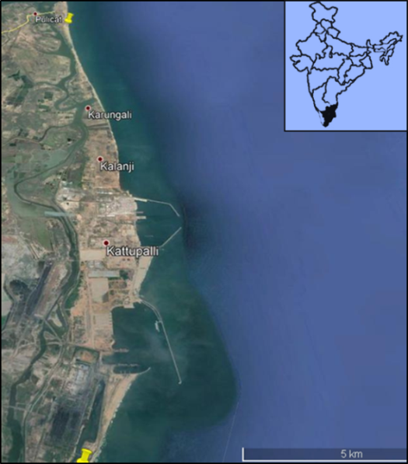

Figure : Location of study area

Related Publications
Chandrasekar, N., Joevivek, V., Saravanan, S., 2013. Coastal vulnerability and shoreline changes for southern tip of India-Remote sensing and GIS approach. Journal of Earth science and climatic change 4:144.

Fenster, M., R. Dolan and R.A. Morton, 2001. Coastal storms and shoreline change: signal or noise. J. Coastal Res., 17: 714-720.

Frederick Ato Armah, 2011. GIS-based Assessment of Short Term Shoreline Changes in the Coastal Erosion-Sensitive Zone of Accra, Ghana. Research Journal of Environmental Sciences, 5: 643-654.

Sheela Nair L., Sundar V. &Kurian N.P., (2015), "Longshore Sediment Transport along the Coast of Kerala in Southwest India”, MoES.pp.40-46.

Kaliraj, S., Chandrasekar, N., Magesh, N.S., (2013), Impacts of wave energy and littoral currents on shoreline erosion/accretion along the south-west coast of Kanyakumari,Tamil Nadu using DSAS

Email: subburajiom@gmail.com

