Genomics of OLIG family of the bHLH transcription factor

Shouhartha Choudhury¹ Prosenjit Paul² and, Supriyo Chakraborty^{3*}
¹Department of Biotechnology, Assam University, Silchar-788011
²School of Life Sciences, Assam University, Silchar-788011

Keywords: OLIG2, OLIG Family, bHLH transcription factor, Gene expression
Abstract:
The present study investigated common primary tumors of the human brain are thought to be of glial cell origin. The glial cell neoplasms cannot be fully classified by cellular morphology. The tumorigenesis in the central nervous system suggests that novel molecular markers found among factors in glial development. Oligodendrocyte lineage gene induces differentiation of neural progenitors and putative immature progenitor cells of the adult central nervous system. The oligodendrocyte lineage genes OLIG1 and OLIG2 encode basic helix-loop-helix transcription factors. The murine bHLH transcription factors are essential for oligodendrocyte development found to chromosome 21. OLIG1 participate oligodendrogenesis and OLIG2 express in immature neuron and multipotential glia in the embryonic olfactory neurons. OLIG2 a marker of diffuse glioma and faithfully restricted to the normal oligodendroglia in the human brain. OLIG3 is a third gene of OLIG family induces in the neural tube in midbrain, hindbrain, and spinal cord. Our data provide evidence that OLIG family and their specific bHLH domain in genomic data. We accumulate eukaryotes organism i.e. Homo sapiens and Mus musculus for comparative and functional analysis. The complete bHLH transcription factor data analysis suggested the number of OLIG genes and their specific domain, motifs, phylogeny, chromosome location, and gene expression. In this study, we performed bioinformatics and computational techniques to the current knowledge of OLIG family of the bHLH transcription factor.

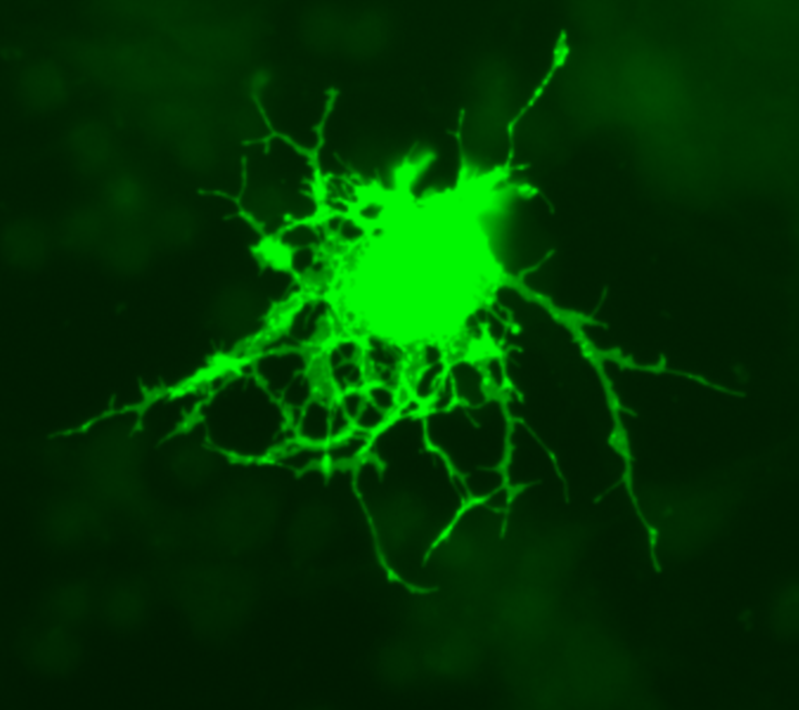

Reference:
- Diamond, M.C., et al., On the brain of a scientist: Albert Einstein. Experimental neurology, 1985. 88(1): p. 198-204.
- Lu, Q.R., et al., Oligodendrocyte lineage genes (OLIG) as molecular markers for human glial brain tumors. Proceedings of the National Academy of Sciences, 2001. 98(19): p. 10851-10856.
- Marie, Y., et al., OLIG2 as a specific marker of oligodendroglial tumour cells. The Lancet, 2001. 358(9278): p. 298-300.
Biography:
Shouhartha Choudhury has completed his B.Tech, M.Tech in Bioinformatics and M.Phil in Life Science and Bioinformatics from India, and now pursuing Ph.D. from School of Life Sciences, Department of Biotechnology, Assam University, Silchar-788011, India

Author details


Full name: Shouhartha Choudhury
Contact number: +91-9954411181
Twitter account: Shouhartha Choudhury
Linked In account: Shouhartha Choudhury
Session name/ number:
Category: (Oral and poster presentation)
Passport Number:

