Title: Ginsenoside rg1 prevents chemotherapy-induced cognitive impairment by suppressing neuroinflammation and promoting neuroplasticity

Dong-Dong SHI¹, Zhang-Jin ZHANG¹
¹School of Chinese Medicine, University of Hong Kong, Hong Kong, China

Keywords: Ginsenoside rg1, chemobrain, neuroinflammation, cytokine dysfunction, microglia, neuroplasticity, MEMRI, dendritic spines

- Abstract
Chemotherapy-induced cognitive impairment, also known as “Chemobrain”, is a common side effect (1). A mouse model of chemobrain was established by intraperitoneally injecting a combination of docetaxel, Adriamycin, and cyclophosphamide (DAC) at 2-day interval. Ginsenoside rg1 was given intraperitoneally at a dose of 5 mg/kg or 10 mg/kg daily for 3 weeks, beginning one week before the DAC treatment. Cognitive performance, locomotor and anxiety-like abilities were evaluated by water maze and open field test. The prefrontal cortex and hippocampus neural activities and dendritic spines were detected by MEMRI and two-photo imaging, respectively. Brain tissue and blood were collected to for the measurement of cytokines, cytokine regulators and biomarkers of neuroplasticity. Rg1-treated mice had significantly more time spent in and entries into the targeted quadrant in the water maze compared to DAC group. A significant increase in MEMRI signal intensity was observed in the prefrontal cortex and hippocampal sub-regions treated with rg1 compared to those without DAC. DAC treated mice exhibited a significant increase in the proinflammatory cytokines (IL-6 and TNF-α) and decrease in the anti-inflammatory cytokines (IL-4 and IL-10), whereas rg1 markedly reversed those cytokine dysfunctions. Besides, rg1 inhibited the activation of astrocytes and microglia and modulated the PPAR-γ/ NF-κB, which partly underlie the rg1-mediated inhibition on neuroinflammation. Rg1 also protected against DAC-induced decreases in the expression of the neuroplasticity biomarkers, BDNF, amino acid neurotransmitter receptors, and CaMKII. These results indicate that ginsenoside rg1 can prevent cognitive impairment from chemotherapy probably via regulating neuroinflammation and synaptic plasticity in related brain regions.

- Image:

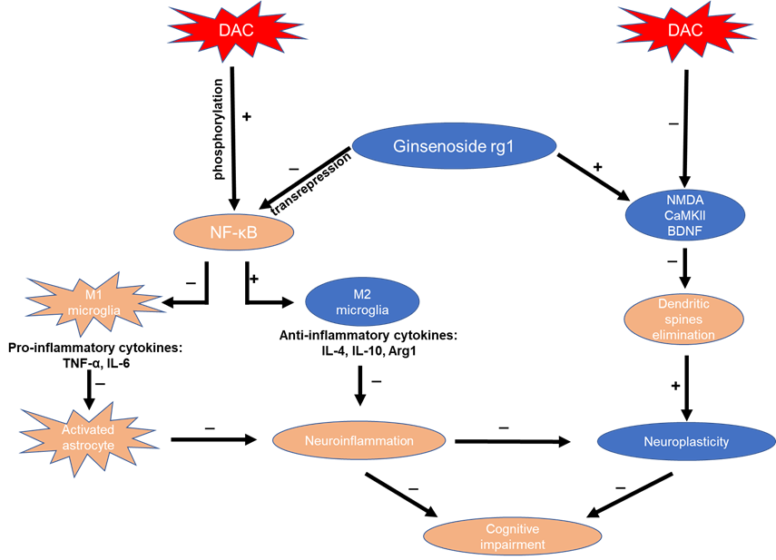

- Reference:
- Asher, A. (2011). Cognitive dysfunction among cancer survivors. Am J Phys Med Rehabil, 90(5 Suppl 1), S16-26. doi:10.1097/PHM.0b013e31820be463
- Biography:
Shi Dongdong has experience in analysis and neurobiology. I have many experimental skills. For example, skills about operating analysis instruments: HPLC, UPLC, PCEC. HPLC-ELSD, HPLC-MS, UPLC-MS, etc and statistical analysis; molecular and cellular biology techniques including cell culture, cell viability assay, FACS analysis, PCR, Western blot as well as skills about proteomics and metabonomics; data analysis skills: Data-processing software: SPSS, SigmaPlot, SIMCA-P, Masslynx, Origin.
- Presenting author details


Full Name: Dong-Dong SHI
Contact number:00852-96099973
Twitter account:
Linked In account:
Session name/ number:
Category: (Oral presentation/ Poster presentation): Poster presentation
Passport Number: E45074997

