A latent neuroprotection program in astrocytes of herbal AO in ischemic stroke

Yacong He¹, Jiangang Shen¹
¹School of Chinses Medicine, The University of Hong Kong, Hong Kong

Keywords: Neurogenesis, astrocytes, ischemic stroke, herbal AO

Abstract
Stroke has emerged as one of the most common causes of mortality and morbidity in modern society and is the third leading cause of death and the almost cause of adult disability in the United States and third world countries. It is estimated that approximately 6.4 million people in the U. S. suffer from stroke daily. In the U.S., approximately 795,000 patients experience at least one stroke every year (including 610,000 new and 185,000 recurrent cases), and approximately 20% of these patients die. Approximately 15 million people worldwide survive minor strokes each year. Unfortunately, although more than 700 neuroprotective drugs showed beneficial effects in preclinical animal studies, none of them proved effective in treating stroke patients. So, we propose to find out an effective drug or active compound to treat for the stroke. The herbal AO is the common used Chinses medicine in stroke clinical treatment, but its effect and related mechanism is limited. In our previous study, the proliferation of herbal AO showed the most significant effect to promote the cell viability after OGD/RO treatment. To further study its neuroprotection effect in vivo, Male adult SD rats(260-290g) were subjected to 2 hours of MCAO to mimic stroke of human. In ischemic stroke model, the density of astrocyte in striatum has been decreased, but it is significantly increased after herbal AO treatment. According to the result, herbal AO could be a promising therapeutic agent for stroke treatment.

Image:
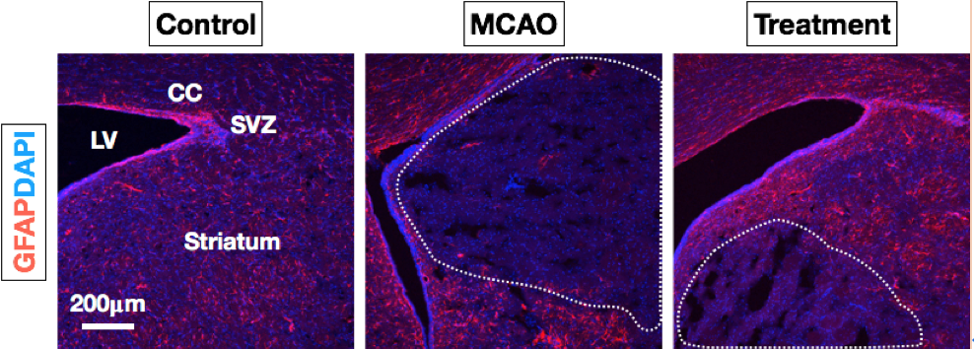

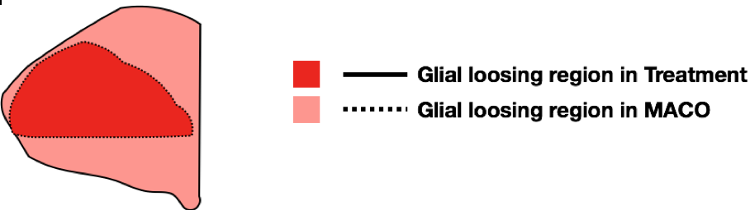

Reference:
Heron M. Deaths: leading causes for 2007. Natl Vital Stat Rep 2011; 59: 1-95.
Centers for Disease Control and Prevention: Prevalence of disabilities and associated health conditions among adults--United States, 1999. MMWR. Morbidity and mortality weekly report 2001, (50.7): 120.
Ims Ii Trial Investigators: The interventional management of stroke (IMS) II study. Stroke 2007, (38.7): 2127-2135.
Biography:
Ya-cong He is 2 year PhD student of School of Chinese Medicine, the University of Hong Kong. She has her expertise in isolation and identification of bioactive compounds in Traditional Chinese Medicine(TCM) and also focuses on evaluating bioactivities of chemical compounds, especially in the aspect of stroke.

Presenting author details
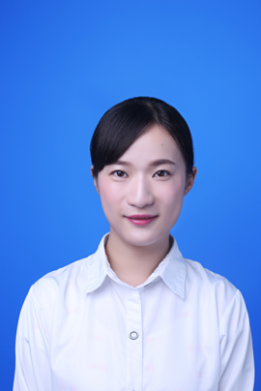

Full Name: Yacong He
Contact number:(852)98267295
Twitter account:
Linked In account:
Session name/ number: Central Nervous System Disorders, 1
Category: (Oral presentation/ Poster presentation): Poster presentation
Passport Number:E37438020

