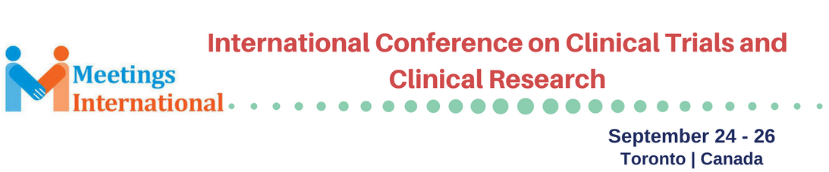

Abstract Template

Title: Using Machine Learning And Augmented Intelligence To Help Pharmaceutical Companies With High Placebo Response And Personalized Medicine

Dr. Joseph Geraci 1, 2,
1Department of Molecular Medicine, Queen’s University, Kingston, ON, Canada
2CEO of NetraMark Corp, Toronto, ON

Keywords: Machine Learning, Machine Intelligence, Precision Medicine, Personalized Medicine, Clinical Trials, Placebo, Augmented Intelligence

- Abstract Body (up to 250 words)
NetraMark’s primary mandate is to create technologies and methods that will improve how people will be treated through personalized medicine. We have created machine learning technologies specifically tailored for data that comes from clinical trials. The algorithms are clever enough to handle the heterogeneity and relatively small data that is typical for a clinical trial. A very important part of the process however lies in the ability for an expert user, such as a clinician or medical scientist, to interact with complex models in a very easy way. For this presentation we would like to share a few things we learned about placebo response and personalized medicine through the use of our NetraAI technology. We discovered a way to predict placebo response for pharmaceutical companies and a way to understand what is driving the various subpopulations in a certain neurodegenerative disorder and major depression. The process involves using our technology as a data microscope to unlock actionable insights about these disorders. This is possible due to a novel way to visualize complex multi-variate models with simple maps that are very easy to read.
This presentation will focus on the use of this novel augmented intelligence tool and we will also introduce our cutting edge methods for modelling patient data by using Quantum Machine Learning on the DWave Quantum Computer. We will explain how this will help transform clinical trials within the next decade.

- Reference:

- GWAS-based machine learning approach to predict duloxetine response in major depressive disorder
M Maciukiewicz, VS Marshe, AC Hauschild, … - Journal of psychiatric research, 2018

- Applying deep neural networks to unstructured text notes in electronic medical records for phenotyping youth depression
J Geraci, P Wilansky, V de Luca, A Roy, JL Kennedy… - Evidence-based mental health, 2017

III. Biography:
Dr. Joseph Geraci is a mathematical physicist who completed postdocs in oncology, neural psychiatry, and machine learning. He is currently the CEO of NetraMark Corp and Assistant Professor at the department of Molecular Medicine at Queen’s University. He is currently leading a team that helps pharmaceutical companies with difficult phase III trials. His main areas of expertise are in machine learning, placebo response, patient subpopulation identification, and drug target discovery.

Presenting author details

Dr. Joseph Geraci
647.953.9000
https://www.linkedin.com/in/joseph-geraci-233a17b/
www.netramark.com

Session name/ number:
Category: Oral presentation

Copyright © 2016-2018 Meetings Int PTE Ltd, All Rights Reserved.
Meetings Int.Pte Ltd

Company Registration No: 201524282R, 28 MAXWELL ROAD, #03-05 RED DOT TRAFFIC, SINGAPORE (069120)
Tel: +6531080483| Toll Free no. +800-852-6126
Web: https://www.meetingsint.com/conferences/clinicaltrials | E-mail: clinicaltrials@meetingseries.org

