Training pharmacist prescribers for advanced clinical roles in UK Emergency Departments
David RP Terry, FRPharmS PhD, Aston University, UK
Matthew Aiello, MA LPC LLB Hons, Health Education England, UK
Mike Carlini, Sigma-Clermont, France
Chi Huynh, MRPharmS PhD, Aston University, UK

Abstract (300 word limit)
Statement of the Problem: The Pharmacists in Emergency Departments (PIED) study (UK 2016, 49 sites, 18,613 patients) identified 494 advanced clinical skills that could be taught to pharmacists to maximize their ability to manage patients attending hospital EDs. Aim: to map clinical skills identified by the PIED study to taught components of advanced clinical training for pharmacist independent prescribers provided by 3 UK Universities. Methodology & Theoretical Orientation: Clinical skills identified by the PIED study were categorized to one of four groups: clinical examination and assessment (n=218); diagnostic skills (n=89); medical management (n=183); and training course components (n=4). Three providers of the clinically enhanced pharmacist independent prescribing programme, approved by Health Education England, were recruited and asked to consider all 494 clinical skills and, if taught, assign a score indicating the extent of training on a scale of 1 to 5 where 1 was minimal content and 5 was extensive content. Findings: All three providers taught PIED identified clinical skills (83 – 17%, 150 – 30%, 242 – 49% respectively). Mean coverage were: clinical examination and assessment 39%; diagnostic skills 35%; medical management 22%; and training course components 17%. Overall approximately 32% of the PIED identified clinical skills were provided by these programmes. Since PIED identified training was associated with pharmacist prescribers managing 35.7% of ED attendees these results suggest that pharmacists completing these training programmes may have the skills required to manage up to 16.7% of all ED attendees – allowing for the 7.8% of patients potentially manageable by non-prescribing pharmacists. Skills with the highest content rating (4.33) included: abdominal, throat and cranial nerve examination. Further work is required to identify optimum training for pharmacists to manage ED attendees. Conclusion & Significance: Advanced training equips pharmacists in the UK for clinical roles in Emergency Departments – with potential implications for the clinical workforce.

Image
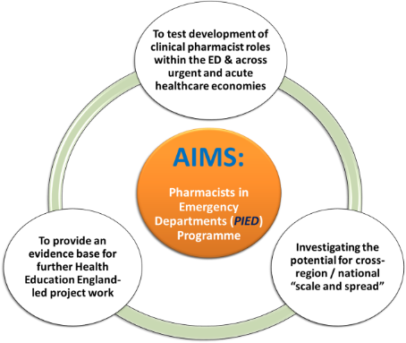
Recent Publications (minimum 5)
- Hughes E, Terry D, Huynh C, Petridis K, Aiello M, Mazard L, Ubhi H, Terry A, Wilson K, Sinclair A. Future enhanced clinical role of pharmacists in Emergency Departments in England: multi-site observational evaluation. Int J Clin Pharm. 2017. DOI 10.1007/s11096-017-0497-4. Available at http://rdcu.be/tIK9 [open access].
- Aiello, M., Terry, D., Selopal, N., Huynh, C., Hughes, E. Examining the emerging roles for pharmacists as part of the urgent, acute and emergency care workforce. Clinical Pharmacist 2017. Vol 9, No 2, online | DOI: 10.1211/CP.2017.20202238
- Terry D, Petridis K, Aiello M, Sinclair A, Huynh C, Mazard L, et al. The potential for pharmacists to manage patients attending emergency departments. Int J Pharm Pract. 2016;24 (Suppl1)(4). DOI: 10.1111/ijpp.12258/epdf
- Terry D, Petridis K, Rainey K and Ubhi H. Pharmacists in Emergency Departments a commissioned study by Health Education West Midlands, Report April 2015.
- Hughes E, Aiello M, Terry D. Clinical pharmacists in urgent and acute care - the future pharmacist. Commissioning. 2014;1(6):48-53.


Biography (150 word limit)
David’s 30 year career includes community pharmacy, hospital, primary-care and academia. He was awarded a PhD in 2011 by Aston University for his work on paediatric medicines management across the interfaces of care. In the same year he became the Director of the Pharmacy Academic Practice Unit – a joint collaboration between Birmingham Children’s Hospital and Aston University. His current work includes developing advanced roles for pharmacists and pharmacy technicians. He is the evaluation lead for the large HEE study concerning Pharmacists in ED (PIED) and is the Programme Director for advanced clinical training at Aston. He was made a Fellow of the Royal Pharmaceutical Society of Great Britain in 2016.
Email: d.terry@aston.ac.uk

Notes/Comments:

