Abstract Template

Studies on the Stability of Expired Pharmaceuticals in the Health Sector

Idris M. El-Mahdi
Department of Pharmaceutics, Faculty of Pharmacy, University of Benghazi, Benghazi, Libya.

Keywords: Shelf-life extension, Stability of medicines, Expiration dates.

- Abstract
Analysis to the literature supports the assumption that the shelf life of many drugs, seems to be "longer" than their expiration dates, leading to unnecessary waste, higher pharmaceutical costs, and possibly reduced access to necessary drugs for some patients. This is of most significance for the current situation in Libya with the political unrest and civil war that divides the Country, and as a direct consequence of this turmoil, shortage of essential drugs occurs. In Benghazi Medical Center (BMC) exists large amounts of essential medicines past its expiration dates. And there is dire need for such medicines in management of in-patients and out-patients. Hence, the aim of this study was to test the stability of expired-medicines at the BMC, and possibly extends its shelf-life. Four products were selected containing: atenolol, paracetamol, amoxicillin, and the highly expensive combination of sofosbuvir and ledipasvir. And they were expired for a period between 6 months and a year. The evaluation tests included measurement of disintegration time, dissolution rate and assay of active content of active ingredient(s) using official methods. The results showed that all of the tested products are still within the acceptance criteria for all the tests, and the products can still be used for therapeutic uses.

- Image:

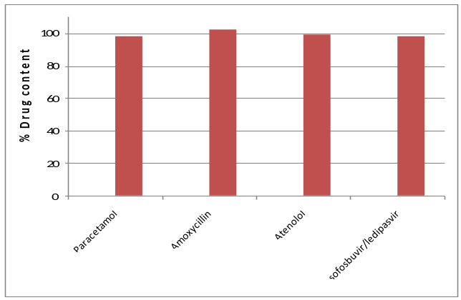
- Drug content of expired medicines tested in this work.

- References:
- Taylor JS, Lyon RC, Prasanna HR, Hussain AS. Stability profiles of drug products extended beyond labeled expiration dates. Program and abstracts of the 2002 FDA Science Forum; February 20-21, 2002; Washington, DC.

- Lyon, Robbe C., et al. "Stability profiles of drug products extended beyond labeled expiration dates." Journal of Pharmaceutical Sciences 95.7 (2006): 1549-1560.

- Drugs past their expiration date. The Medical Letter on Drugs and Therapeutics. 2002; October844 (1142): 93-94. [PubMed]

IV. Biography:
Professor Elmahdi has completed his PhD at the age of 29 years from University of Dublin, Trinity College. He is the Director of Pharmaceutical Research Center at University of Benghazi. He has published/presented more than 50 papers in reputed journals and conferences. He has been serving as Quality Assurance consultant for WHO and both the Ministry of Health and Food & Drug Administration in Libya.

V. Presenting author details


Full Name: Idris M. Elmahdi Buokhamada
Contact number: +218913826640
Session name/ number: Pharmacists in Healthcare System/6
Category: (Oral presentation)
Passport Number: CLZZY5FG

