Idiopathic isolated (right) complete oculomotor nerve palsy management with Ayurvedic treatment – A Case report.
Author:
- Vd. Riju Agarwal, M.S. (Ay.), Associate Prof. & Head, Dept. of Shalakya, Ch.Brahm Prakash Ay.Charak Sansthan, N. Delhi.
- Prof. Vd. K.S. Dhiman, Ph. D, M.D.(Ay.), Director General, CCRAS, New Delhi, Former Prof & Head-Shalakya, IPGT&RA, GAU, Jamnagar.
- Dr. Manju Rani, M.S.(Ay.)Associate Prof. & Head, Dept. of Shalya, Ch.Brahm Prakash Ay.Charak Sansthan, N. Delhi.

- Abstract

Aims To assess the efficacy of Ayurvedic treatment in isolated complete oculomotor nerve palsy by subjective evaluation. Methods Retrospective interventional case report supplemented by Ayurvedic treatment. Using a subjective evaluation, outcome was defined according to patient’s perspective on the basis of improvement in eye movement and ptosis. A patient 33 years male resident of Delhi running a private business in marketing presented with complaints of unable to open his right eye with diminished movements. He was quiet well two and half months back, then he suddenly had nausea, vomiting and headache (on right half) for almost a week. He took treatment from various allopathic hospital but no improvement was observed. With above mentioned complaints patient came to Netra roga OPD no 15 (ophthalmology) of Shalakya Tantra department at Ch. Brahm Prakash Ayurved Charak Sansthan. He took treatment for 2 months and got complete remission in his symptoms. Conclusion Ayurvedic treatment definitely have role in chronic disease like different types of palsies especially oculomotor nerve palsy. A case series or pilot study should be conducted in the similar cases to validate the above case report which may prevent or treat many cases of oculomotor palsies.
Keywords: Ayurveda, oculomotor palsy, Shalakya Tantra, ophthalmology, Ayurvedic treatment.

II. Pics
Image 1 Image 2
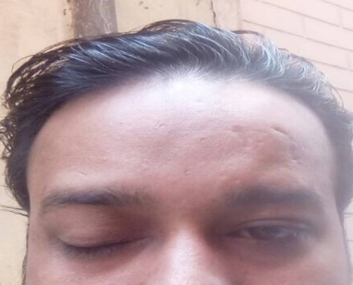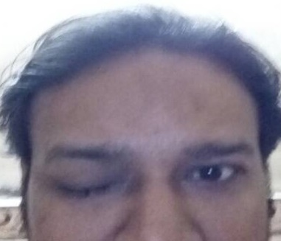

Image 3 Image 4 Image 5
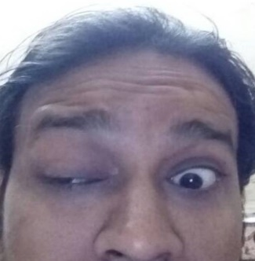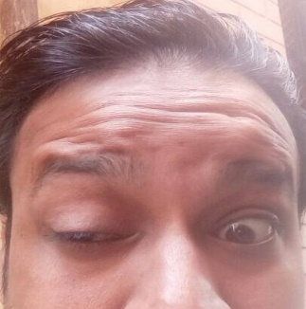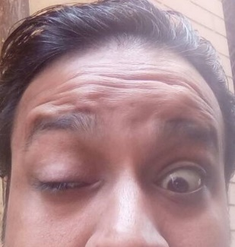

Image 6 Image 7 Image 8
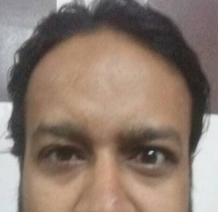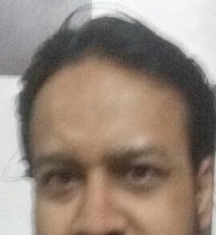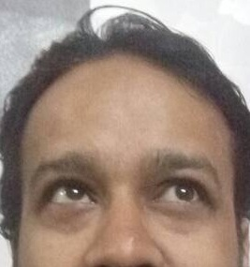
III. REFERENCES
- Agarwal R, Dhiman KS, Rani M, Dhiman K. Idiopathic Isolated (Right) Complete Oculomotor Nerve Palsy Management with Ayurvedic Treatment. J Res Ayurvedic Sci 2018;2(1):55-59 .
- AK Khurana, Comprehensive Ophthalmology, Sixth edition, New Delhi: Jaypee Brothers Medical Publishers; 2015. p. 336.
- S. Agarwal, A. Agarwal, Text book of ophthalmology, Vol 1, section C, Neurophthalmolgy, first edition. New Delhi: Jaypee Brothers Medical Publishers; 2002. p.327.
- S. Agarwal, A. Agarwal, Text book of ophthalmology, Vol 1, section C, Neurophthalmolgy, first edition. New Delhi: Jaypee Brothers Medical Publishers; 2002. p.332.
- S. Agarwal, A. Agarwal, Text book of ophthalmology, Vol 1, section C, Neurophthalmolgy, first edition. New Delhi: Jaypee Brothers Medical Publishers; 2002. p.332.
- AK Khurana Indu khurana, Anatomy and physiology of eye, Second edition, New Delhi: CBS Publishers and Distributors Pvt ltd; 2006. p. 458.
- AK Khurana Indu khurana, Anatomy and physiology of eye, Second edition, New Delhi: CBS Publishers and Distributors Pvt ltd; 2006. p. 458.
- S. Agarwal, A. Agarwal, Text book of ophthalmology, Vol 1, section C, Neurophthalmolgy, first edition. New Delhi: Jaypee Brothers Medical Publishers; 2002. p.332.
- S. Agarwal, A. Agarwal, Text book of ophthalmology, Vol 1, section C, Neurophthalmolgy, first edition. New Delhi: Jaypee Brothers Medical Publishers; 2002. p.332.
- S. Agarwal, A. Agarwal, Text book of ophthalmology, Vol 1, section C, Neurophthalmolgy, first edition. New Delhi: Jaypee Brothers Medical Publishers; 2002. p.333.
- AK Khurana Indu khurana, Anatomy and physiology of eye, Second edition, New Delhi: CBS Publishers and Distributors Pvt ltd; 2006. p. 458.
- S. Agarwal, A. Agarwal, Text book of ophthalmology, Vol 1, section C, Neurophthalmolgy, first edition. New Delhi: Jaypee Brothers Medical Publishers; 2002. p.33.
- Shastri, AD.; editor. Govind Das, Bhaishjya Rantnawali, Vatavyadhi Chikitsa Adhyaya, 26/145-148. Varanasi: Chaukhamba Prakashan; Reprinted 2011. p.547.
- Anonymous, Ayurved sarsangraha. Kolkatta: Shri Baidyanath Ayurveda bhavan; 2016.p.312.Ekangveer rasa
- Shastri, AD.; editor. Govind Das, Bhaishjya Rantnawali, Vatavyadhi Chikitsa Adhyaya, 26/29. Varanasi: Chaukhamba Prakashan; Reprinted 2011. p.531.
- Shastri, AD.; editor. Govind Das, Bhaishjya Rantnawali, Apasmara Chikitsa Adhyaya, 25/35. Varanasi: Chaukhamba Prakashan; Reprinted 2011. p.524.

IV. Biography
Prof.Vaidya Riju Agarwal was born in the year 1977 in Delhi, India. He has pursued his graduation in Ayurveda from A & U Tibbia College, Delhi University and later masters of surgery in Ayurveda (Shalakya Tantra-Ayurvedic ophthalmology) from Rajiv Gandhi Govt Post Graduate College, Himanchal Pradesh University, India. He has more than 14 years of academics and clinical experience in the field of Ayurvedic Ophthalmology (Shalakya) and worked in various capacities like Assistant Professor, Associate Professor in various Ayurvedic institutions in India. He is currently working as Head of Shalakya Department & Associate Professor at Chaudhary Brahm Prakash Ayurved Charak Sansthan, GGSIP University, New Delhi. He has authored four books and published more than 20 research papers in reputed journals/souvenir/peer reviewed journals and has been working as an editorial board member/reviewer in IRJP, JAIM, JRAS, JDRAS journals. He has delivered various research papers as a resource person and also chaired sessions in reputed national/ international seminars/ conferences/workshops/training programs and participated in many events related to Ayurveda. He is a lifetime member of various organizations related to promotion and propagation of Ayurveda like T.A.S. (The Association of Shallaki, India), AIAPGSA (All India Ayurvedic PG Specialist Association) & All India Ayurveda Mahasammelan.
Research Interest: Ayurveda, Ophthalmology, Ayurvedic Ophthalmology, Shalakya Tantra & Clinical research
V. Presenting author details
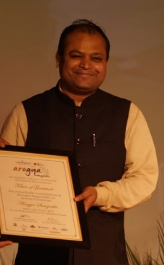
Full Name: Vaidya Riju Agarwal
Contact number: 9650570095
Twitter account:@ayurvedaeye
Linked In account: Vaidya Riju Agarwal
Session name/ number:
Category: (Oral presentation/Poster Presentation): Oral Presentation
Research gate Account: Riju Agarwal

